detectproj

**Table of contents**

Introduction 4

Map projection 7

Distortions 10

Tissot’s indicatrix 15

Classification of map projections  19

Simple projections 22

Pseudo projections 30

Globular projections 34

Perspective projections 39

Polyconic projections 44

Modified azimuthal 47

Interrupted projections 51

Miscellaneous projections 55

Projection aspect 59

Determined parameters of the map projection 64

List of supported map projections 68

Detection methods  73

7 parameter method 76

8 parameter method 79

Optimization techniques 82

Non-linear least squares 84

Hybrid BFGS 87

Derivative-free methods 91

Nelder-Mead method 94

Differential evolution 98

Getting Started 103

System requirements 106

Installation 109

Basic Usage 115

Add early map 119

Import early map 122

Working with control points 127

Choose control points 130

Collect control points 136

Move control points 140

Delete control points 143

List of control points 147

Import control points 151

Import test points 154

Import reference points 159

Export control point 164

Export test points 167

Export reference points 170

Perform analysis 173

Select detection method 176

Select optimization technique 179

Run analysis 182

Browse results 185

Clear results 191

Clear all 194

Export reconstructed graticule 197

Georeferencing analyzed map in ArcGIS 204

Creating graticule above the analyzed territory 207

Densify graticule 211

Assign spherical coordinates to the graticule 214

Georeferencing of the early map 220

Reprojection from Bonne to World Mercator 231

Setting parameters 239

**Introduction**

# Introduction

Maps are an important part of our history andcultural heritage; close attention is paid to their study and research. They can be examined from several perspectives as historic documents, a documentation of the land changes, or as a cartographic source of information. New methods and techniques for map analysis allow for the creation of full or partial geometric reconstruction of its content. This approach belongs to the category of cartometric analysis, the capabilities of which have been significantly improved with the rapid development of the computer technology.

*Created with the Personal Edition of HelpNDoc:* [*Produce electronic books easily*](http://www.helpndoc.com/create-epub-ebooks)

**Map projection**

## Map projection

Map projections are important for creating maps; each map uses a projection. Map projection (or a mapping) transforms a position of the element on the curved surface into a flat surface (map), represented by the plane. A curved surface approximating the Earth is considered to be the sphere or ellipsoid. Each map projection ℙ is defined with the set coordinate functions *F*, *G of two* independent variables *φ, λ*

*X = F(φ, λ),  Y = G(φ, λ),*

which are continuous with their first order partial derivatives.The meridian of a longitude *λ* = *λ*0 = *const* is represented by the curve

*X* = *F*(*φ*, *λ*0),  *Y* = *G*(*φ*, *λ*0),

and analogously, a parallel of a latitude *φ* = *φ*0 = *const, is*

*X* = *F*(*φ*0, *λ*),  *Y* = *G*(*φ*0, *λ*).

There are few hundreds of map projections that may be classified into several families. However, only 20-30 are used in common cartographic practice.

*Created with the Personal Edition of HelpNDoc:* [*Easy EPub and documentation editor*](http://www.helpndoc.com)

**Distortions**

### Distortions

The original surface cannot be perfectly mapped to a plane, the distortions appear. The distortion leads to false representation of the shape, length, or area; it is always present on a map and significantly affects the shape of the graticule. Due to distortions, there is no exact correspondence between points on the sphere and on the plane. In other words, the curved Earth, represented by a sphere, cannot be aligned with a map, represented by a plane, without deformation. The basic distortion is represented by local liner scale,

*μ*2 = *h*2cos2*A* + *k*2sin2*A* + *q*sin2*A*.

where *h* is the local linear scale along the meridian

*h*2 = *e/R*2,

*k* the local linear scale along the parallel

*k*2 = *g/*(*R*cos*φ*)2,

and

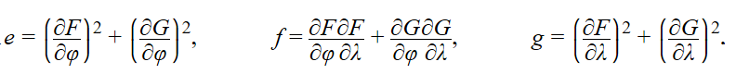

It primarily leads to the false representation of length, but affects all remaining distortions of areas and shapes. Each projection follows the distorion characteristics describing the local linear scale depending on the geographic position *φ, λ* and the azimuth *A*. An impact of distortion may be visualized by the Tissot’s indicatrix.

As mentioned above, each projection involves a distortion of shape, area or length. While some territories might be distortion-free, others could suffer from errors. Therefore, the map projection is selected in order to represent the entire Earth, a hemisphere, continent, or country as accurately as possible.

#### Contour lines of the local linear scale

The impact of the local linear scale may be visualized depending on the geogrpahic position of a point. The contour lines join points with the same value of the local linear scale.

Azimuthal equal-area projection, contour lines of *h*

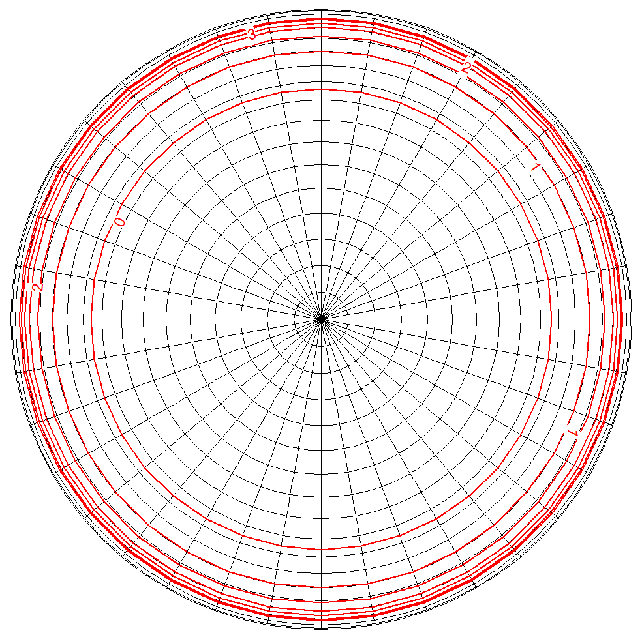

Werber-Staab projection, contour lines of *h*

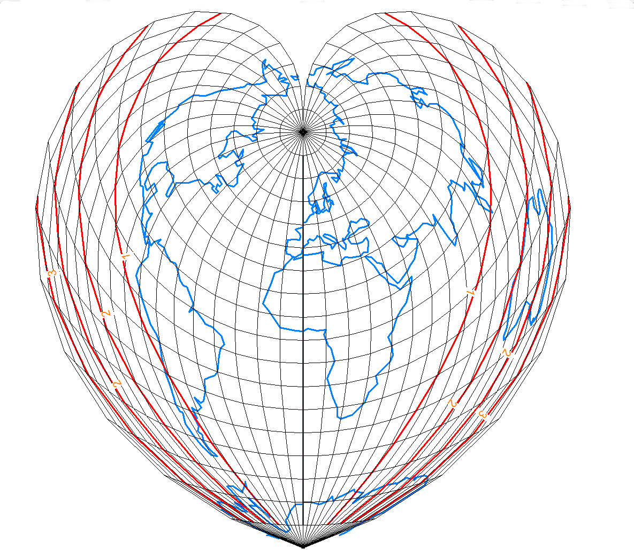

Collignon projection, contour lines of *h*

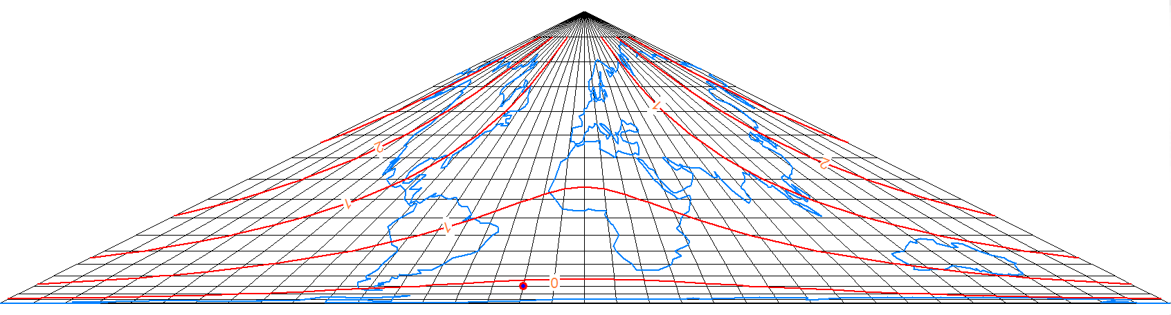

*Created with the Personal Edition of HelpNDoc:* [*Easily create Help documents*](http://www.helpndoc.com/feature-tour)

**Tissot’s indicatrix**

### Tissot’s indicatrix

In a general case, the local linear scale is a function of the geographical position and the azimuth.Thee Tissot’s indicatrix illustrats, how a projection is affected by the distortion of the length, shape, or area. It is represented by an infinitesimal circle *k*(*Q*, *dϱ*) centered at a given point Q=[*φ, λ*] that is mapped to infinitesimal ellipse E(*P*′, d*a*, d*b*, *A*′*ε*) rotated by the angle *A*′*ε*.   
  
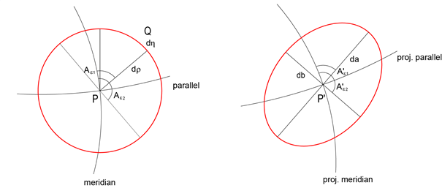

For conformal projections the Tissot’s indicatrix remain circular (larger or smaller than the original), see the Mercator projection.

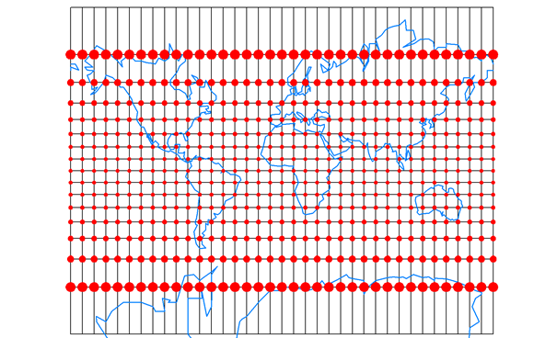

For equal area projections, the ellipse has the same area as the original circle, see the orthographic projection

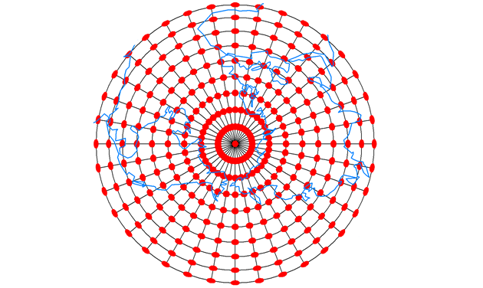

Otherwise, both the shape and area are different, see the Eckert III projection.

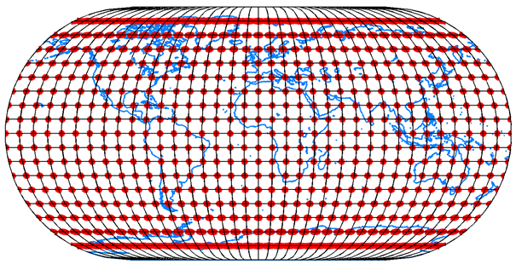

*Created with the Personal Edition of HelpNDoc:* [*Full-featured EBook editor*](http://www.helpndoc.com/create-epub-ebooks)

**Classification of map projections**

### Classification of map projections

Depending on the shape of the graticule, the are several important families.

*Created with the Personal Edition of HelpNDoc:* [*Easily create Web Help sites*](http://www.helpndoc.com/feature-tour)

Simple projections

#### Simple projections

Unfortunately, a sphere cannot be convert to the plane without distortions. Basically, there is a simple geometric illustration that a projection surface is represented by the developed surface touching or intersecting a sphere. It is associated with the cylindrical, azimuthal, and conic projections. An open cylinder, cone are unrolled and flattened to the plane. They are orthogonal, their parallels and meridians always cross at right angles.

**Conic projections:**

*Equidistant (Ptolemy)*

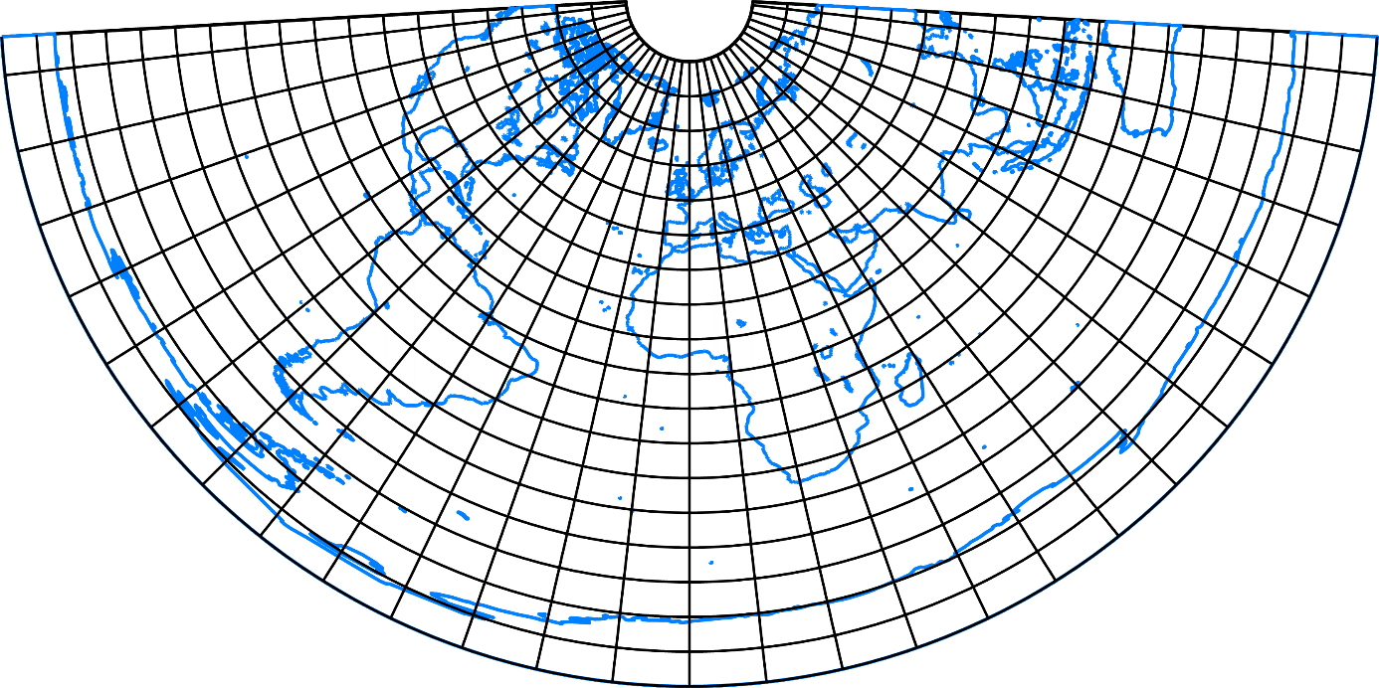

Equal area

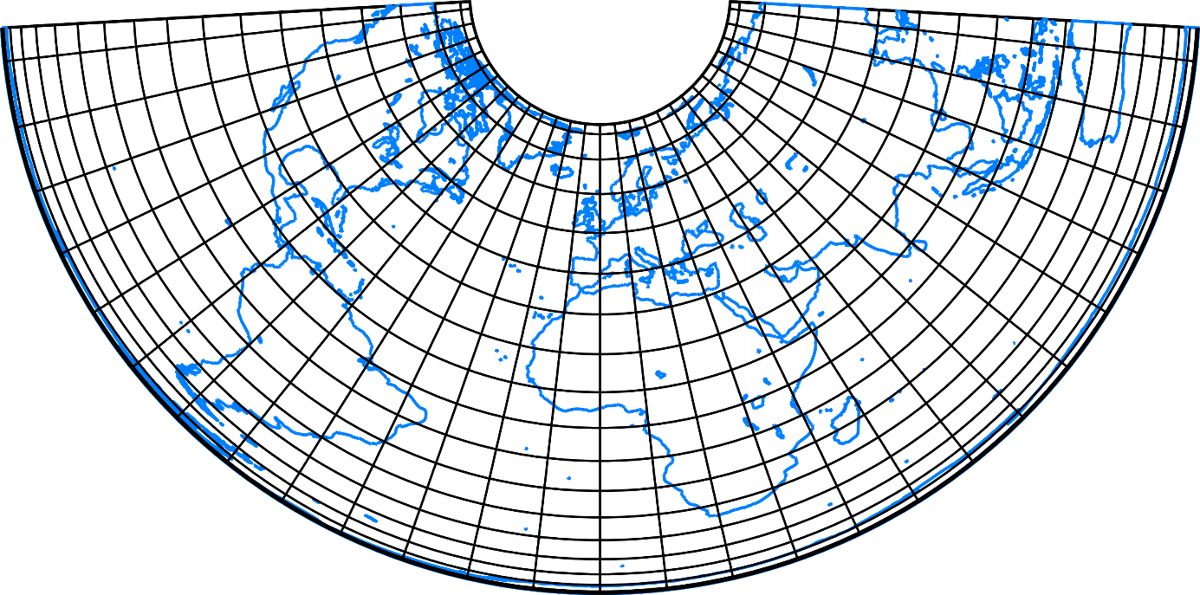

Conformal (Lambert)

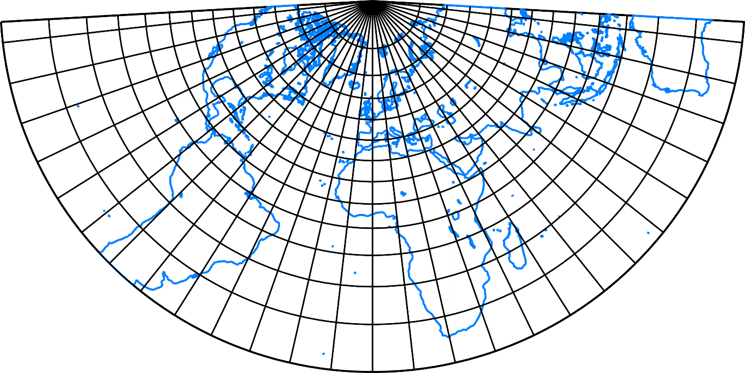

**Cylindrical projections:**

Equidistant

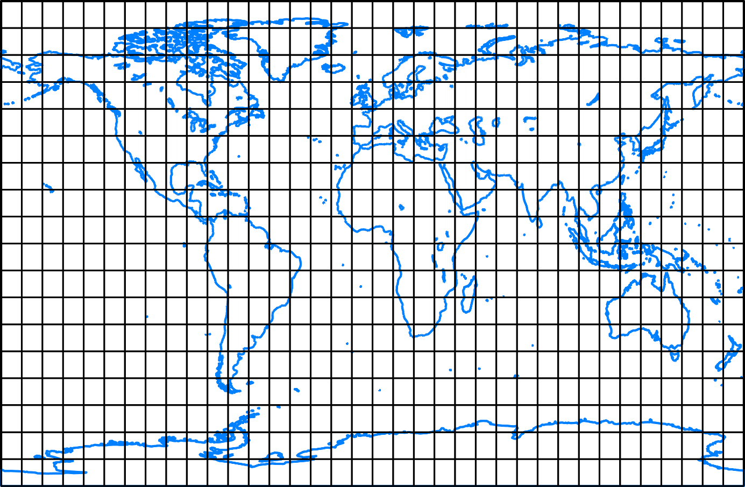

Equal area (Lambert)

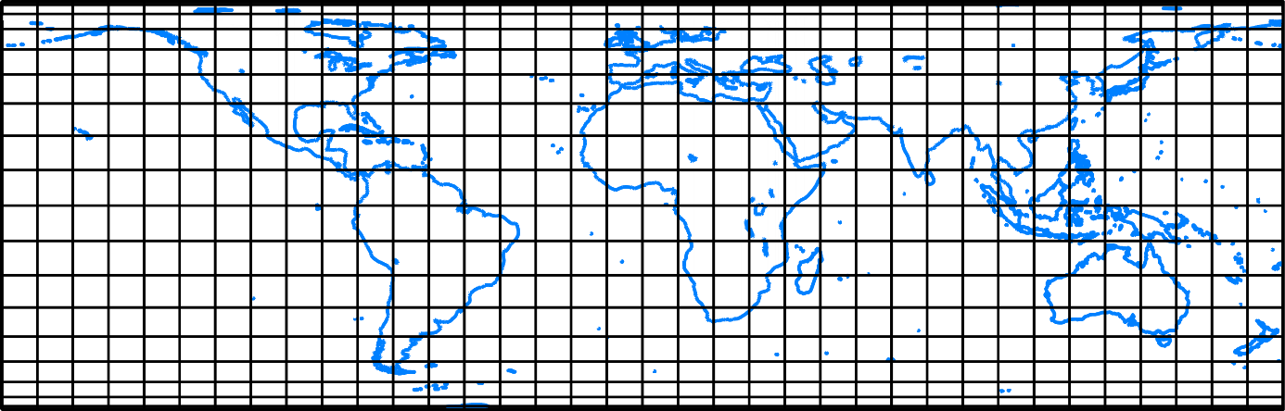

Conformal (Mercator)

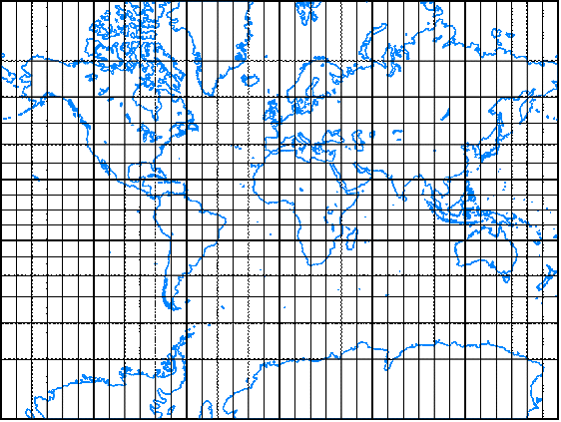

**Azimuthal projections:**

Equidistant

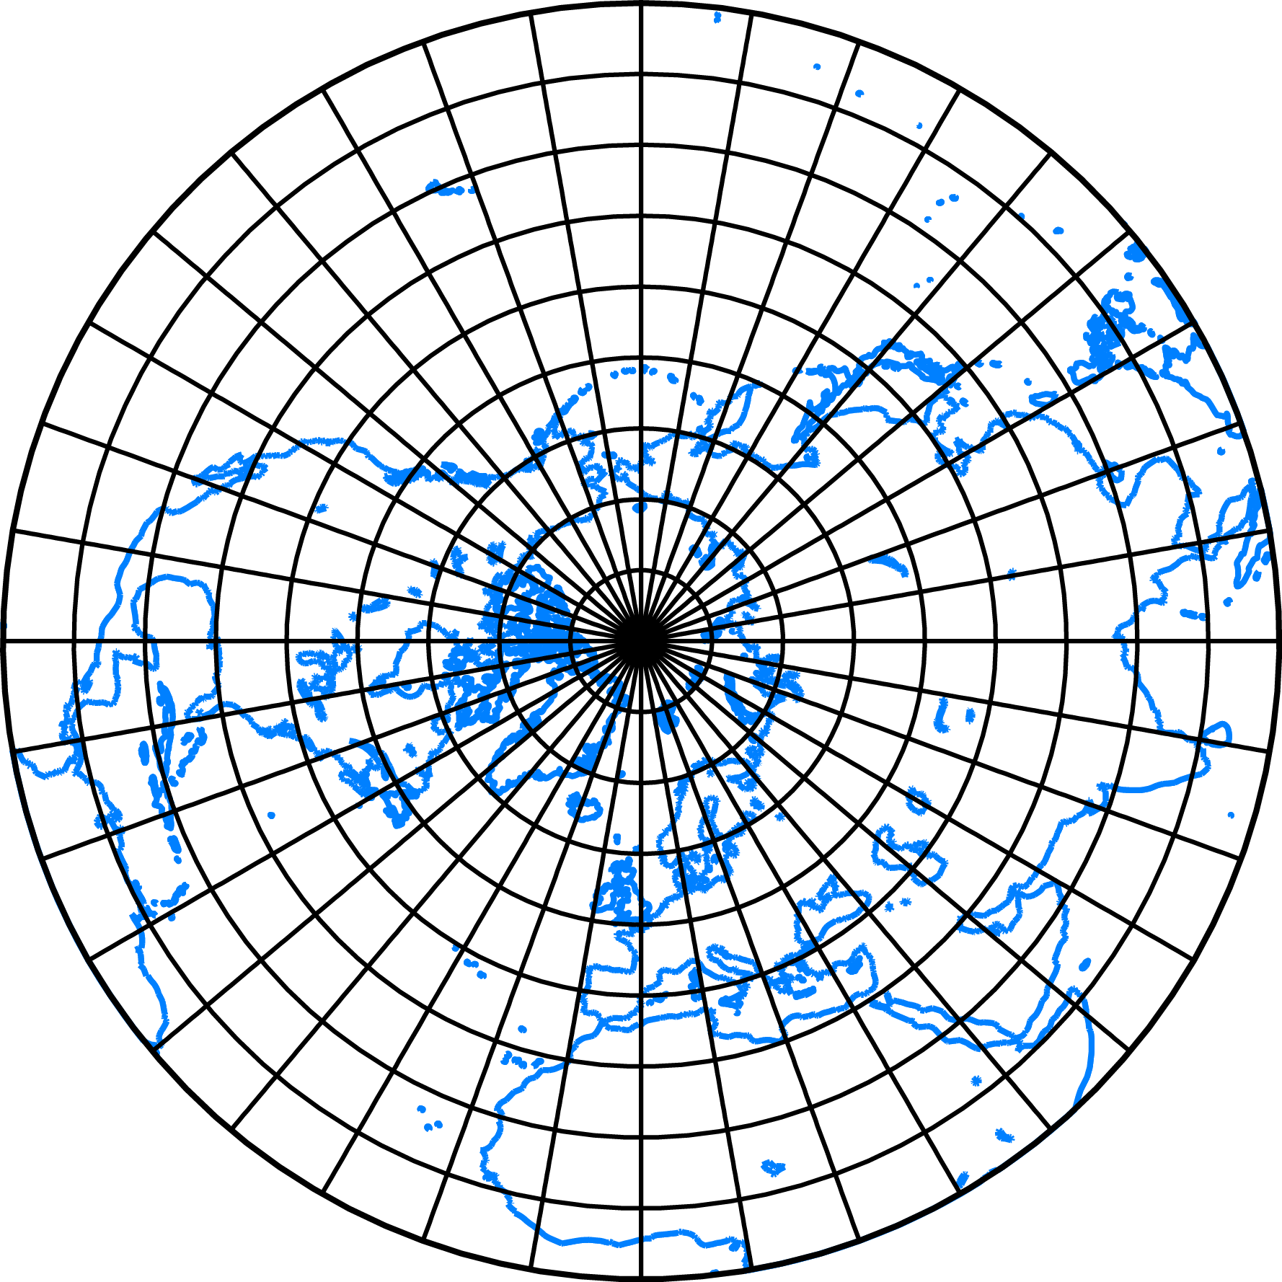

Equal area

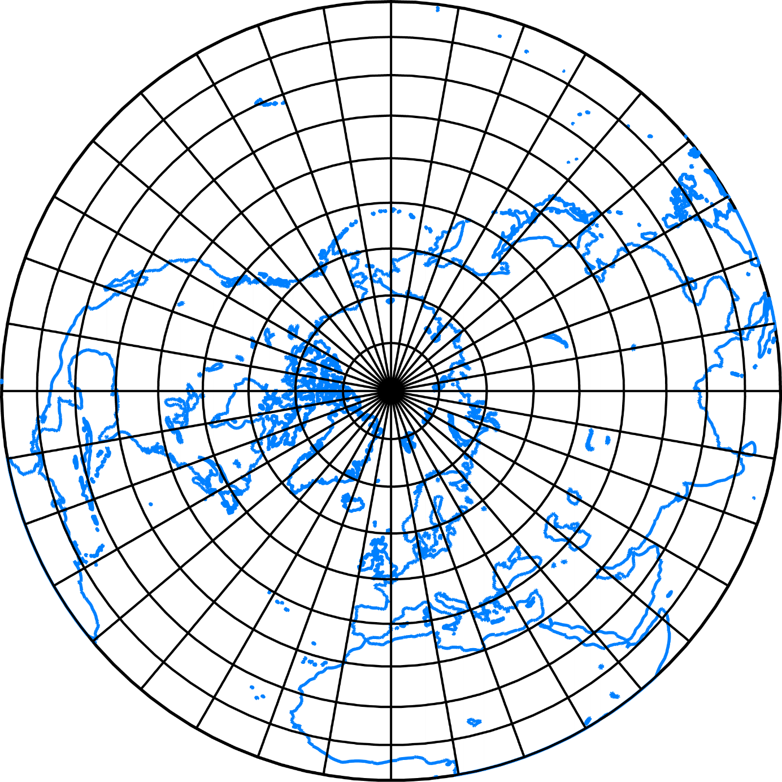

Conformal (stereographic projection)

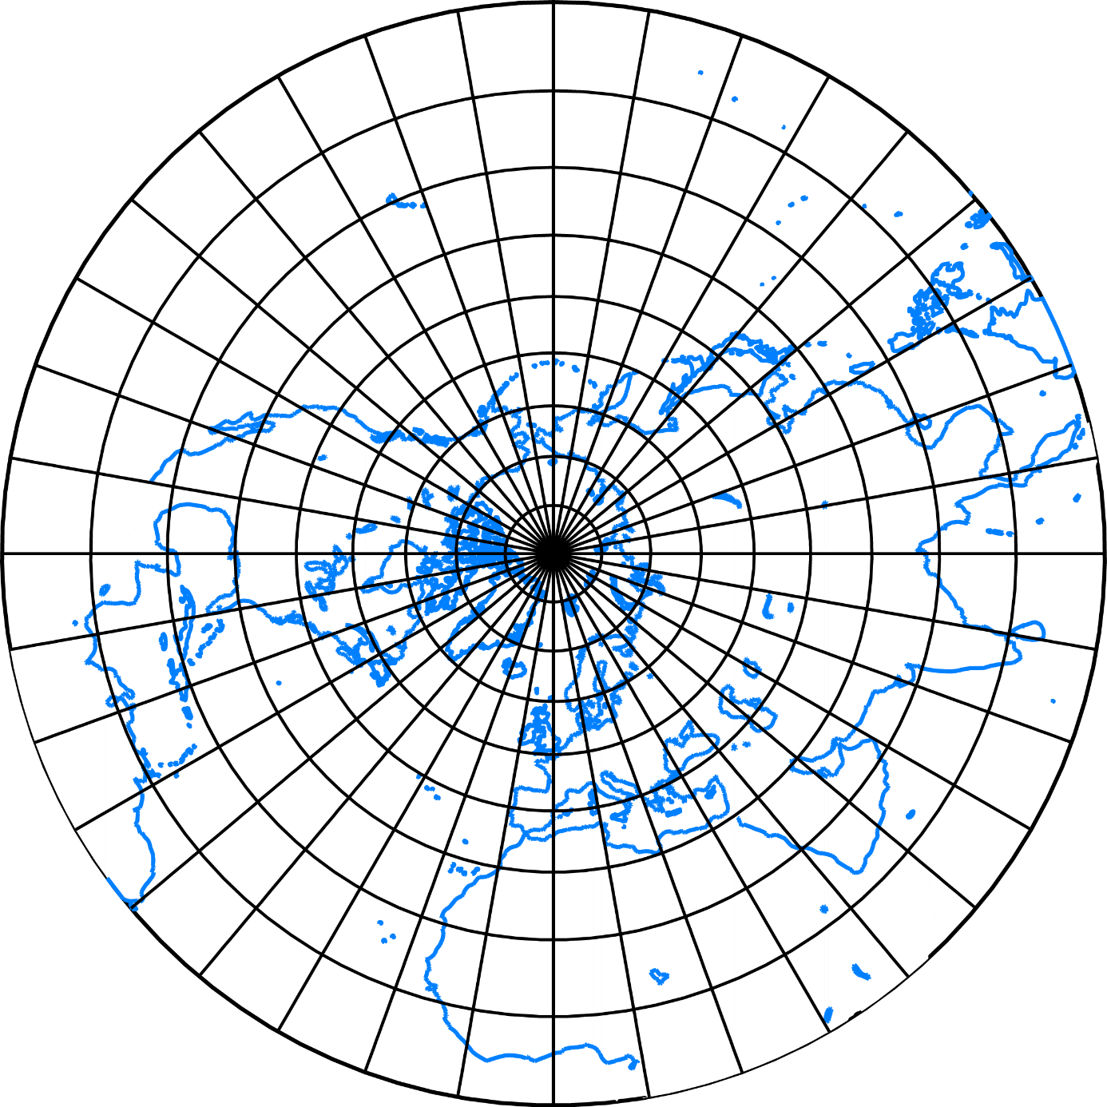

*Created with the Personal Edition of HelpNDoc:* [*Easily create Help documents*](http://www.helpndoc.com/feature-tour)

Pseudo projections

#### Pseudo projections

Sometimes, a concept of the auxilliary gemetrical solids is not available, but some analogies remains. To avoid the poles stretched to the lines or circles leading to strong shape distortions, several refinements can be found in the inherited families: pseudocylindrical, pseudoconic, pseudoazimuthal. They are not orthogonal. Instead of the equator or central meridian, their parallels and meridians always do not cross at right angles.

Bonne  
  
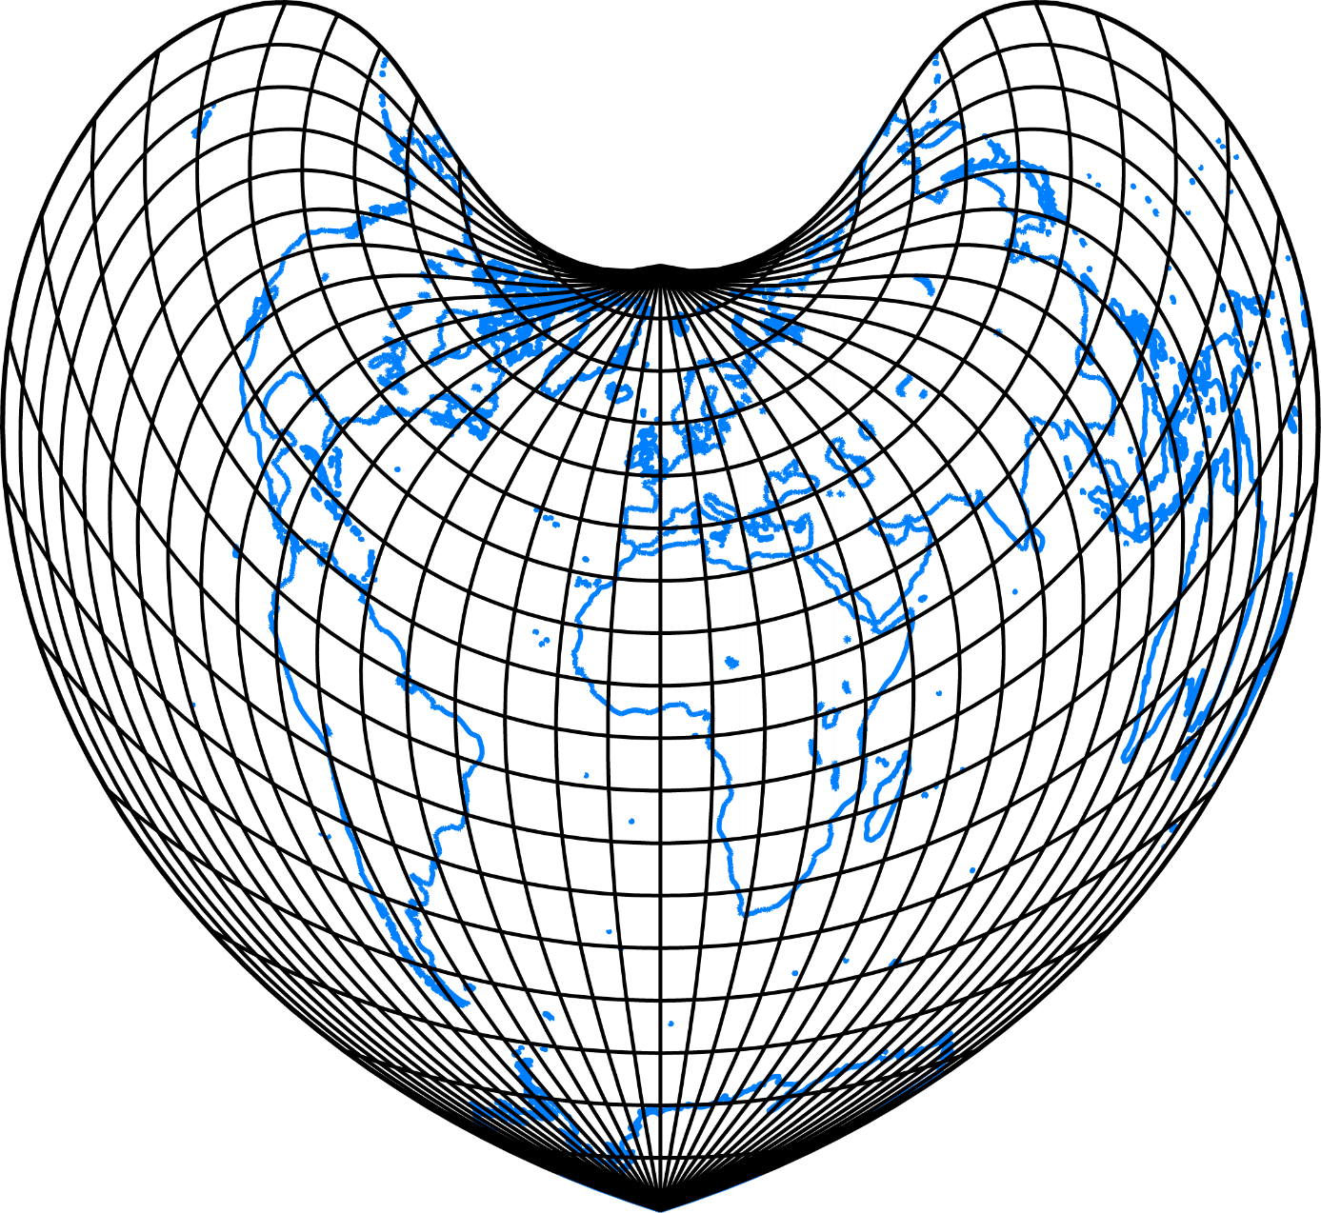

Eckert I.

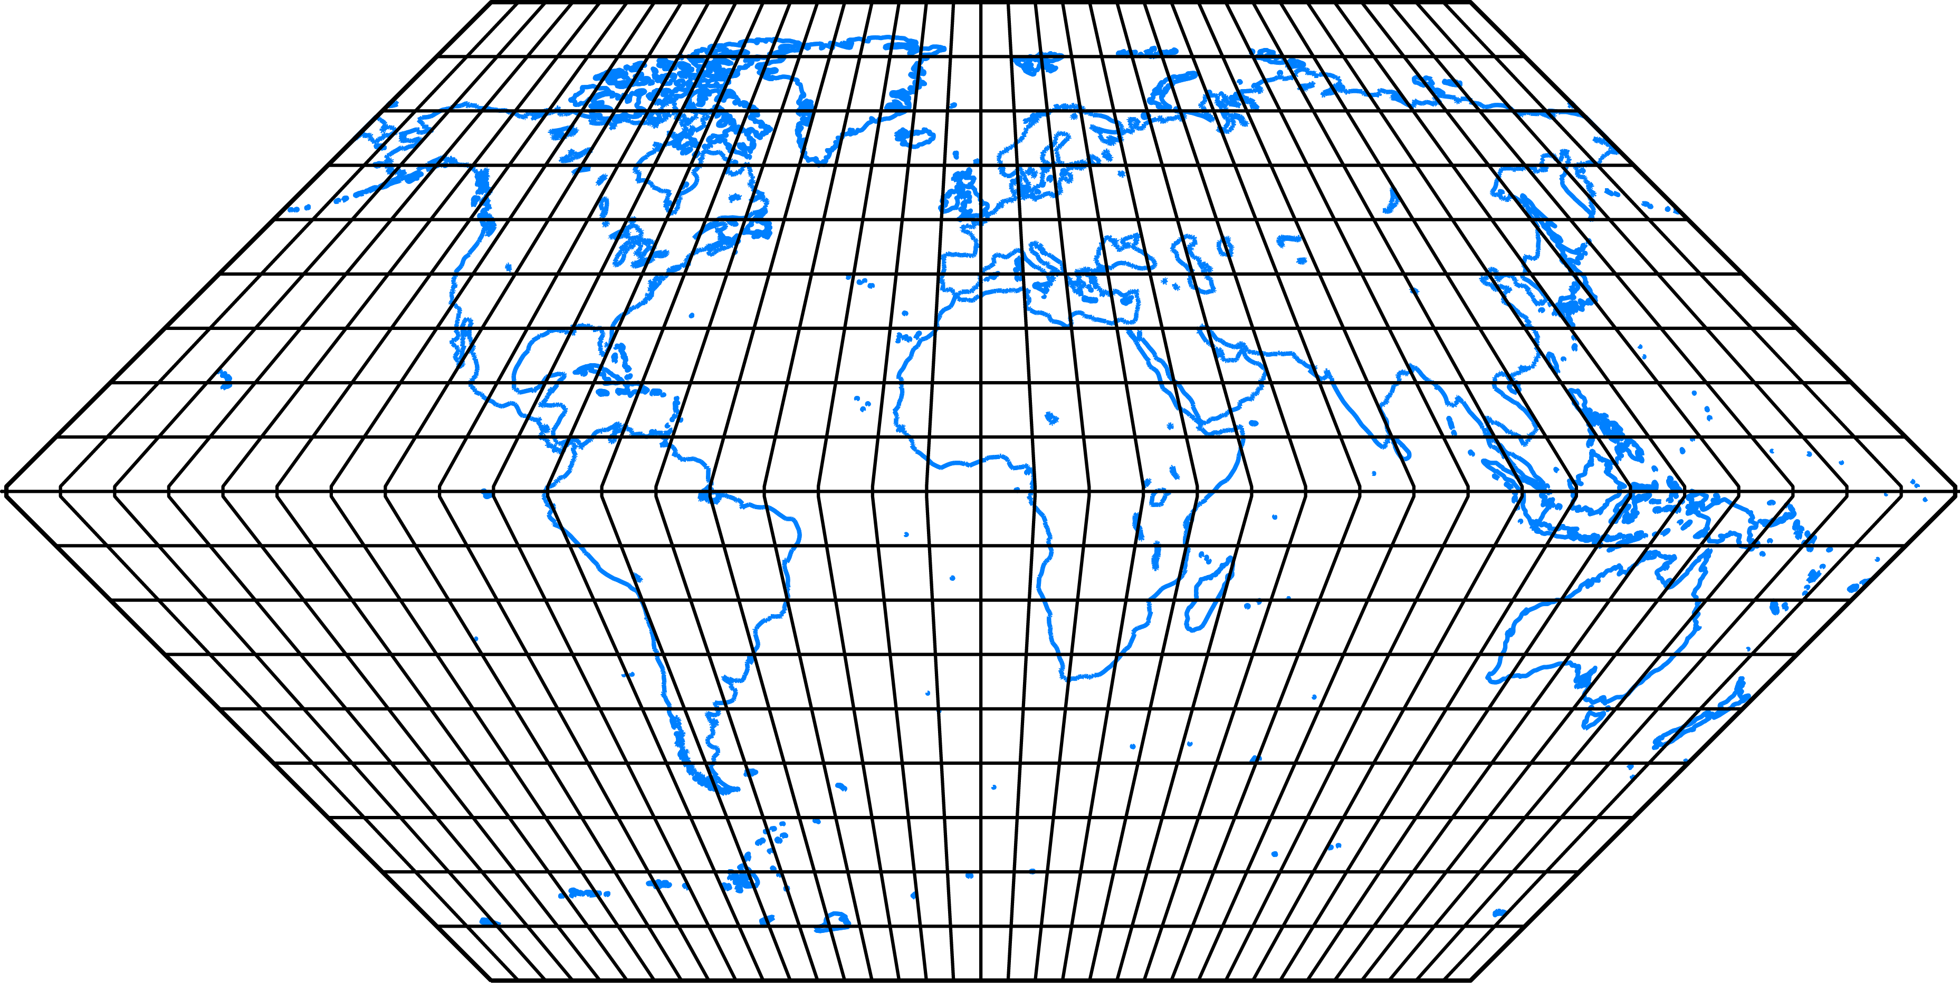

Mollweid

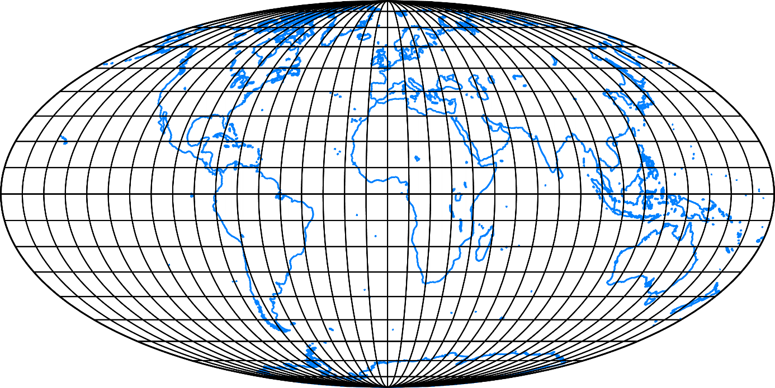

Sinusoidal

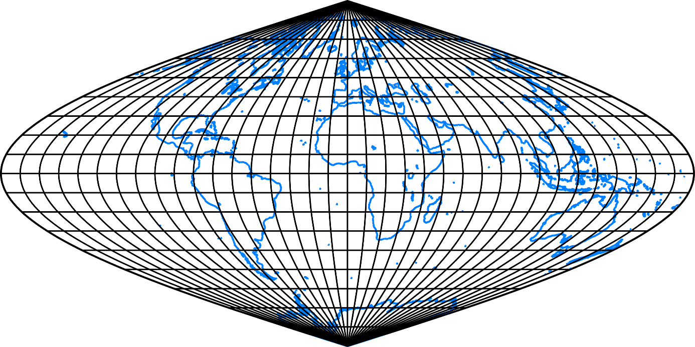

*Created with the Personal Edition of HelpNDoc:* [*Easily create Help documents*](http://www.helpndoc.com/feature-tour)

Globular projections

#### Globular projections

Showing a hemisphere bounded by a circle, they belong to the oldest-known projections using easily drawn curves. While the meridians are circular or elliptical arcs, the parallels are straight lines or circular arcs.

Apian

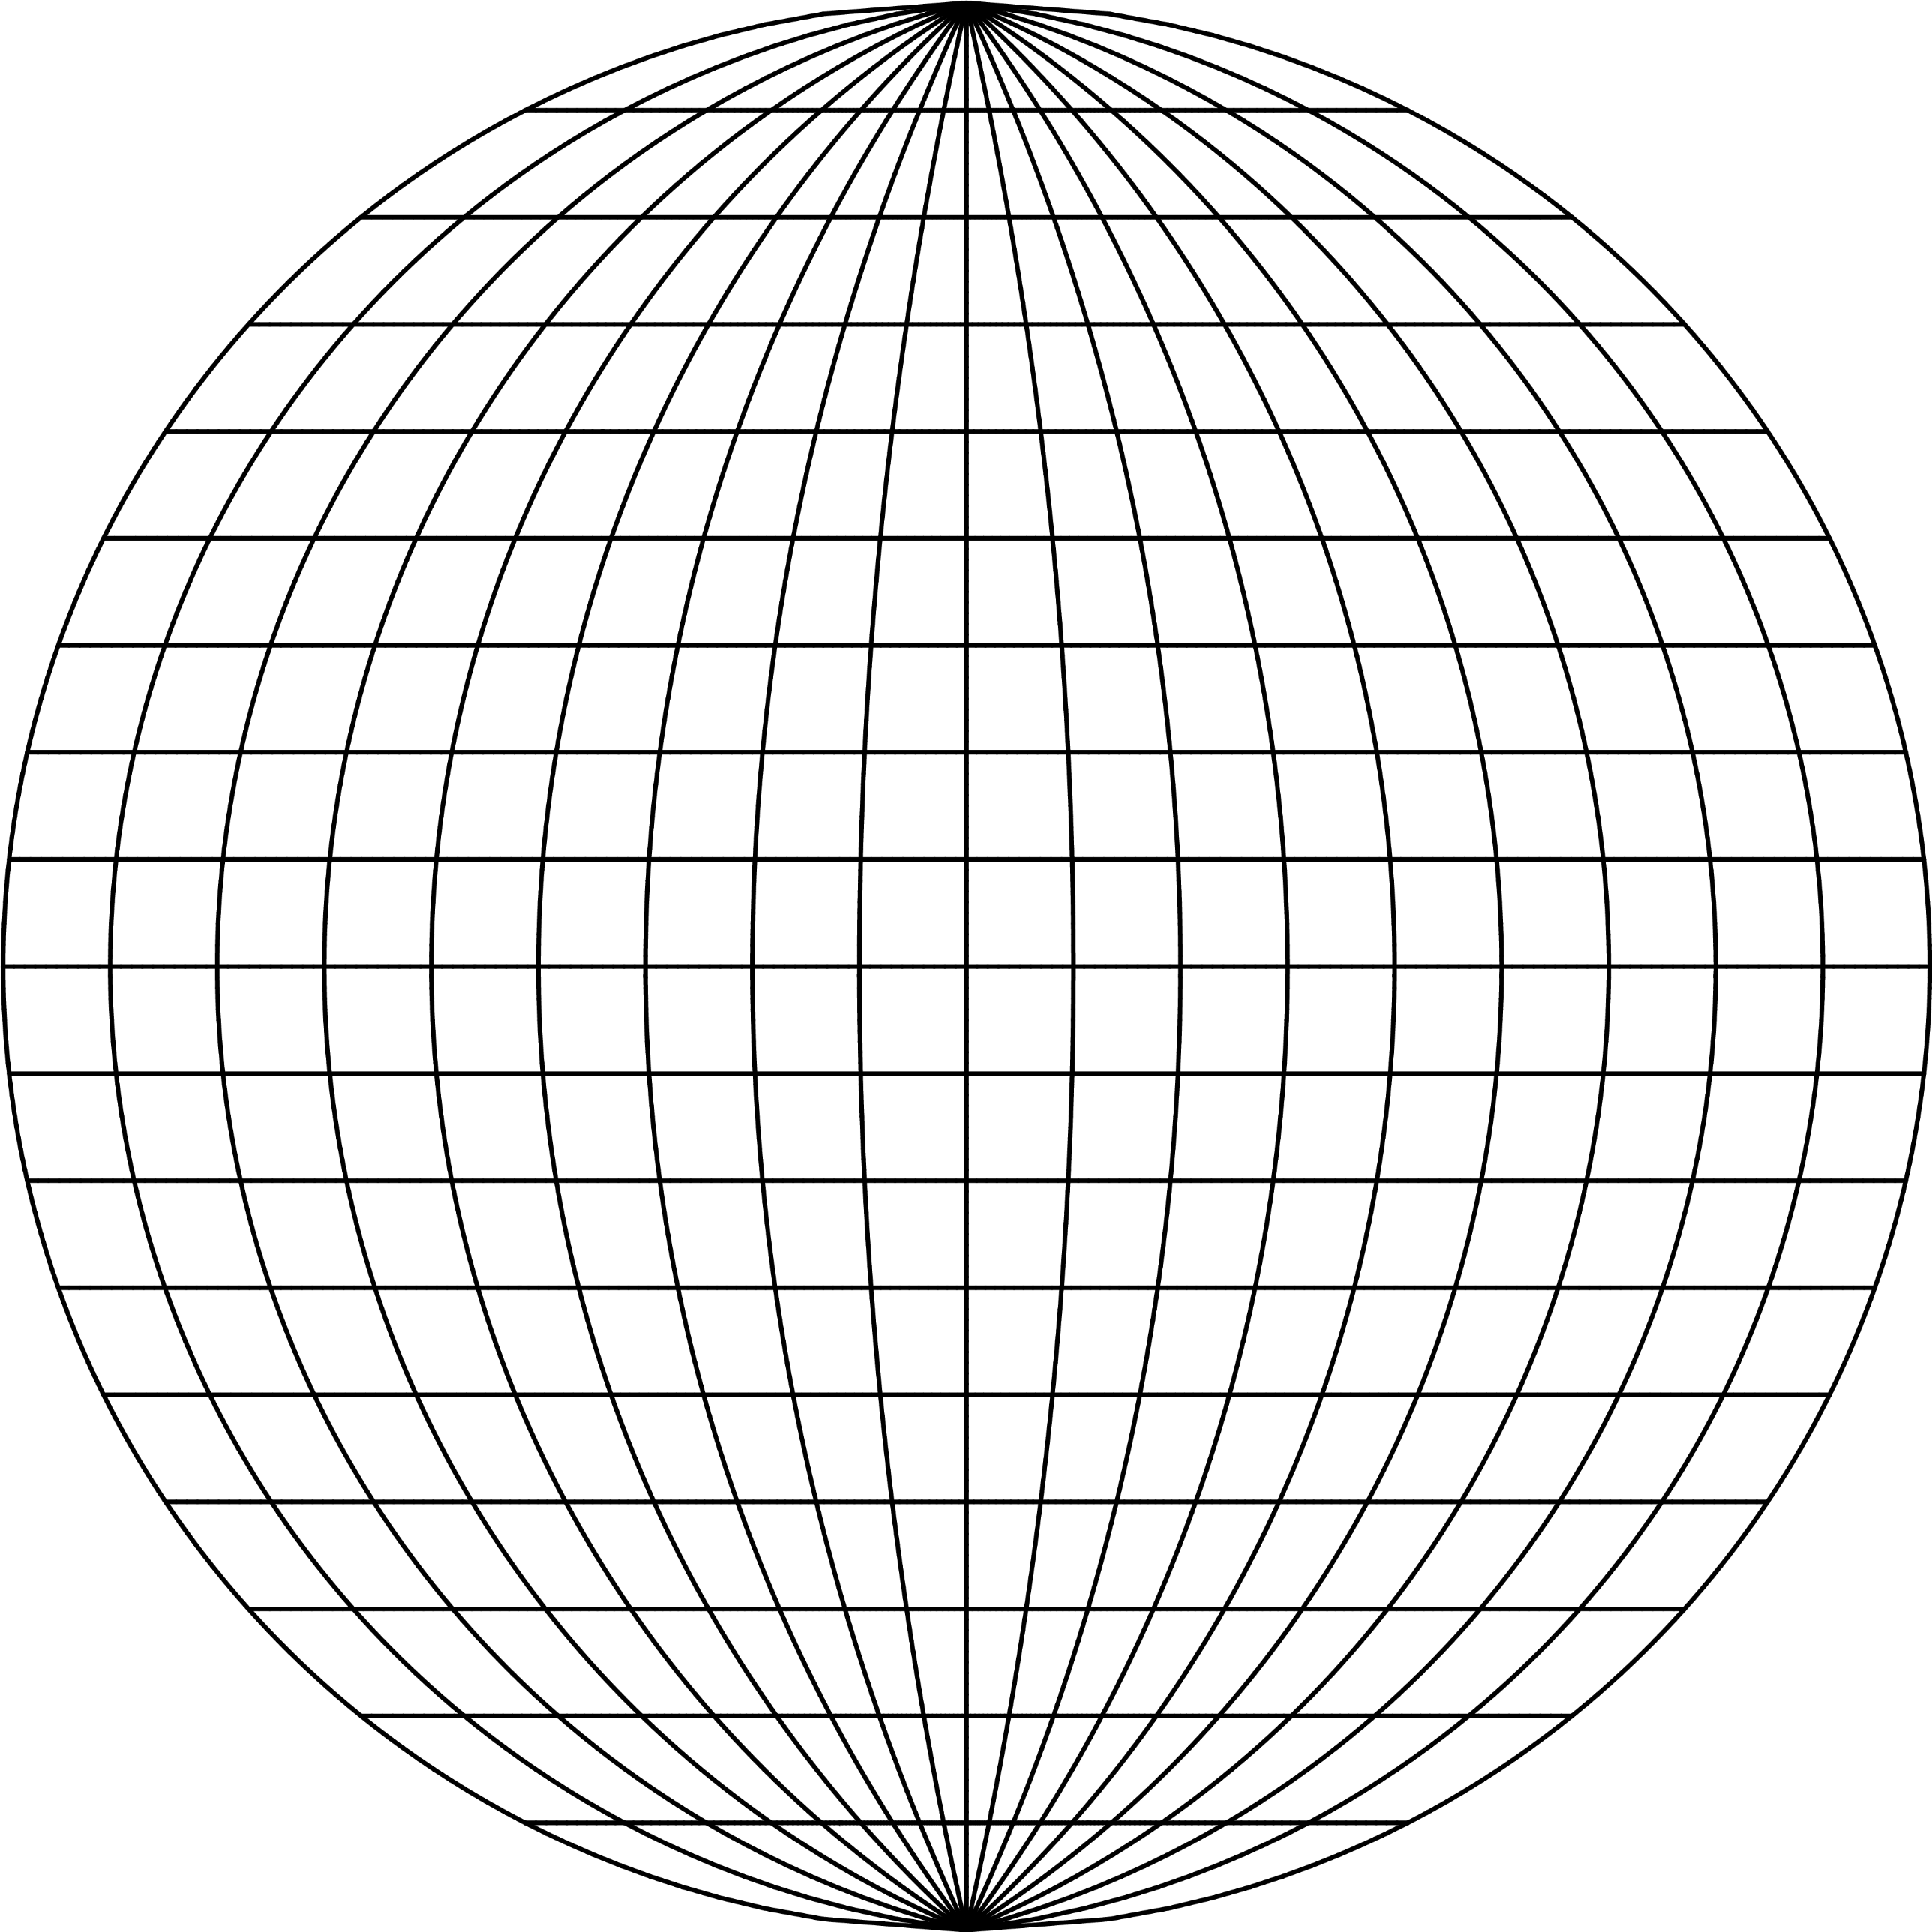

Fournier

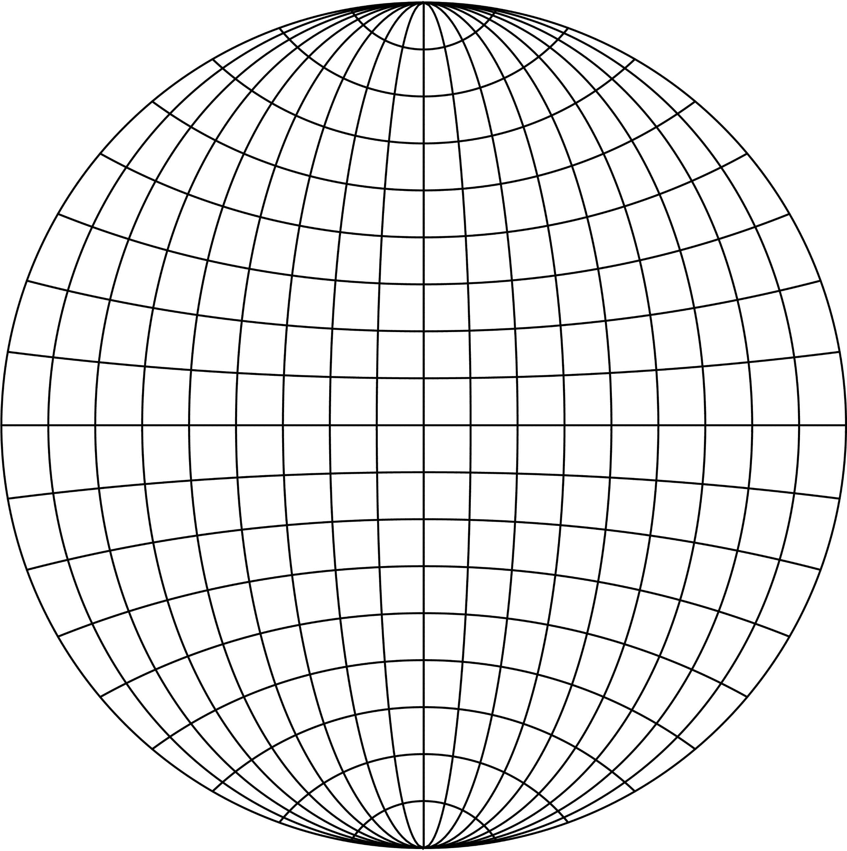

Nicolosi

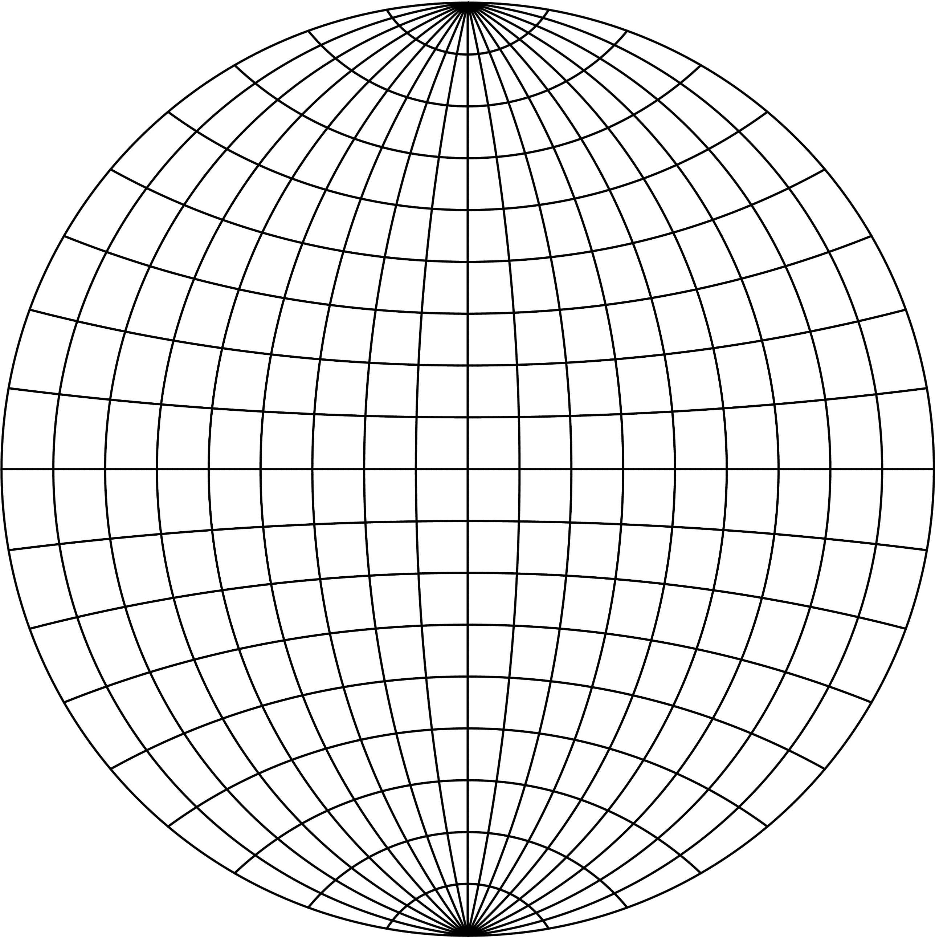

*Created with the Personal Edition of HelpNDoc:* [*Free HTML Help documentation generator*](http://www.helpndoc.com)

Perspective projections

#### Perspective projections

Some cylindrical or azimuthal projections may be derived using a perspective, when the sphere is projected to a part of the cylinder. They differ in a position of the central points which may lie inside, outside, or on the sphere. Analogously, they have poor properties at polar regions. The plane may touch the sphere, but a secant forms are also known. While or the near-side perspective the touching point is above mapped surface, for the far side perspective it is bellow.

Near-side perspective

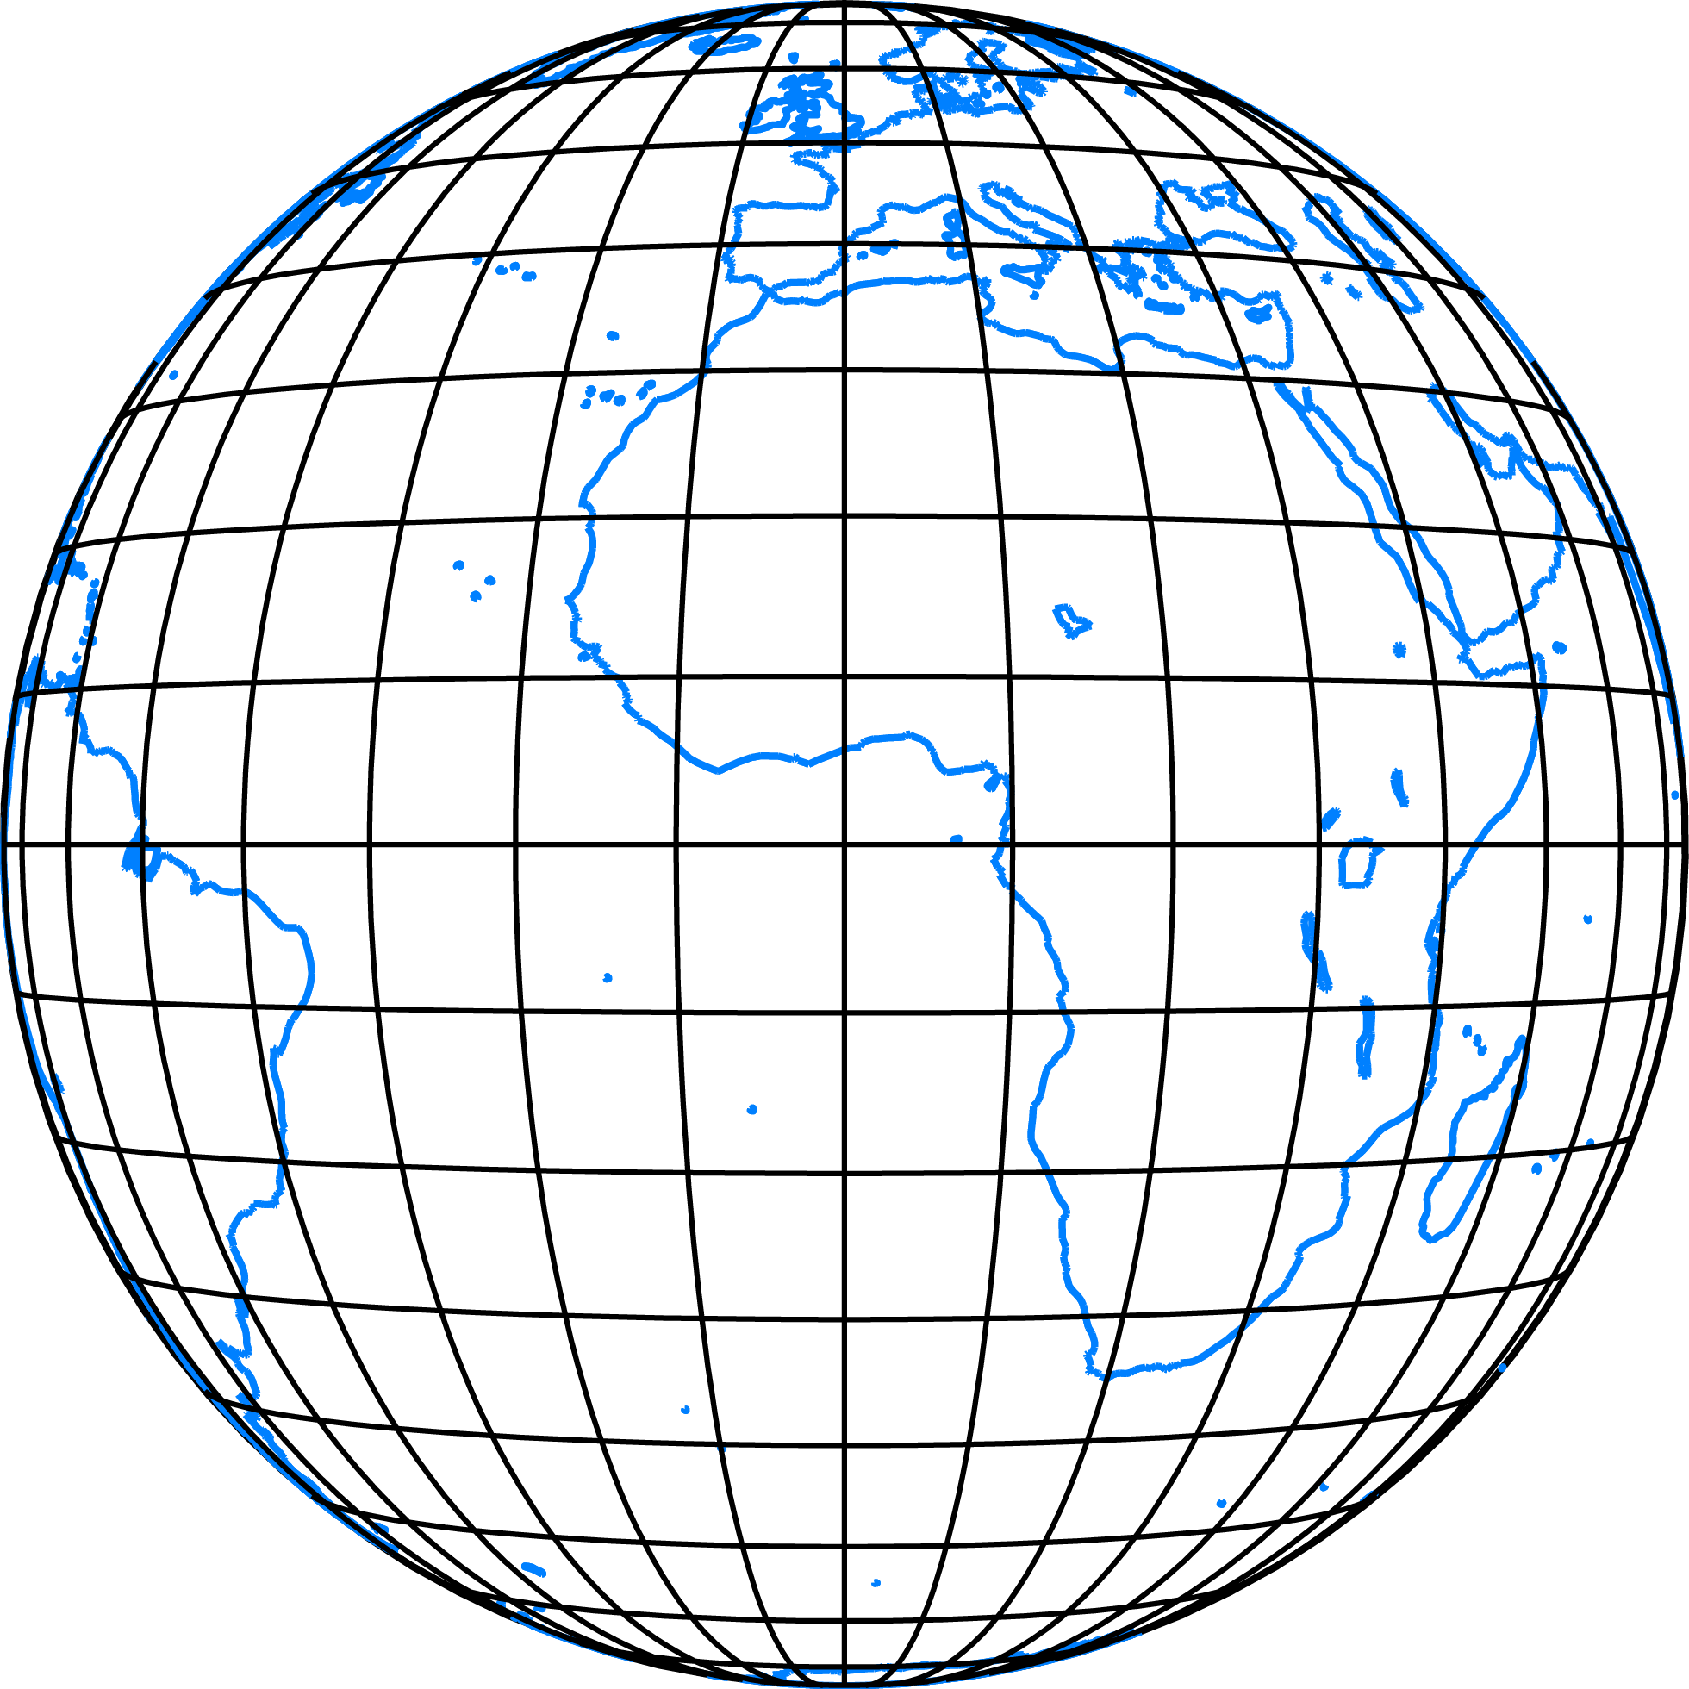

Brown

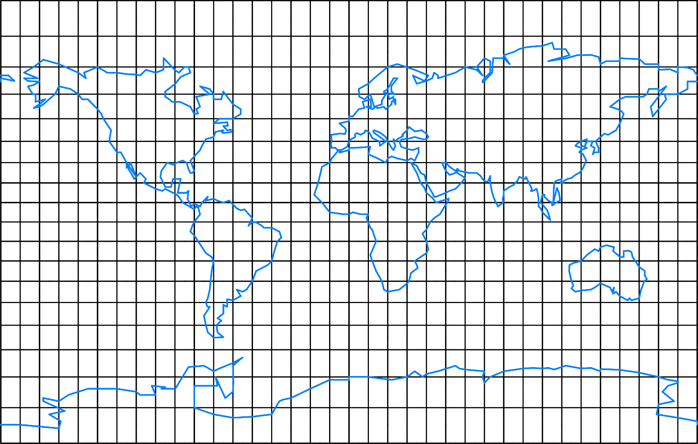

Wetch

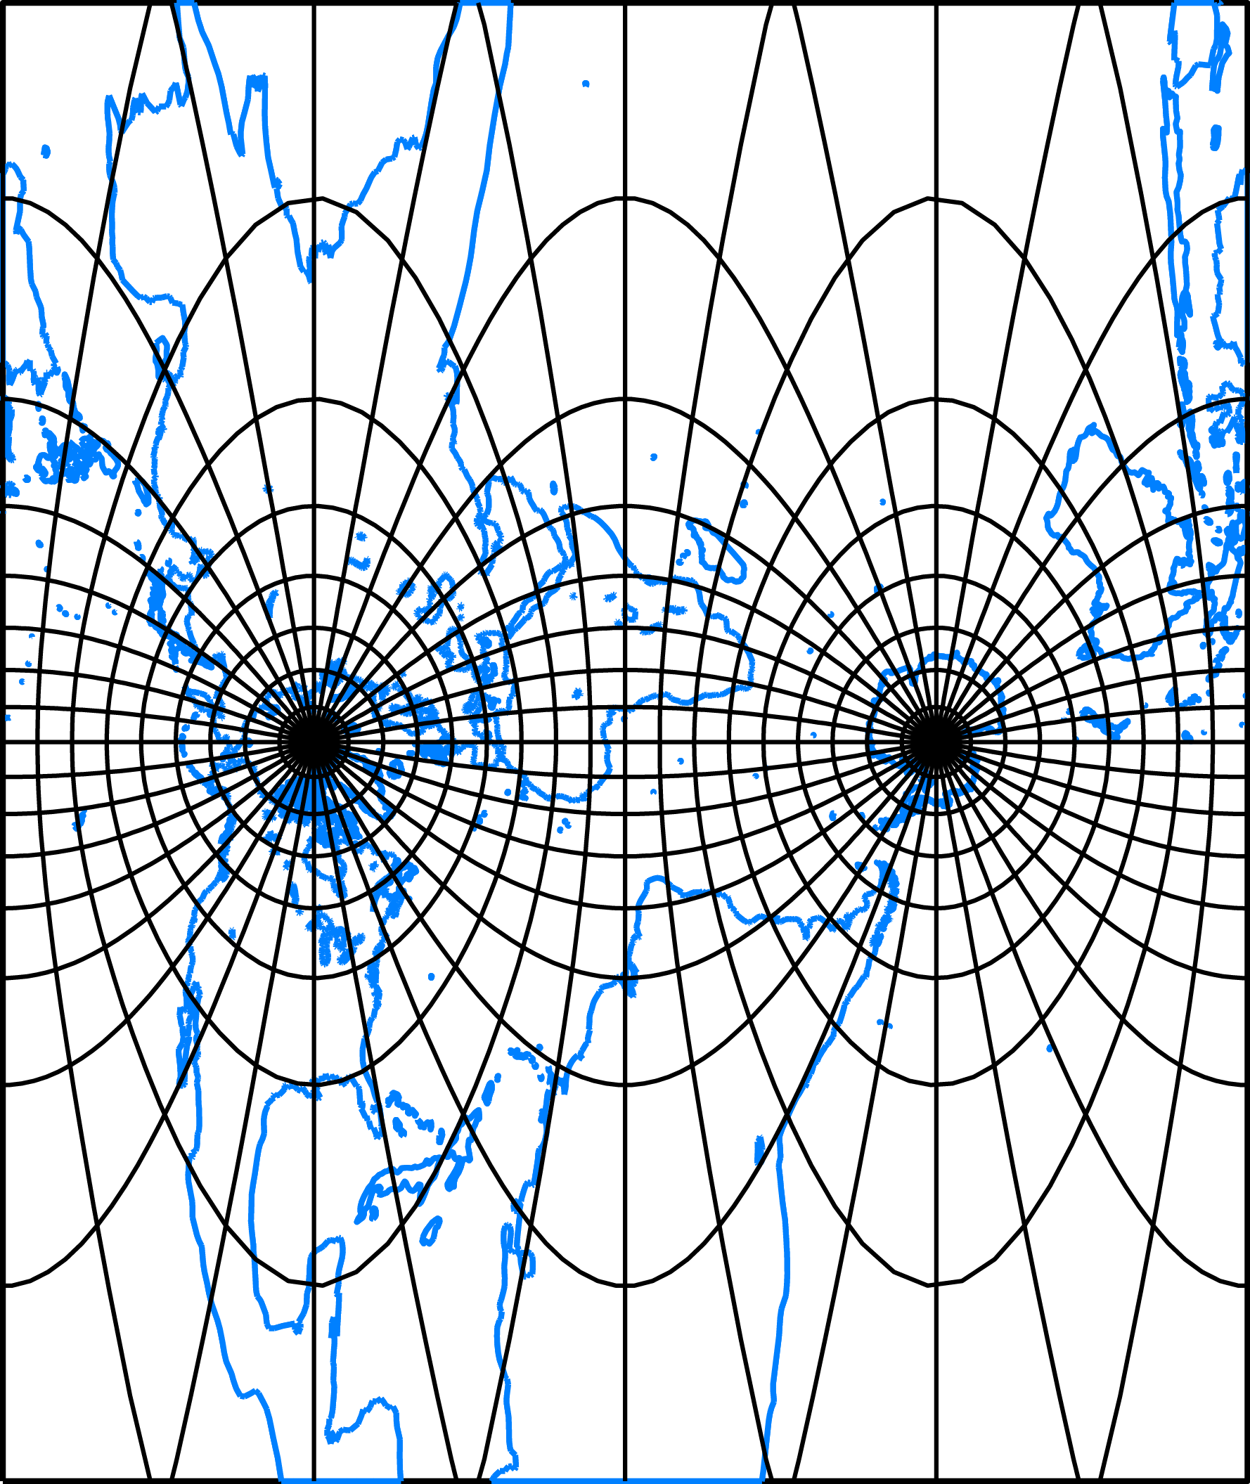

*Created with the Personal Edition of HelpNDoc:* [*Easily create Web Help sites*](http://www.helpndoc.com/feature-tour)

Polyconic projections

#### Polyconic projections

The sphere is projected to the plane with infinitely many cones tangent to each parallel. In other words, the map is split into many strips each tangent to a different cone. The typical shape of the polyconic projections, a sliced apple, can easily be recognized.

Hassler

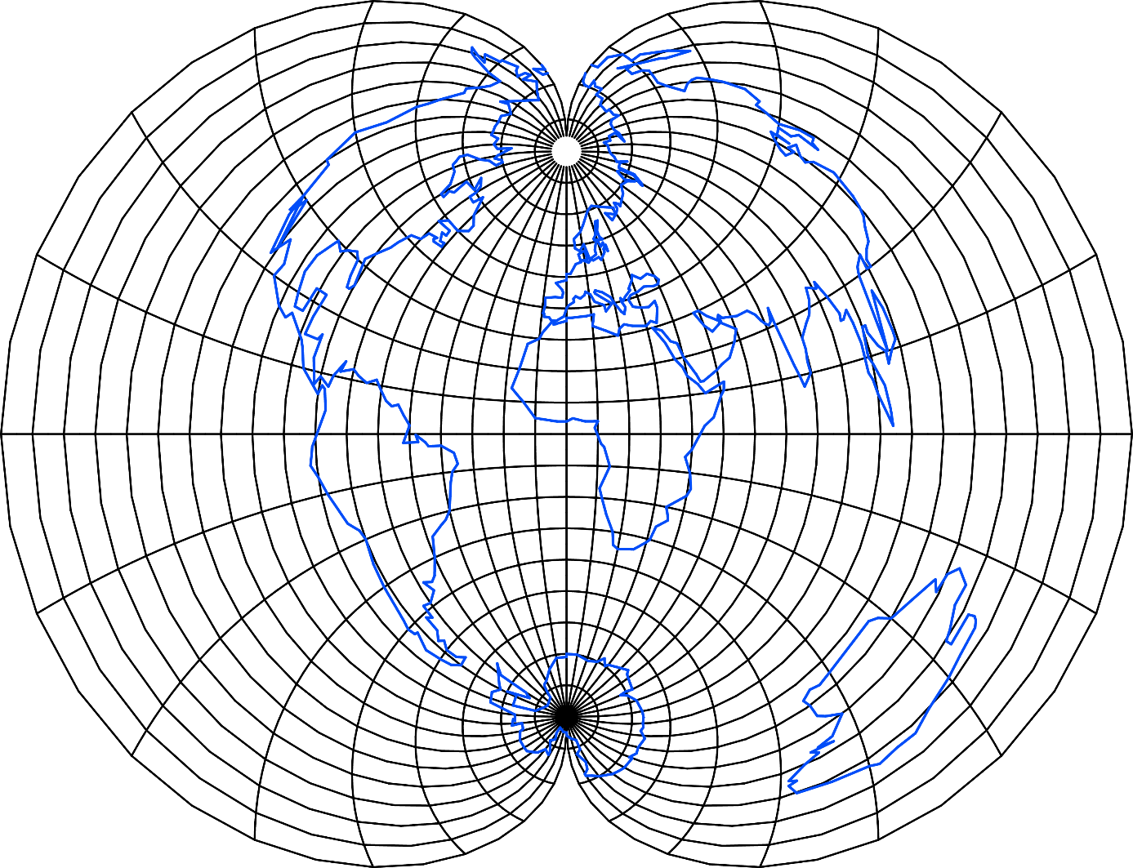

*Created with the Personal Edition of HelpNDoc:* [*Free Web Help generator*](http://www.helpndoc.com)

Modified azimuthal

#### Modified azimuthal

They are based on a geometric modifications of azimuthal projections, different than for pseudoazimuthal projections. Providing a natural depiction the entire planisphere they are used for worls maps.

Aitoff

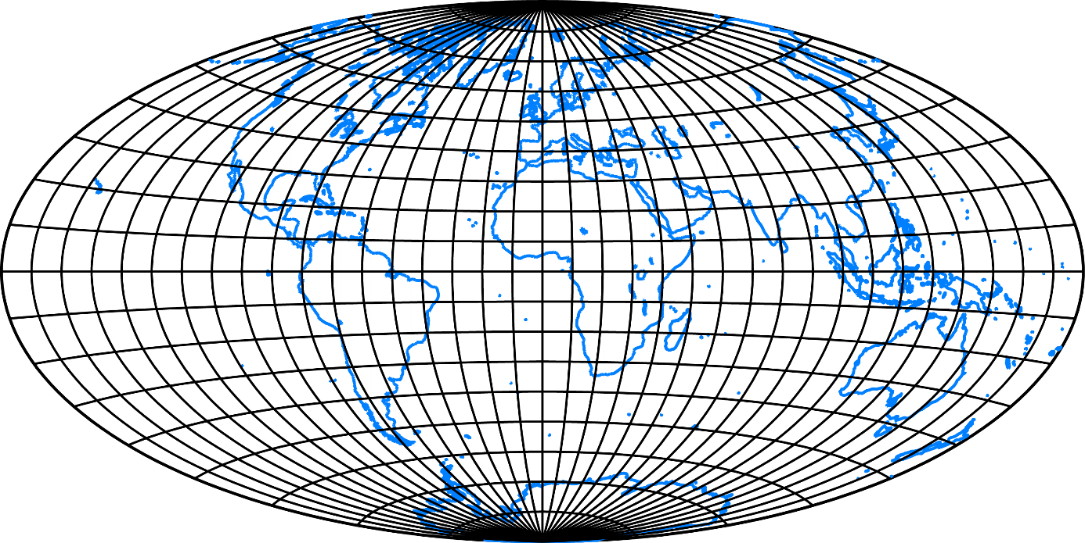

Hammer

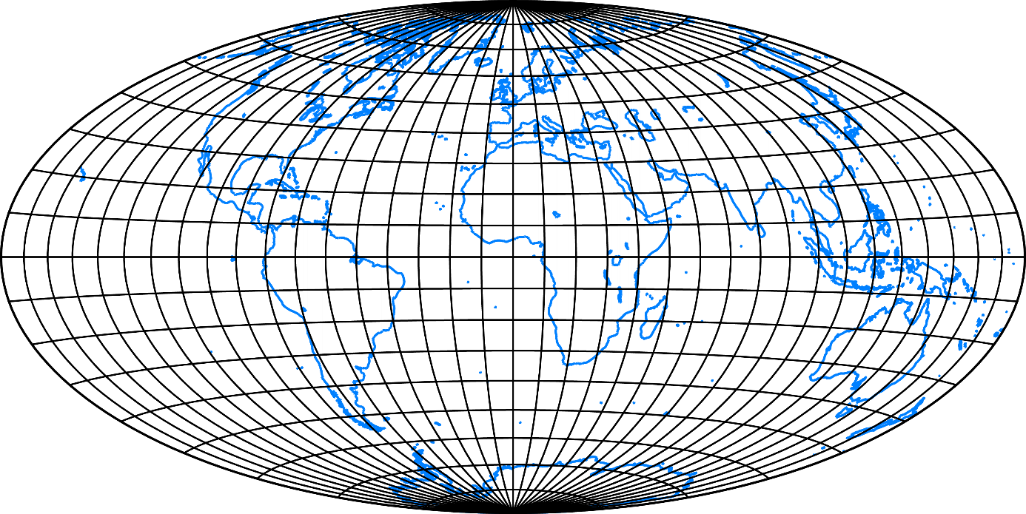

Winkel

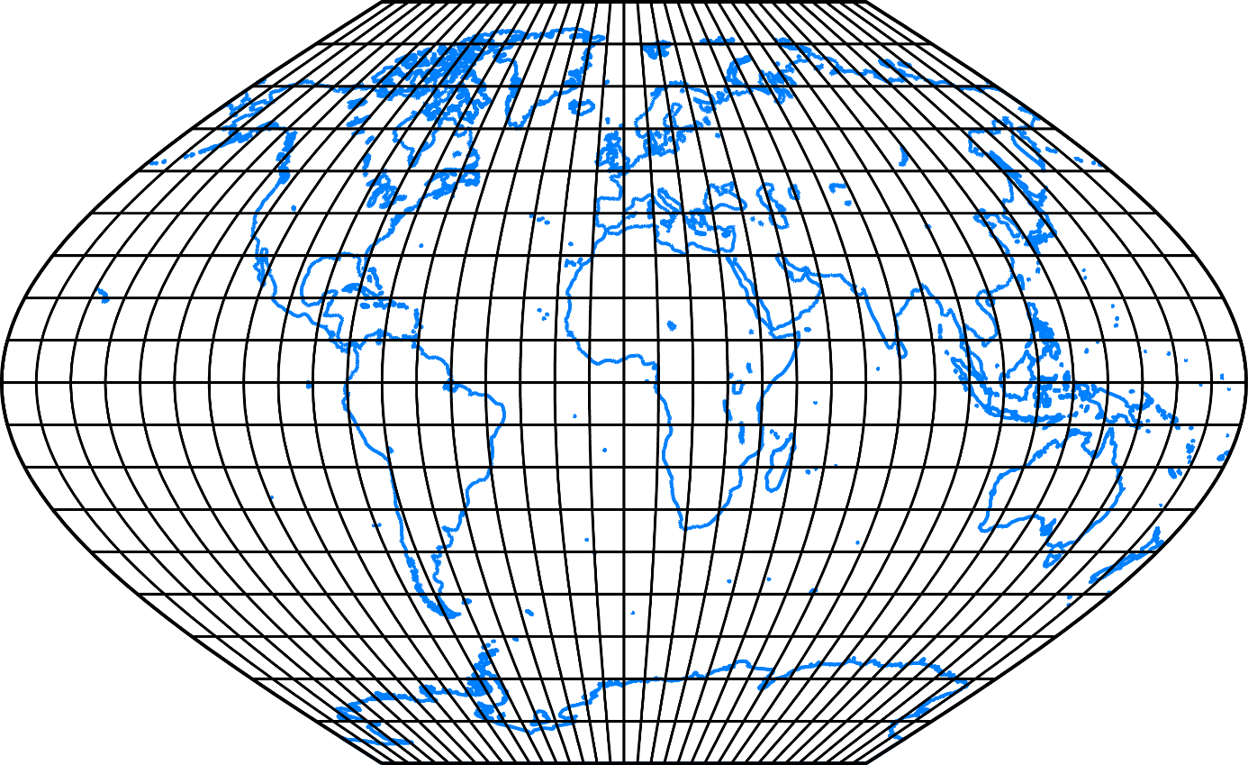

*Created with the Personal Edition of HelpNDoc:* [*Free Kindle producer*](http://www.helpndoc.com/feature-tour/create-ebooks-for-amazon-kindle)

Interrupted projections

#### Interrupted projections

They are based on idea that highly distorted regions may be moved to less-distorted parts near the equator or a central meridian. The sphere is projected per-partes with a common projection or combining several different projections.

Good Homolosine

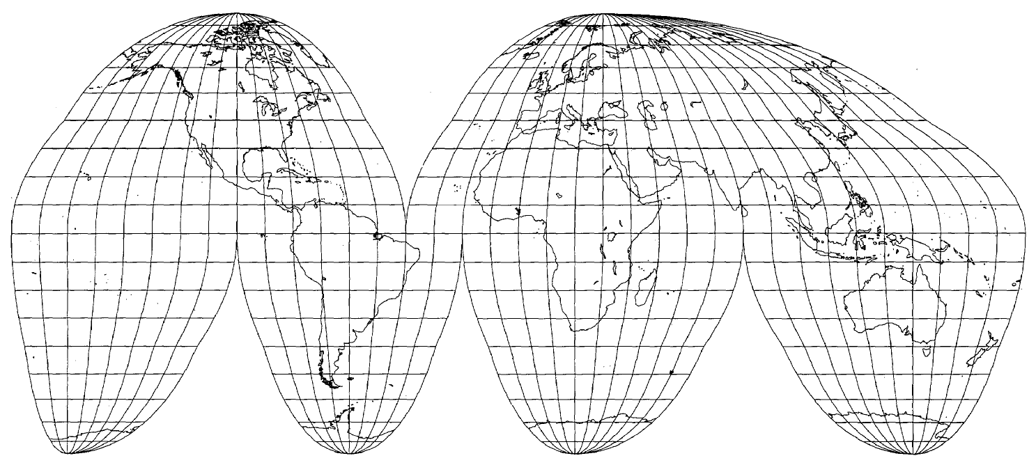  
  
Berghaus star

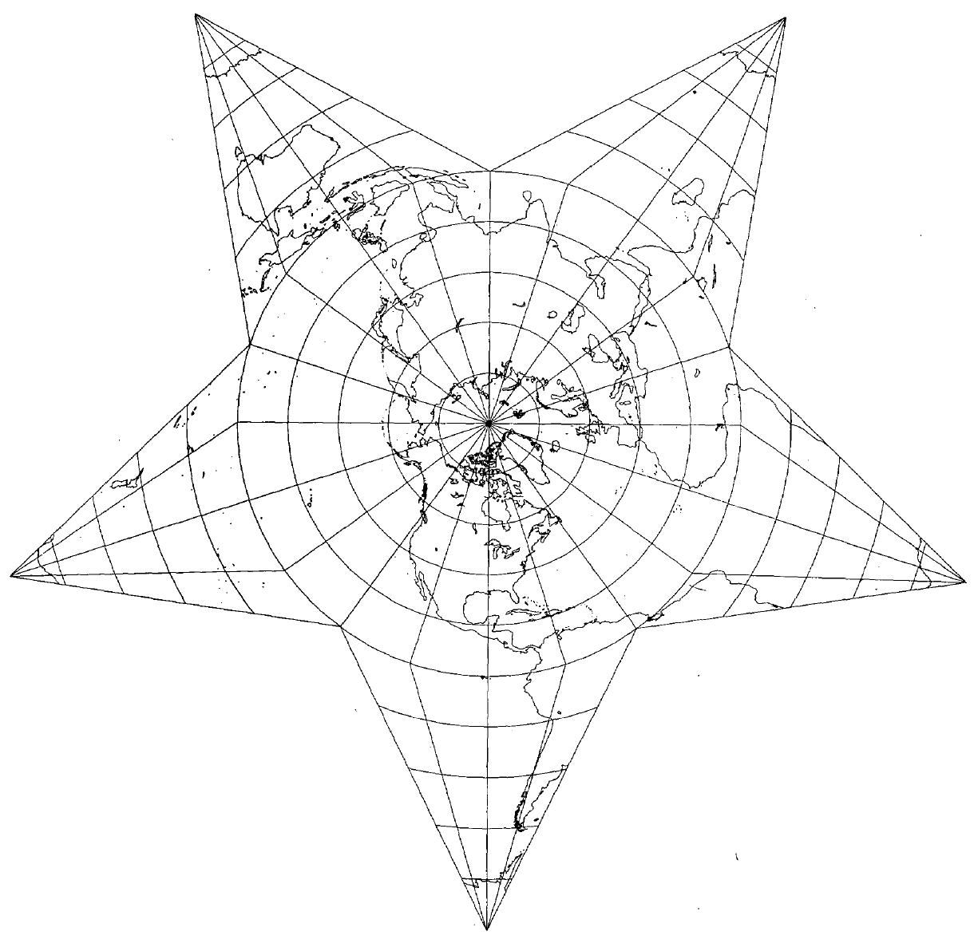

*Created with the Personal Edition of HelpNDoc:* [*Full-featured Help generator*](http://www.helpndoc.com/feature-tour)

Miscellaneous projections

#### Miscellaneous

Many projections can not be classified into the above mentioned group. They are based on the different mathematical/geometrical approaches or have a different shape of meridians/parallels/pole. Some of them are conformal and show the entire planisphere (the only known).

Armadillo

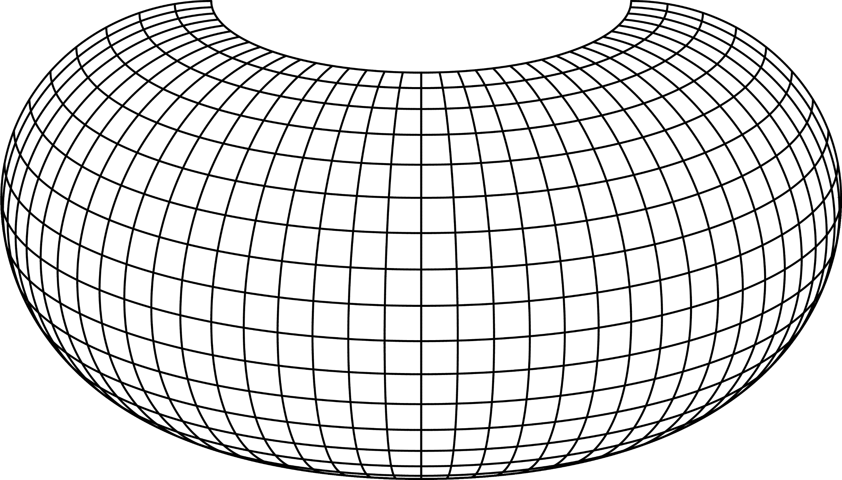

Collignon

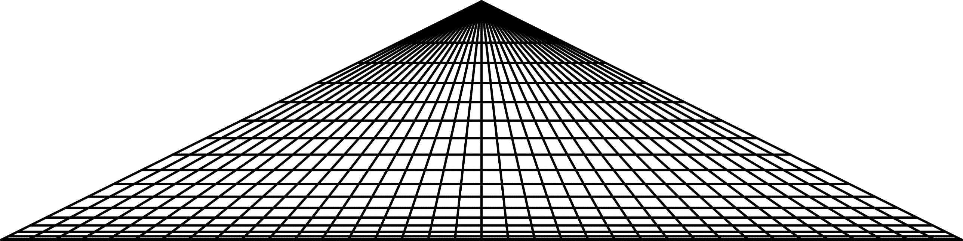

Lagrange

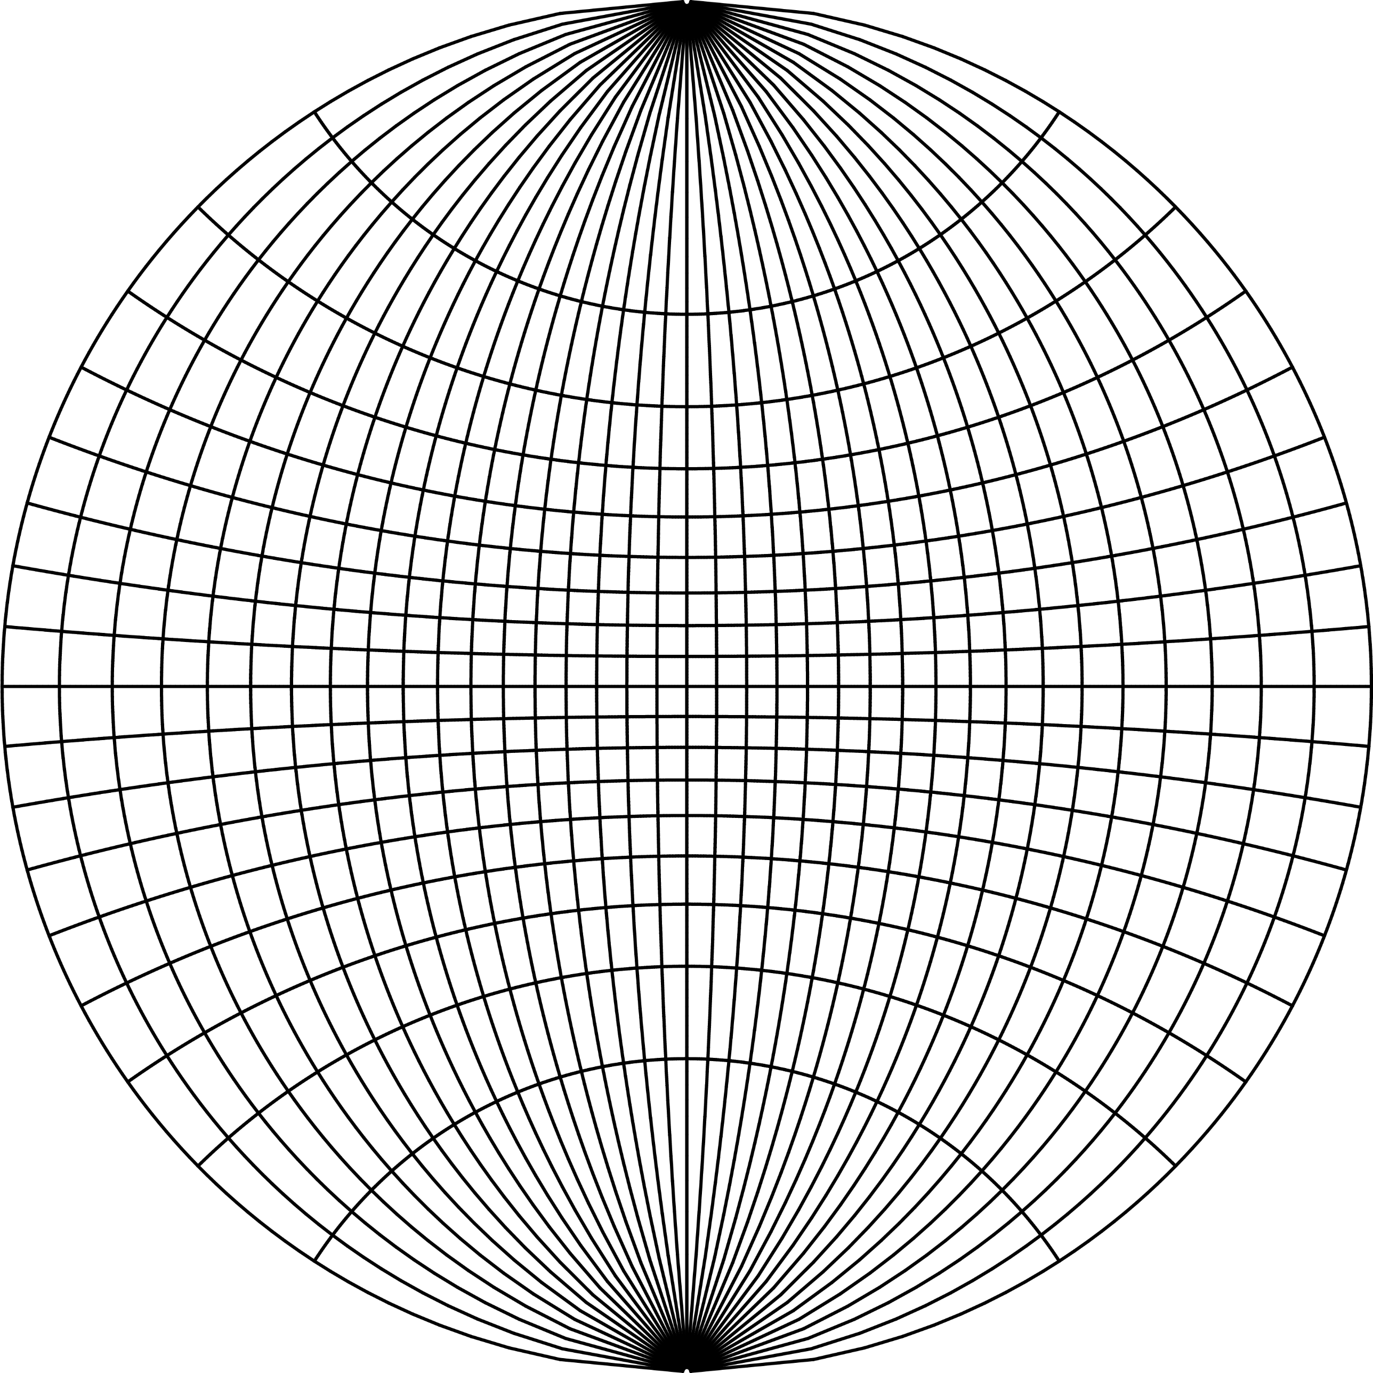

*Created with the Personal Edition of HelpNDoc:* [*Free Qt Help documentation generator*](http://www.helpndoc.com)

**Projection aspect**

## Projection aspect

Map projections are proposed to represent the entire Earth, a hemisphere, continent, or country as accurately as possible. One of the ways to achieve this is an appropriate choice of the projection aspect. There are three projection aspects, which differ in the position of the pole *K* = [*φk*, *λk*]:

* *Normal aspect*

The projection pole *K* = [90○, 0○] coincides with the North Pole of the Earth. In connection with azimuthal projections, it is also known as the polar aspect.

* *Transverse aspect*

The projection pole *K* = [0○, *λk*], *λk*  [ − 180○, 180○], coincides with the equator and it is also called the equatorial aspect. There are an infinite number of positions of the transverse aspect.

* *Oblique aspe*ct

The projection pole *K* = [*φk*, *λk*], where *φk*  [ − 90○, 90○], *λk*  [ − 180○, 180○], is any other point than the North Pole or the equatorial point.

### Modes of the λ ′ .

There is more than one way to measure the transformed longitude λ′ :

* Mode M1   
  λ′ is measured from the “extended” meridian arc (i.e., from its part south of K ) of the base system passing the new pole *K* in the counterclockwise direction.
* Mode M2   
  λ′ is measured from the “extended” meridian arc (i.e., from its part south of K ) of the base system passing the new pole *K* in the clockwise direction, which represents the new prime meridian.
* Mode M3   
  λ′ is measured from the meridian arc (i.e., from its part north of K ) of the base system passing the new pole *K* in the counterclockwise direction. The default method typical for most projections.
* Mode M4   
  λ′ is measured from the meridian arc (i.e., from its part north of K ) of the base system passing the new pole *K* in the counterclockwise direction.

In the *normal aspect* of the projection, the pole to which the projection is related coincides with the North Pole. Such a position is, in general, appropriate for the equatorial regions (cylindrical projections), polar regions (azimuthal projections), or around the parallels (conic projections). They are placed in accordance with the true scale lines, and, thus, the directions of the contour lines of the local linear scales. Therefore, the distortions on the borders of the projected territory are, overall, acceptable. Without loss of precision, it is possible to say that the normal aspect is preferred for the regions dominant in the east-west direction. In other cases, when the analyzed region is perpendicular (or in any angle) to the true scale lines and thus it crosses the contour lines of the local linear scale, the projection pole must be adapted to this situation.

For regions dominant in the north-south direction, the *transverse aspect* is a good choice. In other cases, the *oblique aspect* is suitable.

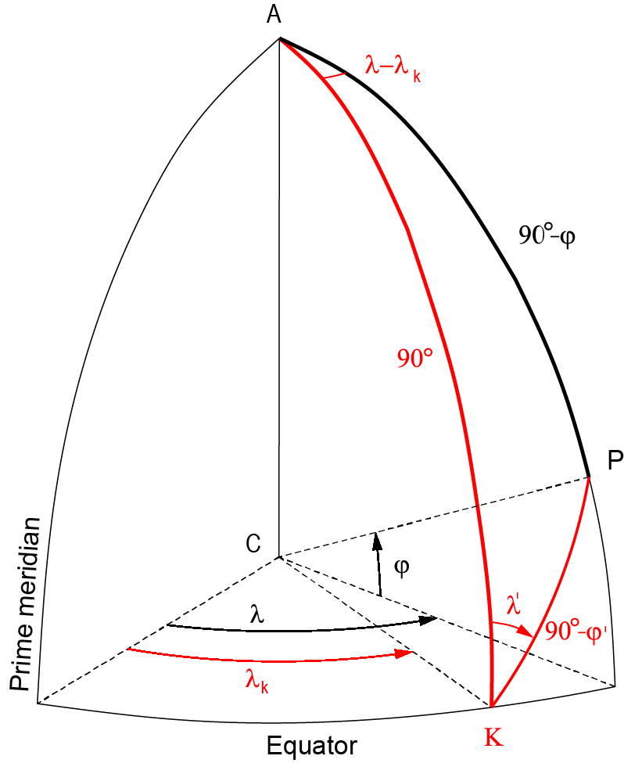

**Conversion to the oblique aspect**

Suppose an arbitrary pole *K* = [*φk*, *λk*] ∈ *S*2, a point *Q* = [*φ*, *λ*] ∈ *S*2 and its image *Q*′ = [*φ*′, *λ*′] ∈ *S*2 is given by

sin*φ*′  =  sin*φk*sin*φ* + cos*φk*cos*φ*cos(*λ* − *λk*),

tan*λ*′ = cos*φ*sin(*λ* − *λk*)/cos*φ*sin*φk*cos(*λ* − *λk*) − sin*φ*cos*φk*,

where *φ*′, *λ*′ refer to the spherical coordinates related to *K*. The second function is independent of *φ*′ and supports the quadrant adjustment.

*λ*′ = atan2[cos*φ*sin(*λ* − *λk*), cos*φ*sin*φk*cos(*λ* − *λk*) − sin*φ*cos*φk*].

#### Graticule shape and the projection aspect

The projection aspect has a crucial impact on the graticule shape. In both the transverse and oblique aspects, the shape of the graticule significantly changes; other constant values of the projection are gentler to the shape of the graticule. It is a known fact that projections may lose their orthogonality shapes of the poles, prime meridian, or equator shape.

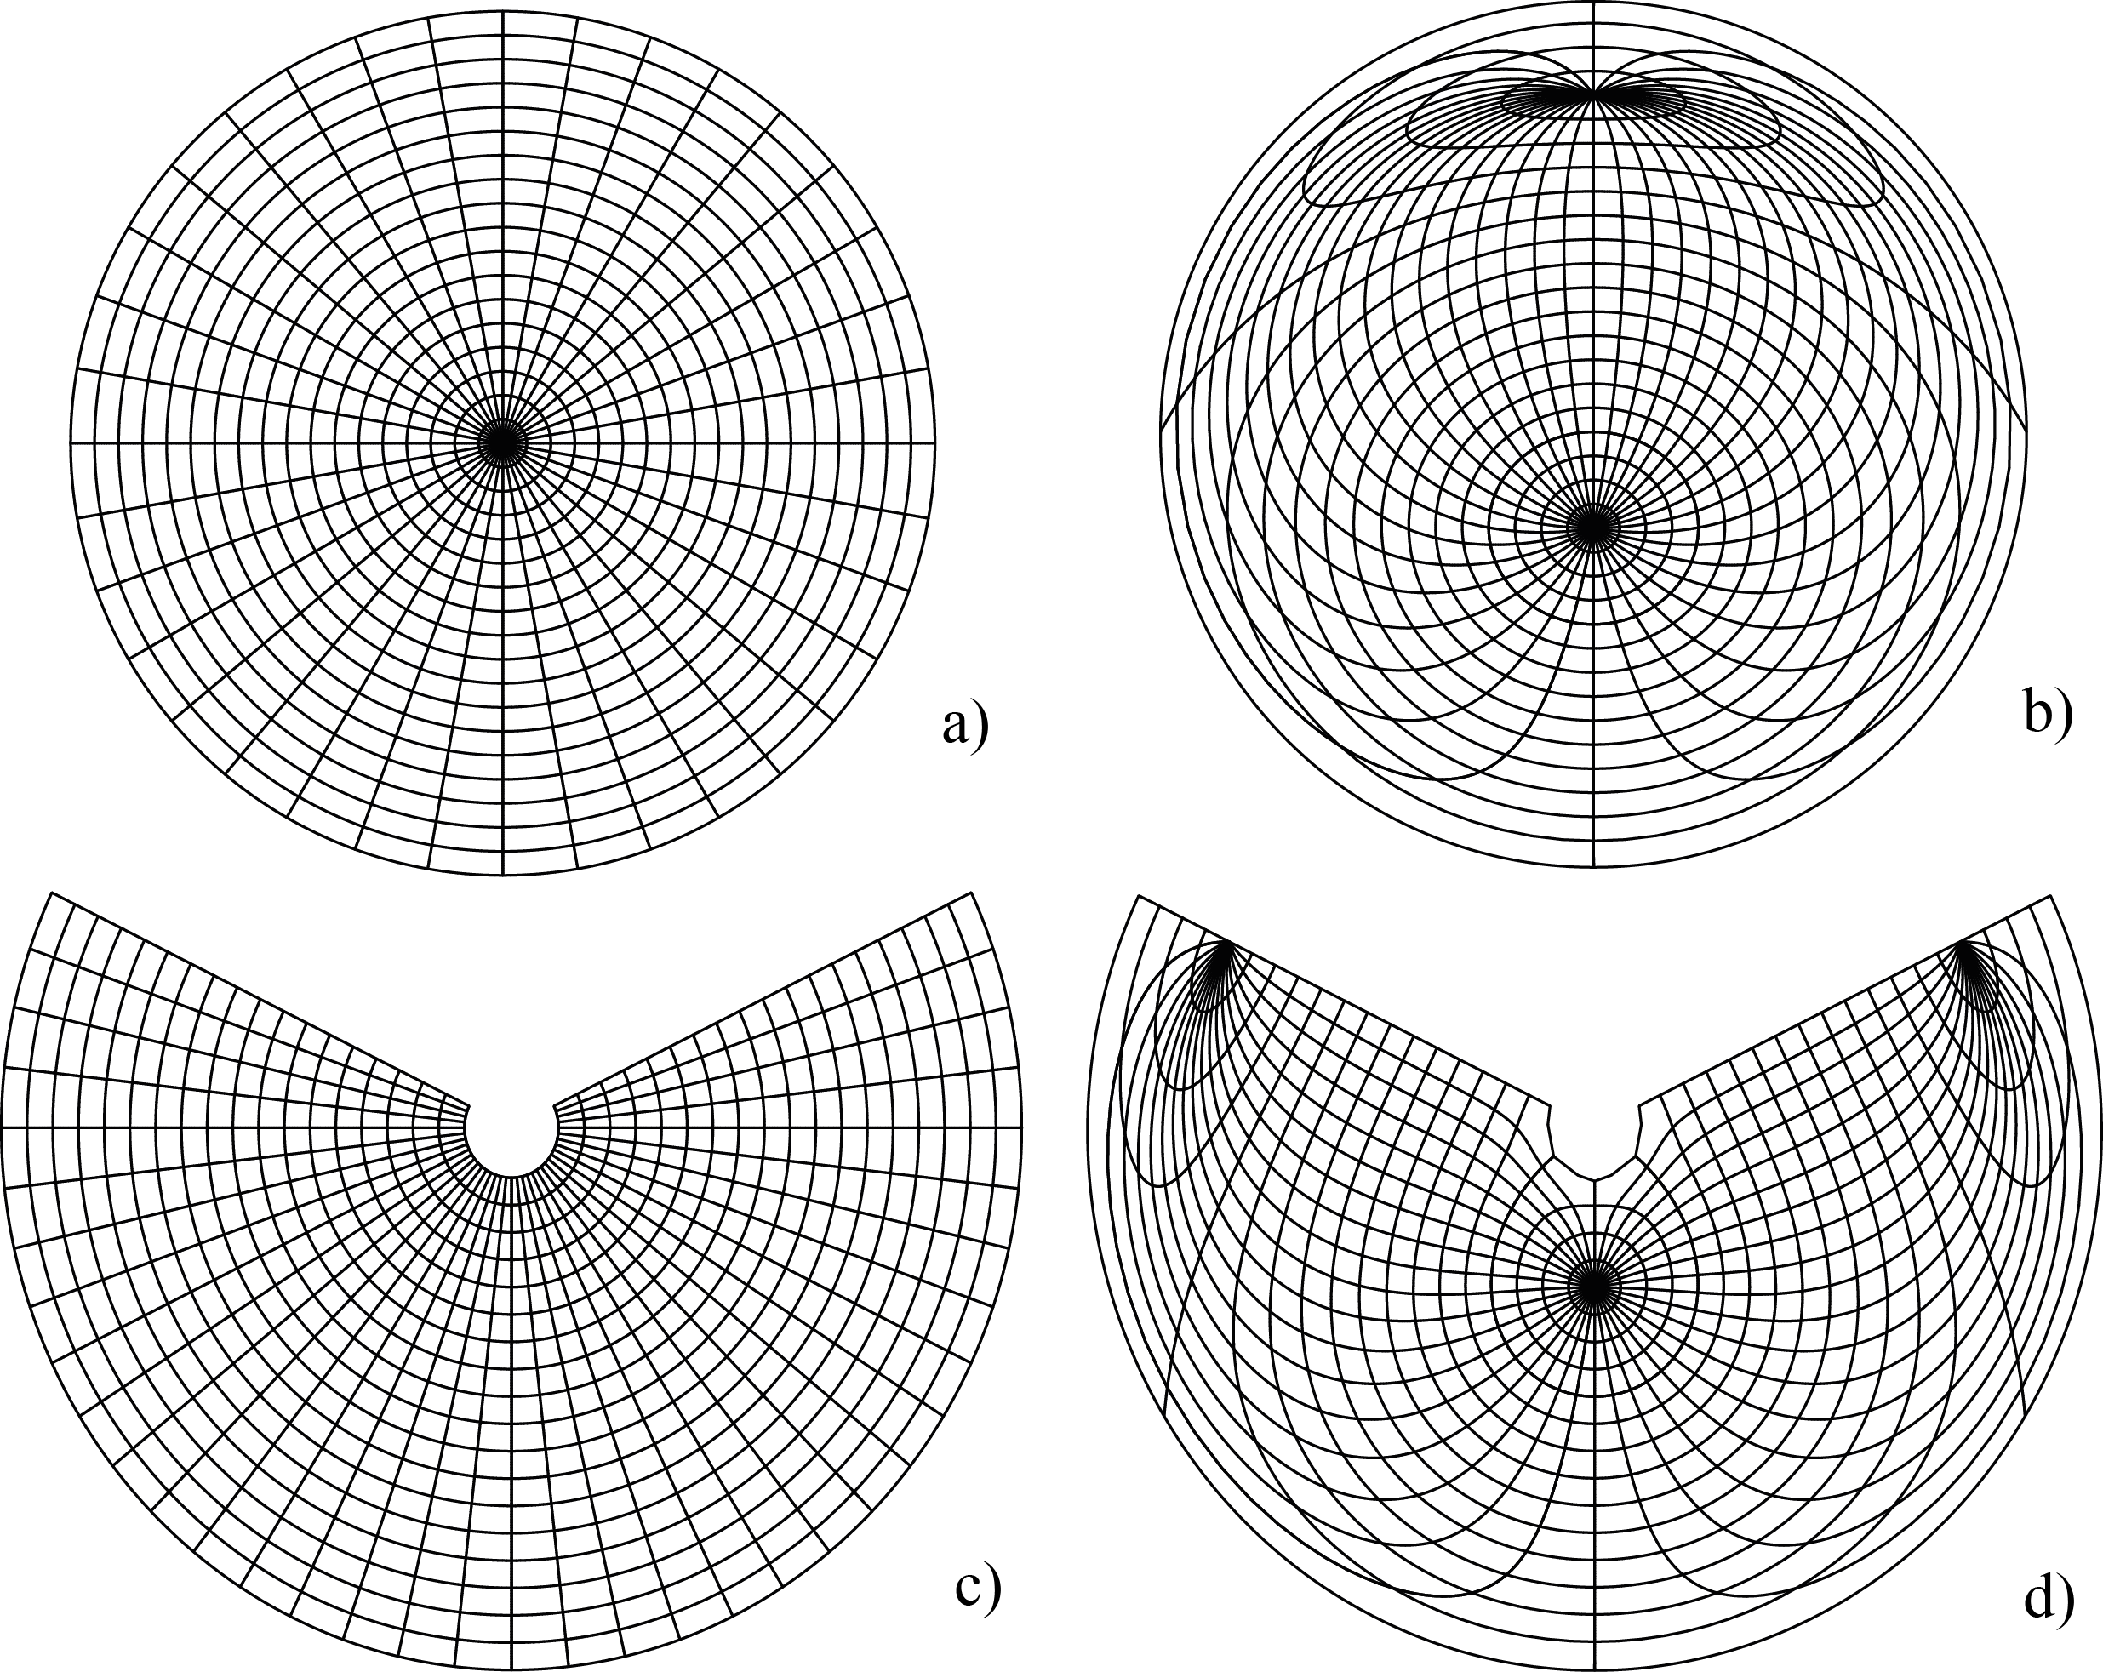

Comparing the azimuthal (a), (b) and conic equidistant (c), (d) projections in the normal and oblique, *K*=[ 50○, 10○] , aspects; the orthogonality and graticule shapes are not preserved

*Created with the Personal Edition of HelpNDoc:* [*Generate EPub eBooks with ease*](http://www.helpndoc.com/create-epub-ebooks)

**Determined parameters of the map projection**

### Determined parameters

Suppose the projection ℙ(*φk*, *λk*, *φ*1, *λ*0, *κ*) described by the set of constant values: transformed pole position [*φk*, *λk*], standard parallel *φ*1, longitude *λ*0 of the central meridian, constant parameter *κ* (may be assigned to any other determined value). Furthermore, suppose the analyzed map *M*(*R*′, Δ*X*, Δ*Y*, *α*) described by its constant values: auxiliary sphere radius *R*′ (illustrating the scale ratio), origin shifts Δ*X*, Δ*Y*, and angle of rotation *α*. For the oblique aspect, the projection equations in closed form may be written as functions of the determined parameters

*X*(*R*′, *φk*, *λk*, *φ*1, *φ*2, *λ*0, Δ*X*, *κ*, *α*)  =  *F*(*φ*′, *λ*′),

*Y*(*R*′, *φk*, *λk*, *φ*1, *φ*2, *λ*0, Δ*Y*, *κ*, *α*)  =  *G*(*φ*′, *λ*′).

#### Determined parameters of the projection

During the analysis, the bellow-mentioned constant parameters of the projection ℙ are determined. They have a strong influence on the shape of the graticule.

* **Transformed pole position [φk, λk]**

This has a crucial influence on the shape of the graticule and the projection footprint. While conic, cylindrical, or azimuthal projections are currently used in the transverse/oblique aspects, for other categories of projections they are used rarely, and the normal aspect is preferred.

* **Standard parallels φ1, φ2**

Currently, the conic projection in a secant form specifies the latitudes of two standard parallels *φ*1, *φ*2, *φ*1 ≠ *φ*2, representing intersections of the cone and the secant plane, or *φ*1 = *φ*2 for its tangent form. For the cylindrical projection, the secant form uses two standard parallels *φ*1 =  − *φ*2, but for the tangent form, it is *φ*1 = *φ*2 = 0. A special case is represented by the azimuthal projection, where *φ*1 = *φ*2 = 90○. Some pseudo- or polyconic projections require a specification of the standard parallel *φ*1, but, for others, it is not used.

* **Longitude λ0 of the central meridian**

To minimize the distortion and provide a true projection of the mapped region, setting the prime meridian as the central meridian is inappropriate. This applies in particular for the regions far east and west of the prime meridian. The central meridian is frequently chosen in the axis of the symmetry of the mapped region; it passes through the center of the region. Its longitude *λ0* represents, for the normal aspect of the projection, the next determined parameter.

* **Arbitrary constant parameter of the map projection κ**

This may be any constant value of the map projection*.* It is widely used in connection with perspective projections, where the distance of the center of projection from the sphere *S*2 center represents the estimated parameter. It may also represent any multiplicative constant frequently used to minimize the distortions.

#### Determined parameters of the map

During the analysis, the map constant values are also estimated. For the map *M* the constant parameters represent its scale, shift, and rotation. They do not have any influence on the shape of the graticule, or the projection footprint. The optimization process should be partially or fully invariant to values of map constants.

* **Auxiliary sphere radius R′**

Both the analyzed and reference maps may have different scales. The radius *R*′ of the auxiliary sphere *S*2 is determined so that the map in the estimated projection fits best with the analyzed one. Because the analyzed map dimensions are currently in centimeters (map in paper form), the determined radius *R*′ will be small, usually in meters. However, for the electronic version of the maps (e.g., topographic maps), the estimated radius will be higher and close to the Earth’s radius *R*. The auxiliary sphere radius may be used to determine the approximate scale *S* of the analyzed map

*S* = *R/R*′.

* **Shifts ΔX, ΔY**

Both the analyzed and reference coordinate systems may be shifted each other; their origins are moved. This applies particularly to a scanned map in paper form, where the origin is subsequently set to the left upper pixel of the raster. To avoid sign inconsistency in the *X*, *Y* coordinates for the mapped region and make their values more convenient, the false northing Δ*Y* or false easting Δ*X* are widely used.

* **Angle of rotation α**

This optional parameter represents an additional rotation of the analyzed map. In most cases, it is caused by the inappropriate insertion of the paper form of the map into the scanner, or its additional rotation on the page (portrait vs. landscape), when a document is typographically processed. This parameter is estimated by M8, which is invariant to all map constant values. Involving a rotation reduces the residuals by one order of magnitude.

*Created with the Personal Edition of HelpNDoc:* [*Free PDF documentation generator*](http://www.helpndoc.com)

**List of supported map projections**

### List of supported map projections

Currently, the following map projections are supported:

|  |  |  |  |  |  |  |  |
| --- | --- | --- | --- | --- | --- | --- | --- |
| **#** | **Shortcut** | **Projection** | **Family** | **Aspect** | ***φ*1** | ***φ*2** | ***κ*** |
| 1 | adamh | Adams, hemisphere | Miscellaneous | N |  |  |  |
| 2 | adams1 | Adams 1, world in square | Miscellaneous | N,T,O |  |  |  |
| 3 | adams2 | Adams2, world in square | Miscellaneous | N,T,O |  |  |  |
| 4 | aea | Albers Equal Area | Conic | N,T,O | x | x |  |
| 5 | aeqd | Equidistant | Azimuthal | N,T,O |  |  |  |
| 6 | aitoff | Aitoff | Pseudoazimuthal | N,T,O |  |  |  |
| 7 | api | Apianus | Miscellaneous | N,T,O |  |  |  |
| 8 | apiel | Apianus elliptic | Miscellaneous | N,T,O |  |  |  |
| 9 | armad | Armadillo | Miscellaneous | N,T,O |  |  |  |
| 10 | august | August Epicycloidal | Pseudocylindrical | N,T,O |  |  |  |
| 11 | bacon | Bacon | Globular | N,T,O |  |  |  |
| 12 | boggs | Boggs Eumorphic | Pseudocylindrical | N,T,O |  |  |  |
| 13 | bonne | Bonne | Pseudoconic | N,T,O | x |  |  |
| 14 | breus | Breusign | Azimuthal | N,T,O |  |  |  |
| 15 | cc | Central | Cylindrical | N,T,O | x |  |  |
| 16 | cea | Equal Area | Cylindrical | N,T,O | x |  |  |
| 17 | clar | Clark General Vertical Perspective | Globular | N,T,O |  |  |  |
| 18 | collg | Collignon | Miscellaneous | N,T,O |  |  |  |
| 19 | crast | Craster Parabolic | Pseudocylindrical | N,T,O |  |  |  |
| 20 | cwe | Conformal world in ellipse | Miscellaneous | N,T,O |  |  |  |
| 21 | denoy | Denoyer Semi Elliptical | Pseudocylindrical | N,T,O |  |  |  |
| 22 | eck1 | Eckert I. | Pseudocylindrical | N,T,O |  |  |  |
| 23 | eck2 | Eckert II. | Pseudocylindrical | N,T,O |  |  |  |
| 24 | eck3 | Eckert III. | Pseudocylindrical | N,T,O |  |  |  |
| 25 | eck4 | Eckert IV. | Pseudocylindrical | N,T,O |  |  |  |
| 26 | eck5 | Eckert V. | Pseudocylindrical | N,T,O |  |  |  |
| 27 | eck6 | Eckert VI. | Pseudocylindrical | N,T,O |  |  |  |
| 28 | eisen | Eisenlohr | Miscellaneous | N,T,O |  |  |  |
| 29 | eqc | Equidistant | Cylindrical | N,T,O | x |  |  |
| 30 | eqdc | Equidistant | Conic, true parallel | N,T,O | x |  |  |
| 31 | eqdc2 | Equidistant | Conic, true parallels | N,T,O | x | x |  |
| 32 | eqdc3 | Equidistant | Conic, pole=point | N,T,O | x | x |  |
| 33 | fahey | Fahey | Pseudocylindrical | N,T,O | x |  |  |
| 34 | fouc | Foucaut Sine-Tangent | Pseudocylindrical | N,T,O |  |  |  |
| 35 | fouc_s | Foucaut sinusoidal | Pseudocylindrical | N,T,O | x |  |  |
| 36 | fourn | Fournier I. | Globular | N,T,O |  |  |  |
| 37 | fourn2 | Fournier II. Elliptical | Globular | N,T,O |  |  |  |
| 38 | gall | Gall Stereograhic | Cylindrical | N,T,O | x |  |  |
| 39 | gins8 | Ginsburg VIII. (TsNIIGAiK) | Pseudocylindrical | N,T,O |  |  |  |
| 40 | gnom | Gnomonic | Azimuthal | N,T,O |  |  |  |
| 41 | goode | Goode Homolosine | Pseudocylindrical | N,T,O |  |  |  |
| 42 | guyou | Guyou | Miscellaneous | N |  |  |  |
| 43 | hammer | Hammer | Pseudoazimuthal | N,T,O |  |  |  |
| 44 | hataea | Hatano Asymetrical Equal Area | Miscellaneous | N,T,O |  |  |  |
| 45 | hire | La Hire Perspective | Azimuthal | N,T,O |  |  |  |
| 46 | jam | James Perspective | Azimuthal | N,T,O |  |  |  |
| 47 | kav5 | Kavrayskiy V. | Pseudocylindrical | N,T,O |  |  |  |
| 48 | kav7 | Kavrayskiy VII. | Pseudocylindrical | N,T,O |  |  |  |
| 49 | krovak | Krovak | Conic | O | x |  |  |
| 50 | laea | Lambert Equal Area | Azimuthal | N,T,O |  |  |  |
| 51 | lagrng | Lagrange Conformal | Miscellaneous | N,T,O | x |  |  |
| 52 | larr | Larrivee | Miscellaneous | N,T,O |  |  |  |
| 53 | lask | Laskowski | Miscellaneous | N,T,O |  |  |  |
| 54 | lcc | Lambert Conformal | Conic | N,T,O | x |  |  |
| 55 | leac | Lambert Equal Area | Conic | N,T,O | x |  |  |
| 56 | leac2 | Lambert Equal Area | Conic, pole=point | N,T,O | x |  |  |
| 57 | litt | Littrow | Miscellaneous | N,T,O |  |  |  |
| 58 | loxim | Loximuthal | Pseudocylindrical | N,T,O | x |  |  |
| 59 | mbt_s | MacBryde-Thomas Sine I. | Pseudocylindrical | N,T,O |  |  |  |
| 60 | mbt_s3 | MacBryde-Thomas Flat-Pole Sine III. | Pseudocylindrical | N,T,O |  |  |  |
| 61 | mbtfpq | MacBryde Flat-Pole Parabolic | Pseudocylindrical | N,T,O |  |  |  |
| 62 | mbtfps | MacBryde Flat-Pole Sinusoidal | Pseudocylindrical | N,T,O |  |  |  |
| 63 | merc | Mercator | Cylindrical | N,T,O | x |  |  |
| 64 | moll | Mollweide | Pseudocylindrical | N,T,O |  |  |  |
| 65 | nell | Nell | Pseudocylindrical | N,T,O |  |  |  |
| 66 | nell_h | Nell-Hammer | Pseudocylindrical | N,T,O |  |  |  |
| 67 | nicol | Nicolosi | Globular | N,T,O |  |  |  |
| 68 | ortel | Ortelius | Globular | N,T,O |  |  |  |
| 69 | ortho | Orthographic | Azimuthal | N,T,O |  |  |  |
| 70 | parab | Craster Parabolic | Pseudocylindrical | N,T,O |  |  |  |
| 71 | peiq | Peirce Quincuncial | Miscellaneous | N |  |  |  |
| 72 | pers | General Perspective | Globular | N,T,O |  |  | x |
| 73 | persf | Far-side Perspective | Globular | N,T,O |  |  | x |
| 74 | persn | Near-side Perspective | Globular | N,T,O |  |  | x |
| 75 | poly | Hassler | Polyconic | N,T,O |  |  |  |
| 76 | putp1 | Putnins *P*1 | Pseudocylindrical | N,T,O |  |  |  |
| 77 | putp2 | Putnins *P*2 | Pseudocylindrical | N,T,O |  |  |  |
| 78 | putp3 | Putnins *P*3 | Pseudocylindrical | N,T,O |  |  |  |
| 79 | putp3p | Putnins *P*′3 | Pseudocylindrical | N,T,O |  |  |  |
| 80 | putp4 | Putnins *P*4 | Pseudocylindrical | N,T,O |  |  |  |
| 81 | putp4p | Putnins *P*′4 | Pseudocylindrical | N,T,O |  |  |  |
| 82 | putp5 | Putnins *P*5 | Pseudocylindrical | N,T,O |  |  |  |
| 83 | putp5p | Putnins *P*′5 | Pseudocylindrical | N,T,O |  |  |  |
| 84 | putp6 | Putnins *P*6 | Pseudocylindrical | N,T,O |  |  |  |
| 85 | putp6p | Putnins *P*′6 | Pseudocylindrical | N,T,O |  |  |  |
| 86 | qua_aut | Quartic Authalic | Pseudocylindrical | N,T,O |  |  |  |
| 87 | rpoly | Rectangular Polyconic | Pseudocylindrical | N,T,O | x |  |  |
| 88 | sinu | Sinusoidal | Pseudocylindrical | N,T,O |  |  |  |
| 89 | solo | Solovyev | Azimuthal | N,T,O |  |  |  |
| 90 | stereo | Stereographic | Azimuthal | N,T,O |  |  |  |
| 91 | twi | Twilight General Vertical Perspective | Globular | N,T,O |  |  |  |
| 92 | urm5 | Urmayev 5 | Pseudocylindrical | N,T,O |  |  |  |
| 93 | vandg | Van der Grinten I. | Polyconic | N,T,O |  |  |  |
| 94 | vandg2 | Van der Grinten II. | Polyconic | N,T,O |  |  |  |
| 95 | vandg3 | Van der Grinten III. | Polyconic | N,T,O |  |  |  |
| 96 | vandg4 | Van der Grinten IV. | Polyconic | N,T,O |  |  |  |
| 97 | wag1 | Wagner I. | Pseudocylindrical | N,T,O |  |  |  |
| 98 | wag2 | Wagner II. | Pseudocylindrical | N,T,O |  |  |  |
| 99 | wag3 | Wagner III. | Pseudocylindrical | N,T,O | x |  |  |
| 100 | wag4 | Wagner IV. | Pseudocylindrical | N,T,O |  |  |  |
| 101 | wag6 | Wagner VI. | Pseudocylindrical | N,T,O |  |  |  |
| 102 | wag7 | Wagner VII. | Pseudocylindrical | N,T,O |  |  |  |
| 103 | wer | Werner-Staab | Pseudoazimuthal | N,T,O |  |  |  |
| 104 | were | Werenskiold I. | Pseudocylindrical | N,T,O |  |  |  |
| 105 | wink1 | Winkel | Pseudocylindrical | N,T,O | x |  |  |
| 106 | wink2 | Winkel | Pseudocylindrical | N,T,O | x |  |  |
| 107 | wintri | Winkel Tripel | Modified azimuthal | N,T,O | x |  |  |

*Created with the Personal Edition of HelpNDoc:* [*Create help files for the Qt Help Framework*](http://www.helpndoc.com/feature-tour/create-help-files-for-the-qt-help-framework)

**Detection methods**

# Detection methods

Determining the best fit projection parameters represents a complex problem leading to the convex/global unconstrained optimization of the objective function *φ*, describing the similarity of the analyzed and reference maps.

Let *P* ∈ *M* and *Q* ∈ *S*2 be the sets of features on the analyzed map *M* and on the sphere *S*2, ℙ*x*:*S*2 → *M*′ be the analyzed projection, and *P*′ ∈ *M*′ be the image of *Q* in ℙ*x*.

The dissimilarity *δx*, *δx* ≥ 0,

*δx* = *f* (ℙ*x*(*Q*), *P*) = *f* (*P*′*x*, *P*),

of features on the analyzed map *M* and on the sphere *S*2 projected with ℙ, is measured by the objective function *f* at a point *x*. For each analyzed map projection ℙ, the vector of its best constant values 

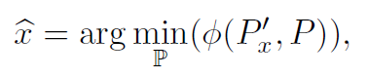

minimizing *f*, may be determined.  The minimized function is represented by the sum of the squares of residuals on the corresponding points

*f* (*P*′*x*, *P*), = rTr.

*Created with the Personal Edition of HelpNDoc:* [*Full-featured Kindle eBooks generator*](http://www.helpndoc.com/feature-tour/create-ebooks-for-amazon-kindle)

**7 parameter method**

### The 7-parameter method

The first method, denoted M7, determines the vector   of 7 unknown parameters.

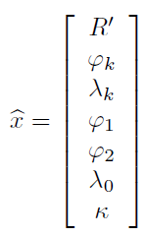

At least, four analyzed features are sufficient; it does not take into account the rotation between *P*, *P*′*x*. The coordinate systems of the analyzed and reference maps (0, *x*, *y*) and (0, *X*, *Y*), are aligned in the centers of mass *c* = [*xc*, *xc*]

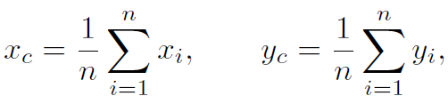

and *C* = [*Xc*, *Yc*], where

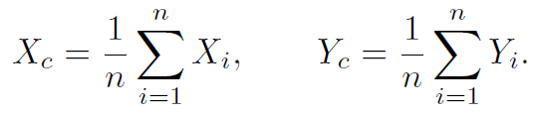

The analysis will be performed in local coordinate systems with origins in *c*, *C*. Let us denote *P* to be the set of elements of which the Cartesian coordinate system (*c*, *x*′, *y*′) has been reduced to the center of mass *c* of *P*

*x*′*i* = *xi* − *xc*,

*y*′*i* = *yi* − *yc*.

Analogously, *P*′*x* is the set of elements of which the Cartesian coordinate system (*C*, *X*′, *Y*′) has been reduced to the center of mass *C* of *P*′*x*

*X*′*i* = *Xi* − *Xc*,

*Y*′*i* = *Yi* − *Yc*.

The residuals under the aligned sets are computed from

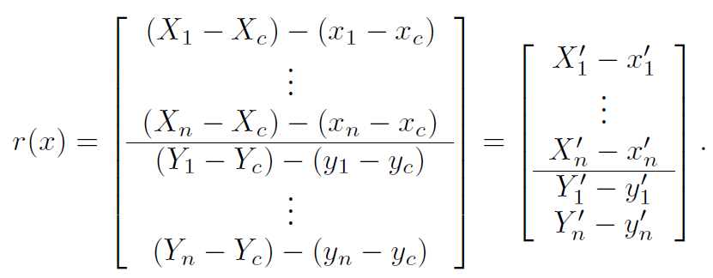

*Created with the Personal Edition of HelpNDoc:* [*Full-featured multi-format Help generator*](http://www.helpndoc.com/help-authoring-tool)

**8 parameter method**

### Method M8

The M8 method determines the map constants directly using the weighted Helmert 2D similarity transformation. Hence, the increments of the auxiliary sphere radius *R*′ and rotation *α* are not determined from NLS, but from the scale coefficients *q*1, *q*2 of the transformation (this approach may be adapted to any optimizing strategy). From iteration to iteration, 6 unknown parameters [*φk*, *λk*, *φ*1,  *φ*2, *λ*0, *κ*] of the projection are estimated

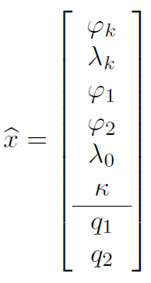

using the NLS procedure and with the scale coefficients (i.e., map constants) they are used to determine the projected coordinates *Xi*, *Yi*

*Xi*(*φk*, *λk*, *φ*1, *φ*2, *λ*0, *κ*, *q*1, *q*2)  =  *F*(*φ*′*i*, *λ*′*i*),

*Yi*(*φk*, *λk*, *φ*1, *φ*2, *λ*0, *κ*, *q*1, *q*2)  =  *G*(*φ*′*i*, *λ*′*i*).

Hence, the vector of the residuals

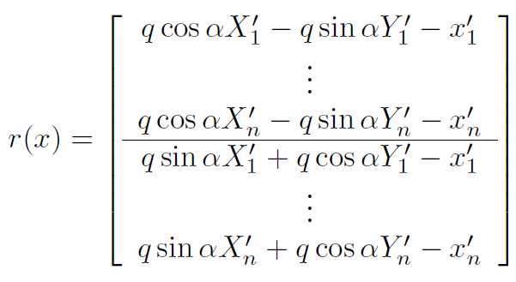

may be rewritten to

*r*(*xk*) = *Akqk* − *l*,

where *Ak* is the design matrix

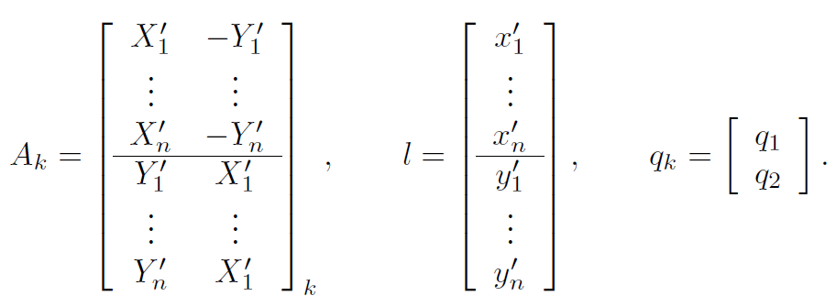

Finally, the solution at the current iteration is determined from the linear least squares solution

*qk* = (*ATkWkAk*)− 1*ATWkl*.

Taking into account that

∥*qk*∥2  =   √(*q*21 + *q*22),        *αk*  =  arctan(*q*2/*q*1)*k*,

the radius of the auxiliary sphere *R*′*k* at the *k*-th iteration is

*R*′*k* = *R*′0∥*qk*∥2.

Unfortunately, the Jacobian matrix of M8 is complicated. Instead of the analytical form, the numerical differentiation is used.

*Created with the Personal Edition of HelpNDoc:* [*News and information about help authoring tools and software*](http://www.helpauthoringsoftware.com)

**Optimization techniques**

*Created with the Personal Edition of HelpNDoc:* [*Easily create Qt Help files*](http://www.helpndoc.com/feature-tour)

**Non-linear least squares**

## Non-linear least squares

Non-linear least squares solution minimizes the sum of the squared residuals *r* between the observations *y* ∈ ℝ*m* and a model *f*(*x*) ∈ ℝ*m*

min*x*∈ ℝ*n*0.5||*r*||22 = min*x*∈ ℝ*n*0.5||*f*(*x*) − *y*||22.

It leads to the overdetermined system of linear equations with the unique minimizer. If *f*(*x*) is a non-linear function, the non-linear least squares problem is solved.

Let us summarize the most important properties of NLS:

* In general, the non-linear least squares method has a faster convergence rate than the non-deterministic optimizing approach. It may be used in situations when the benefit of the exact solution is not directly measurable or the global optimization is time-consuming. The non-linear least squares approach may be classified as (nearly) real-time. Therefore, it can be implemented in the form of an applet and run on the client-side.
* If a local minimum exists, it is found regardless of the initial solution. Therefore, no further verification is needed. For non-convex optimization, a convergence to any local minima is guaranteed.
* However, there are some restrictions to the minimized function. Only such functions where the gradient is known may be optimized.
* For a non-convex problem, multiple local minima exist. If the global minimum is required, a repeated optimization with the random initial guess is useful. If the same minimum is found regardless of the initial values of parameters, it is likely the global minimum. However, a more reliable verification based on the global optimization is required. Currently, the differences between local and global minima are bellow the graphical accuracy of the analyzed map.
* The non-linear least squares implementation is non-trivial; some advanced numerical procedures are required (SVD, QR factorization, generalized Cholesky decomposition). Moreover, the algorithm may lead to another optimization problem; this typical for the line-search as well as for the trust region approaches.

*Created with the Personal Edition of HelpNDoc:* [*Single source CHM, PDF, DOC and HTML Help creation*](http://www.helpndoc.com/help-authoring-tool)

Hybrid BFGS

### Hybrid BFGS

The combination of the Gauss-Newton and BFGS methods is efficient for solving the non-linear least squares. It will be proposed as the line search method using a positive definite update of the Hessian matrix. For non-zero residual problems, it converges superlinearly, and quadratically for zero residual problems. The equation

*f*(*xk*) − *f*(*xk*+ 1) ≥ *τf*(*xk*),

indicates which actualization step will be taken, *τ* ∈ (0, 1) is a positive constant. The selection criterion may be rewritten to the following form of

*τ* = (*f*(*xk*) − *f*(*xk*+ 1))/*f*(*xk*).

Depending on *τ* ,the following strategy is chosen:

* If *τ* > *τmin*, the nearly zero residual problem is solved, where the Gauss-Newton method with the quadratic convergence rate is more efficient. The simple update computes *Bk*+ 1 from the Gauss-Newton method

*Bk*+ 1 = *JT*(*xk*)*WkJ*(*xk*).

* If *τ* < *τmin*, the large residual problem is solved. The BFGS update

*Bk*+ 1 = *Bk* + *ykyTk /(yTksk*) - *BksksTkBTk/(sTkBksk*).

with the superlinear convergence rate is more efficient.

For practical computations, the recommended value is *τmin* = 0.0001. From a wide set of the analyzed algorithms, the hybrid method proved to be very efficient in all the measured aspects. Improving properties of the Gauss-Newton method for large residual problems as well as BFGS for the zero residual problems it contains the best features of both methods. For the projection analysis, its performance is adequate and provides real-time analysis of the projection parameters.

The algorithm may be summarized as follows:

1:  *k* ← 1; *xk* ← *x*0, *Hk* ← *I*, *Wk* ← *I*. //Initialize parameters

2:  *B*(*xk*) ← *JT*(*xk*)*WkJ*(*xk*); ∇*f*(*xk*) ← *JT*(*xk*)*f*(*xk*) //Compute Hessian matrix and gradient

3:  **repeat**

4:       *hk* ← *B*†(*xk*)∇*f*(*xk*) //Compute the search direction

5:       *αk* ← inStep(*xk*, *hk*, *x*, *x*) //Use the line search, the inexact line search

6:       *xk*+ 1 ← *xk* − *αkhk* //Compute new solution

7:       Correct(*xk*+ 1, *x*, *x*) //Perform reflection into the search space *SD*

8:       *yk* ← ∇*f*(*xk*+ 1) − ∇*φ*(*xk*)

9:       *sk* ← *xk*+ 1 − *xk*

10:      *τ* ← (*f*(*xk*) − *f*(*xk*+ 1))/*f*(*x***)** //Compute the decision criterion

11:      **if** *τ* > *τmin*∨*yTksk* < 0 //Gauss-Newton update

12:          *Bk*+ 1 = *J*(*xk*)*TWkJ*(*xk*)

13:      **else** *τ* < *τmin* //Cumulative quasi-Newton update

14:         *Bk*+ 1 = *Bk* + *ykyTk/(yTksk*) − *BksksTkBTk/(sTkBksk)*

15:      *k* ← *k* + 1

16: **until** convergence conditions are held

The fast convergence of the vector *x*k to the global minimum *j*k = 2○, λk = -109.1○, of *φ*(*x*k ) using hybrid BFGS; iterations 1-8, together with contour lines, are shown.

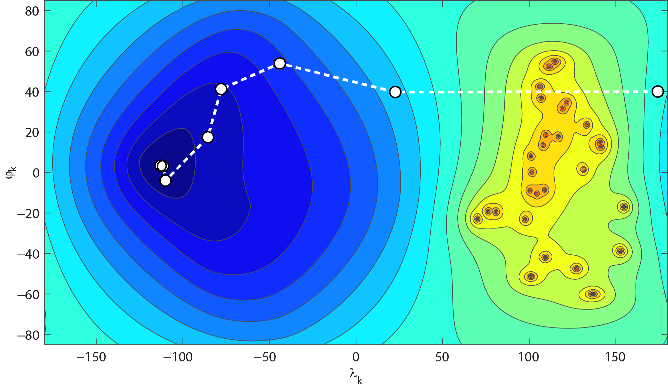

*Created with the Personal Edition of HelpNDoc:* [*Easily create iPhone documentation*](http://www.helpndoc.com/feature-tour/iphone-website-generation)

**Derivative-free methods**

## Derivative-free methods

While the non-linear least squares approach led to the convex optimization, where a solution can be found in real-time, the derivative-free approach brings a solution of the better quality, but it is computationally more expensive. Let us summarize the pros and cons of the derivative-free methods:

* Derivative-free methods are applicable to problems with non-differentiable functions. Such functions encountered in engineering application may not be smooth or continuous. The free derivative approach is also typical for situations when the evaluation of the function is costly, or the function is too noisy. In such situations, the derivatives are unreliable or may not be available. Due to the innovations and progress in the numerical optimization method, such situations are becoming less frequent.
* For small-sized problems up to 20 parameters, derivative-free methods are relatively successful. Compared to NLS approach, they are more efficient at finding the global minimum. However, there are many functions where finding a global minimizer represents a difficult problem, even on “unlimited hardware”; it represents the NP hard problem.
* The derivative-free methods are globally convergent to any local or the global minimum, but its location may be slightly inaccurate; the gradient of the minimized function is not available. For the accurate position of the minimum more attempts are required.
* Their implementation is, in general, simple. Computationally difficult operations such as the pseudo-inverse, or numerical differentiation, are not necessary.

Let us point out some drawbacks of derivative-free methods:

* The main limitation of derivative-free methods is the fact that they are reasonable for problems up to a few tens of variables (usually, less than 20 variables). However, some modern methods are applicable to mid-sized problems containing hundreds of variables. Keep in mind, the map projection analysis problem contains 7-8 determined variables.
* Due to the fact that the objective function needs to be sampled with sufficient density, the number of the objective function evaluation is much greater. To construct a full polynomial approximation of the objective function of *n* variables, approximately *n*2 attempts are required. The derivative-free methods are about one or two orders of magnitude computationally more expensive, which excludes them from the real-time analysis.
* The deterministic solution assumes knowledge of the objective function gradient which is used to determine the search direction. Most of global optimizing problems are NP-hard; there is no deterministic solution of the problem. The stochastic methods take a random search direction; the results may become unpredictable or ambiguous. When restarting the algorithm, the current solution may differ from the previous one. Concurrently, the location of the optimizer is less accurate, compared to the NLS solution.

*Created with the Personal Edition of HelpNDoc:* [*News and information about help authoring tools and software*](http://www.helpauthoringsoftware.com)

Nelder-Mead method

### Nelder-Mead method

The Nelder-Mead method is the most popular direct-search optimizing method. Despite its simplicity, it achieves very good results, especially for small-sized problems up to twenty variables and for noisy objective functions, where the least squares give a poor result. However, for large problems, it is not efficient.

The Nelder-Mead method performs an evaluation of the objective function at a finite, and relatively small, set of points, represented by vertices △*j* of the simplex △, without any information about the gradient. From iteration to iteration, a new simplex △ = {△*j*}*m*+ 1*j*= 1 is built.

The vertices △*j* of the simplex △ are ordered according to the value of the objective function

*f*(△1) < *f* (△2) < ... < *f* (△*m*+ 1).

Consider △1 ≡ *x* to be the best vertex of the simplex corresponding with the vector *x* of the determined parameters and △*m*+ 1 the worst vertex of the simplex. As well as the previous methods, the Nelder-Mead algorithm is iterative, and after applying a stopping condition at *k*-th iteration, the minimizer *^x* of the objective function *f*

≡ △*k*1 = argminℙ(*f* (*P*, *P*′*x*)),

is given by the best vertex △*k*1 of the simplex.

The Nelder-Mead algorithm keeps a set of *m* + 1 simplex vertices sorted according to the objective function values *f* (△1) < *f* (△2) < ... < *f* (△*m*+ 1). From iteration to iteration, a new centroid *△̂* of *m* best vertices is determined. A reflection of the worst vertex △*m*+ 1 is performed. If the value of the objective function at the reflected vertex is better than the value at the penultimate vertex *f* (△*r*) < *f* (△*m*), the worst simplex vertex is replaced with the reflected.

If the reflected point is better then the best simplex vertex *f* (△*r*) < *f* (△1),  follow this promising direction, and the simplex is expanded. If the expanded point is better than the reflected one (and thus better than △1), the worst vertex is replaced with the expanded; otherwise, it is replaced with the reflected one.

The algorithm can be summarized as follows:

1. ***Initialization***

Create a random simplex △0, set *k* = 0, *W* = *I*. Set the Nelder-Mead parameters depending on the dimension of the problem

*α* = 1,  *β* = 1 + 2*n*,  *γ* = 34 − 12*n*,  *δ* = 1 − 1*n*.

1. ***Sort vertices***

Order simplex △*k* vertices in ascending order so that

*f* (△*k*1) < *f* (△*k*2) < ... < *f* (△*km*+ 1).

1. ***Compute centroid***

Compute the simplex centroid  from the *m* best points

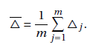

which will be used for the simplex operations.

1. ***Reflection***

Compute the reflection point △*r* = (1 + *α* − *α*△*m*+ 1. The reflected point △*r* is accepted, △*m*+ 1 = △*r*, if *f* (△1) < *f* (△*r*) < *f* (△*m*), compute the projection equation ℙ:*Q* → *P*′*xk*.

1. ***Expansion***

If *f* (△*r*) < *f* (△1), compute the expansion △*e* = (1 + *αβ*) − *αβ*△*m*+ 1. The expansion point △*e* is accepted, △*m*+ 1 = △*e*,  if *f* (△*e*) < *f* (△*r*). Otherwise, △*m*+ 1 = △*r*.

1. ***Outer contraction***

If *f* (△*m*) ≤ *f* (△*r*) ≤ *φ*(△*m*+ 1), compute the outer contraction △*co* = (1 + *αγ*)− *αγ*△*m*+ 1. The contraction point △*co* is accepted, △*m*+ 1 = △*co*, if *f* (△*co*) < *f* (△*r*). Otherwise, go to step 8; a shrink is performed.

1. ***Inner contraction***

If *φ*(△*r*) > *φ*(△*m*+ 1), compute the inner contraction △*ci* = (1 + *αγ*)+ *αγ*△*m*+ 1. The contraction point △*ci* is accepted, △*m*+ 1 = △*ci*,  if *f* (△*ci*) < *f* (△*r*). Otherwise, go to step 8; a shrink is performed.

1. ***Shrink***

Perform a shrink of the simplex; only the best vertex does not change

△*j* = △1 + *δ*(△*j* − △1),  *j* = 2, ..., *m* + 1,

where *j* = 2, ..., *m* + 1.

1. ***Terminal condition***

If the terminal condition is held, stop the iteration process. Otherwise, *k* = *k* + 1, and go to step 2.

A convergence of the simplex △*j* to the global minimum *j*k = -1.0○, λk = 73.1○, of *φ*(*x*k ); the stereographic projection in the near transverse aspect, selected steps from the first 30 iterations are visualized.

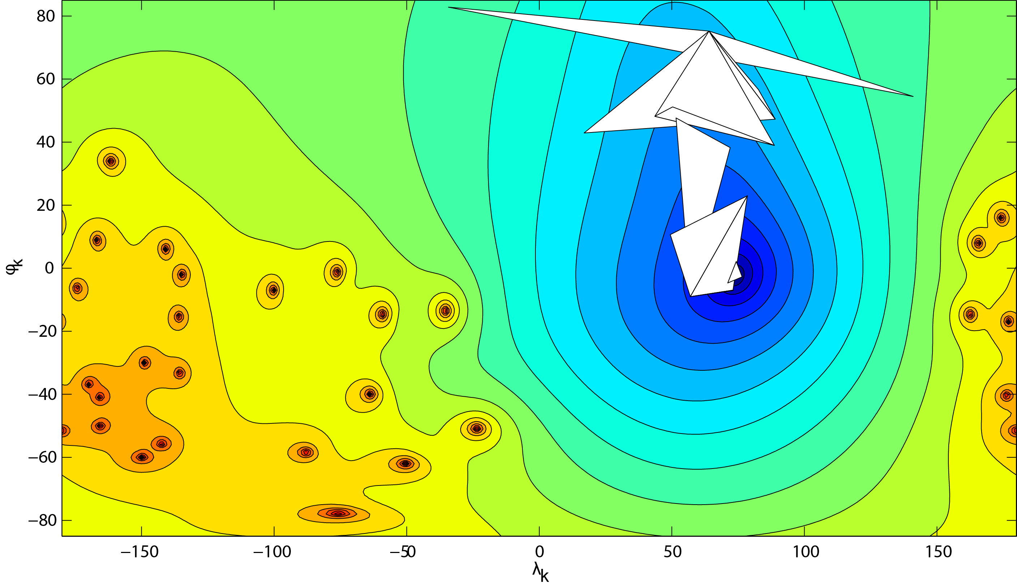

*Created with the Personal Edition of HelpNDoc:* [*Full-featured multi-format Help generator*](http://www.helpndoc.com/help-authoring-tool)

Differential evolution

### Differential evolution

Differential evolution, the well-known and efficient optimizing strategy in the continuous search domain, was proposed as the replacement of the simulated annealing. Differential evolution follows the general model of the evolutionary algorithms, involving the following evolutionary operators: crossover and mutation. The individuals are not represented with binary numbers, but they are coded as floats. This natural representation makes differential evolution more transparent and easy-to understand; the evolutionary operators for crossover and mutation utilize simple arithmetic operations.

The general *benefits* of differential evolution may be described as follows:

* *Easy implementation*

The simplicity of the proposal means that this method is frequently used; the main procedure contains only several lines of source code.

* *Efficiency*

Despite its simplicity, differential evolution represents one of the most powerful and efficient global optimizing methods with fast convergence (relative to the other evolutionary algorithms).

* *Easy to compute*

The method has small computational demands (low complexity and good memory utilization) and may be used for medium- and large-sized problems containing hundreds of variables.

* *Adaption*

Differential evolution may be adapted to a wider set of optimizing problems, regardless of the dimension of the problem and the type of the objective function.

However, some *disadvantages* should be mentioned.

* *Sensitivity to the parameters*

The differential evolution is partially sensitive to the initial values of the parameters and the mutation strategy as well as to the numerical values of the crossover and mutation probability.

* *Computational cost*

Compared to the deterministic algorithms, the differential evolution is computationally expensive and has a slower convergence. In particular, the second issue excludes differential evolution from real-time methods. It also represents a major obstacle for the current use, when the map projection needs to be analyzed.

During the optimizing process, differential evolution works with population of the constant size of *np*. The method of generating the trial solution by the crossover operator, using a weighted difference of several individuals from the population, is different; it will be discussed later. The replacement rule updates a population only if the offspring is better; this approach is analogous to elitism. For each generation *g*, the best individual is evaluated, and the algorithm generates a non-decreasing sequence of the best individuals such that

*f* (*xbest*,*g*+ 1) ≤ *f* (*xbest*,*g*) ≤ ... ≤ *f* (*xbest*, 1).

The slightly modified version of the algorithm, involving the dither technique (MFDE), will be described.

Creating the initial population distributed randomly over the search space represents the first step of the algorithm. Subsequently, the reproductive cycle is entered. For each element of the actual population, evolutionary operators such as mutation, crossover, and selection are undertaken.

Based on the MFDE strategy, the modified mutation factor *Fi*,*g*, as well as the decreasing factor *di*,*g* are evaluated. The random strategy, represented by the DE/rand/1 scheme generating the new vector *vi*,*g* at the *g*-th generation from three random vectors *xr*1,*g*, *xr*2,*g*, *xr*3,*g*, was set as primary. The crossover operator follows the binomial scheme, where *CR* = 0.8.

Then, the replacement operator compares the fitness of the trial and target vector; the better of them proceeds to the new generation. Finally, the best and worst individuals are found, and the stopping conditions are checked. Due to the complexity of the algorithm, an extended notation will be more readable.

The algorithm, which, due to the complexity is not written in the pseudo-code, can be summarized as follows:

1. ***Create the initial population***

Set the initial population size to *NP* = 10*D,* where *D* is the dimension of the problem. (*D* = 7 for M7, *D* = 8 for M8) For *i* = 1, ..., *NP* and for *j* = 1, ..., *D* create the initial random population *P*0. Initialize *Wi*,*g* = *I*. For each individual *xi*,*g*, evaluate the residuals *r*(*xi*,*g*) and the objective function *φ*(*xi*,*g*).

1. ***Main loop***

For the given set of generations *g* = 1, ..., *MAXGEN*, until the stopping criteria *ε* have been satisfied, do the following steps:

* 1. *Mutation step*

Initialize *d*1,*g* = 1.2. For all *i* = 1, ..., 10*D* in the current generation: Compute the decrement factor *di*,*g*

*di*,*g* = *di*,*g*− 1 − 1 ⁄ *NP*,

and the modified mutation factor *Fi*,*g*. Pick 3 random points with the indices *r*1, *r*2, *r*3 and compute the mutation vector *vi*,*g*

*vi*,*g* = *xr*1,*g* + *F*(*xr*2,*g* − *xr*3,*g*),

where *F* ≡ *Fi*,*g*.

* 1. *Cross-over step*

For all *i* = 1, ..., 10*D* and for all *j* = 1, ..., *D* in the current generation: perform a binomial crossover

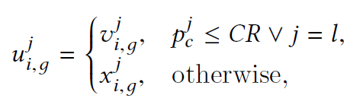

where

*pjc* = *rand*(0, 1).

* 1. *Reflection step*

For all *i* = 1, ..., 10*D* in the current generation: flip all elements *uji*,*g* ≠ *SD* into the search space *SD*.

* 1. *Selection step*

To compare the trial vector *ui*,*g* and the target vector *xi*,*g*, evaluate the objective function values *φ*(*ui*,*g*), *φ*(*xi*,*g*), the better of them proceeds to the next generation

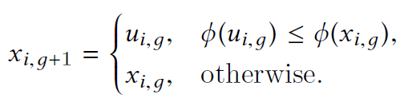

Update the current population.

* 1. *Stopping criteria*

Find the worst and best individuals in the current population



check the terminal conditions and stop the iteration process, if necessary. Increment the generation *g* = *g* + 1.

1. ***Global optimizer***

Determine the global optimizer as the best individual from the population at the last generation *g*

 ≡ *xbest*,*g*.

A convergence of the population *Pg* to the global minimum *j*k = -2.9○, λk = 55.2 ○, of *φ*(*x*k ); of *f* , every 10th generation, together with contour lines, are shown.

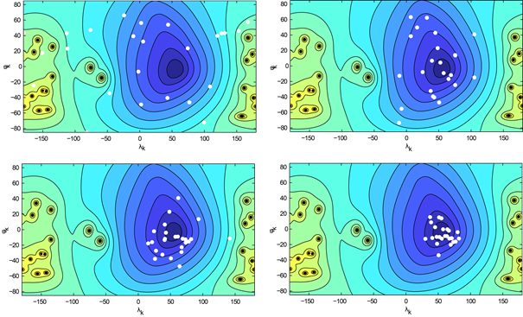

*Created with the Personal Edition of HelpNDoc:* [*Free CHM Help documentation generator*](http://www.helpndoc.com)

**Getting Started**

*Created with the Personal Edition of HelpNDoc:* [*Full-featured EPub generator*](http://www.helpndoc.com/create-epub-ebooks)

**System requirements**

## System requirements

If you want to run detectproj on your PC, you need:

· 2 gigahertz (GHz) or faster 32-bit (x86) or 64-bit (x64) processor.

· 2 gigabyte (GB) RAM (32-bit) or 4 GB RAM (64-bit).

· 20 MB available hard disk space (32-bit) or 25 MB (64-bit).

Additional requirements to use:

* Operation system: Win 7 – Win10, 32/64-bit, GNU/LINUX, 32/64-bit, kernel 3.0+, Mac OS X.
* Java: Java Runtime Environment, at least 1.6 and higher, 32/64-bit.
* Internet connection: download speed > 2Mb/s.

*Created with the Personal Edition of HelpNDoc:* [*Easily create EBooks*](http://www.helpndoc.com/feature-tour)

**Installation**

## Installation

The detectproj software is distributed as:

* On-line as Java WebStart application, Java JAR file (compressed Java class files and additional resources), Java Runtime Environment required.
* EXE file, JAR file converted to executive binary file), Java Runtime Environment required.
* EXE file, installation package, no additional libraries are required.

### Configure Java Runtime Environment

To configure Java, do the following steps:

1. Download and install the Java Runtime Environment from Oracle.
2. Run the Java Control panel:
   * Right-click on the **Start** button and select the **Control Panel** option.
   * In the Windows Control Panel, click on **Programs**.
   * Click on the Java icon to open the Java Control Panel. See here for details.
3. Add the Java security exception for the site:
   * Click **Add** in the Exception Site List window.
   * Type the URL "https://natur.cuni.cz" into the empty field that is provided under **Location**.
   * Continue to click **Add** and enter URLs until your list is complete.
   * Click **OK** to save the URLs that you entered. If you click **Cancel**, the URLs are not saved. See here for details.

### Run detectproj from JNLP file

To run detectproj as Java Web Start Application, do the following steps:

* + 1. Before running JNLP file, Java Runtime Environment must be installed and configured.
    2. Click on the Launch button  and run the jnlp file. Alternately, store the JNLP file to the local folder and click on the file.
    3. Accept "Running the application may be a security risk" and click on the **Run** button.

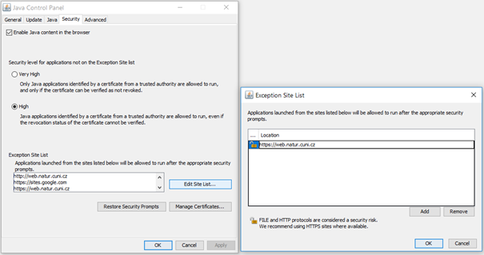

### Run detectproj from EXE file

To run detectproj as a desktop application from the detectprojv2j.exe, do the following steps.

1. Before running the application, Java Runtime Environment must be installed and configured.
2. Click on the detectprojv2j.exe file and run the application.

### Install detectproj and run

In this case, Java Runtime Environment does not need to be installed, no additional libraries are required.

To install detectproj from the package, do the following steps:

1. Click on the detectprojv2j-setup.exe file and run the application wizard.

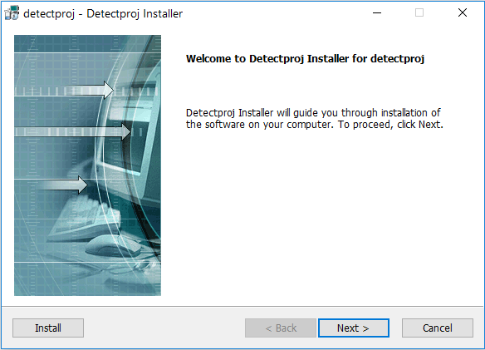

1. After starting the installation in the detectproj-Detectproj installer window, click on **Next**.

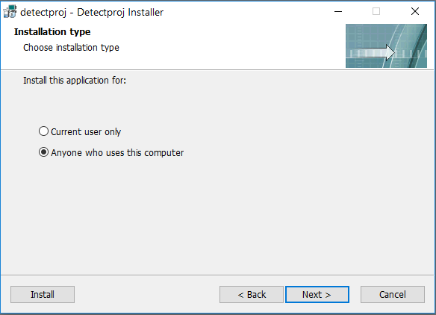

1. Choose the installation type and click on **Next**.

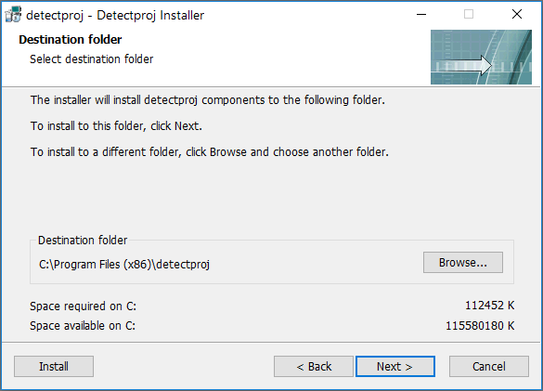

1. Click on **Browse** to change the installation folder and continue on **Next**.

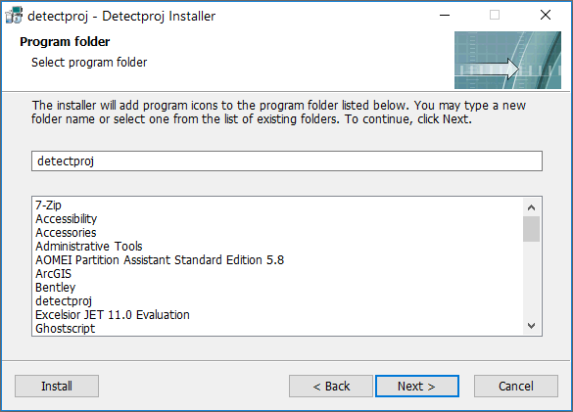

1. Select a program group, continue on **Next** and wait until the end of installation.

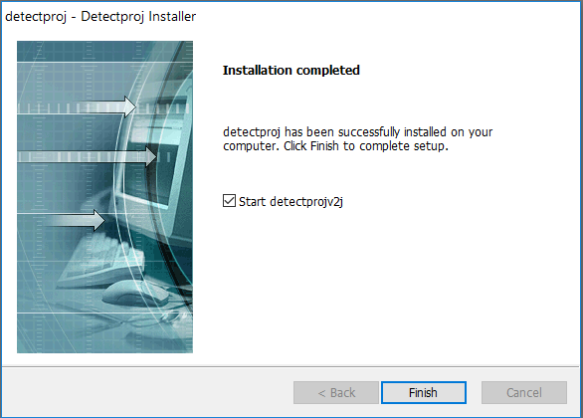

1. After the installation process is completed continue to click **Finish**. Selecting *Start detectproj* you may run the application.

*Created with the Personal Edition of HelpNDoc:* [*Free EBook and documentation generator*](http://www.helpndoc.com)

**Basic Usage**

## Basic Usage

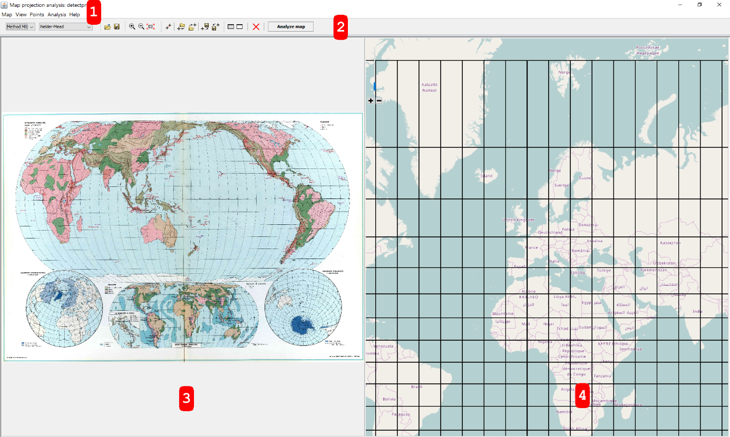

### 1 Main menu



Manage program, access to main functions.

#### Map Menu

Import map: Import analyzed early map.

Export graticule: Export reconstructed graticule, test points, reference points, and projected points to DXF file.

Exit: Exit the application

#### View Menu

Zoom In: Zoom the map window 3, or 4.

Zoom Out: Pan the map window 3, or 4.

View All: Zoom out the map window 3, or 4 to see the entire map.

#### Points Menu

Add control points: Enable adding control points.

Import test points: Import control points for the analyzed map from the *.TXT file.

Import reference points: Import control points for the reference map from the *.TXT file.

Export test points: Save collected test points to the *.TXT file.

Export reference points: Save collected reference points to the *.TXT file.

#### Analysis Menu

Detection method: Set the projection detection method M7 or M8.

Optimization technique: Set the optimization technique (Non-linear Least Squares, Nelder-Mead, Differential Evolution)

Analysis: Run the analysis.

Show results: Show the table with results.

Clear results: Clear all results in the table, reconstructed graticule, and reconstructed points.

Clear: Clear all collected points, results in the table, reconstructed graticule, and reconstructed points.

#### Help Menu

Help: Display help

About: Show the about box.

### 2 Main Toolbar



 Detection method

 Optimization method

 Import map.

 Export graticule.

 Zoom in.

 Zoom out

 View all

 Add control points

 Import test points

 Import reference points

 List of control points

 Export test points

 Export reference points

 Show results

 Clear results

 Clear all

 Perform analysis

### 3 Analyzed map window

View the analyzed map, manage control points, zoom the situation. The analyzed map is represented by JPG, PNG, GIF file.

### 4 Reference map window

View the reference map, manage control points, zoom the situation.The reference map is represented by the Open Street Map.

### Main controls:

Left mouse click: add control point.

Right mouse click: delete the control point

Mouse wheel: Zoom in/out.

Left mouse drag: move the control point.

Right mouse drag: dynamic shift of the map.

*Created with the Personal Edition of HelpNDoc:* [*What is a Help Authoring tool?*](http://www.helpauthoringsoftware.com)

**Add early map**

## Add early map

The first step of the analysis is represented by importing early map from a file.

*Created with the Personal Edition of HelpNDoc:* [*Generate EPub eBooks with ease*](http://www.helpndoc.com/create-epub-ebooks)

**Import early map**

## Import early map

The existing early map can be imported from a file. For successful import, the file should not exceed 50 MB.

The following graphic formats are supported:

* JPG - Joint Photographic Expert Group,
* PNG - Portable Network Graphics,
* GIF - Graphics Interchange program.

The supported formats are given by the [java.awt.image.BufferedImage](https://docs.oracle.com/javase/8/docs/api/java/awt/image/BufferedImage.html) class and can not be changed.

Currently, TIFF format is not supported.

#### Import early map file

* + 1. Click in the **File** menu, and select the **Import map** item. Alternately, click on the  icon.
    2. In the dialog window **Upload early map** select the graphic file.  
         
       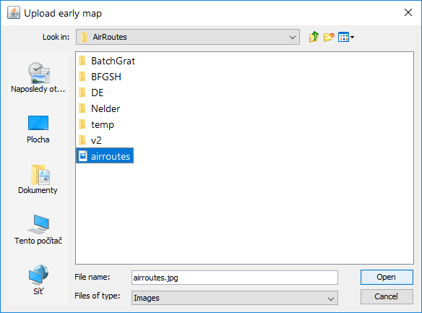
    3. Click on **Import** to import the early map file.  
         
       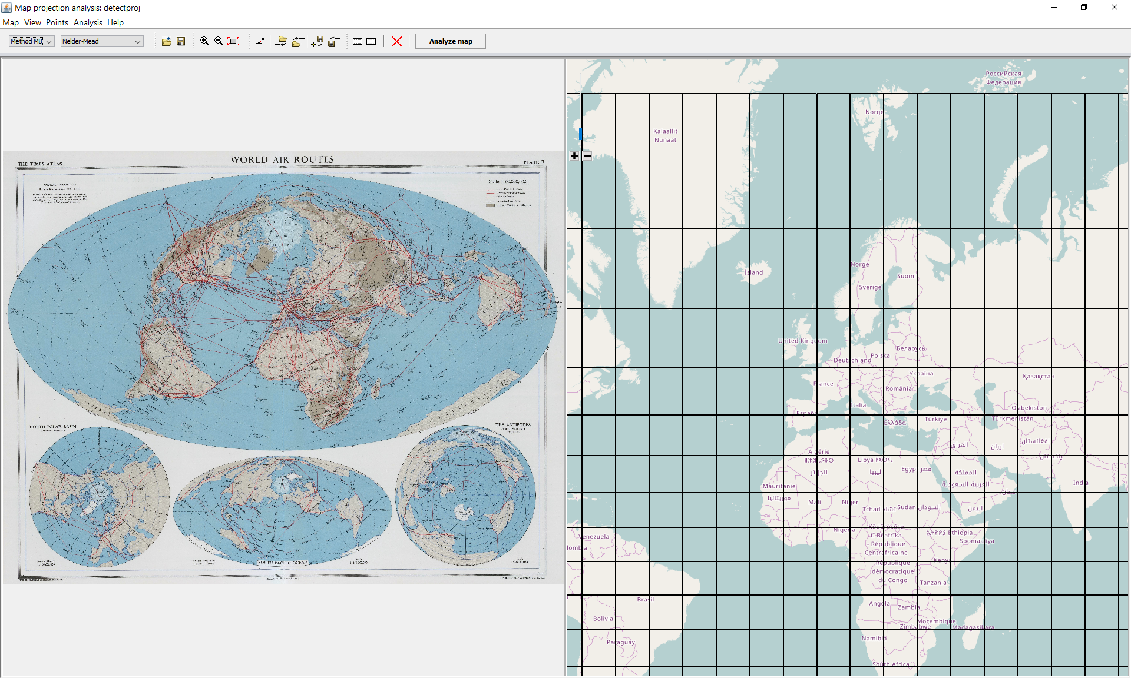

#### Import early map file using drag and drop

1. In the **Windows Explorer** or any two-panel file manager (Total Commander, Free Commander, muCommanser) select the graphic file (*.JPG, PNG, GIF files).  
     
   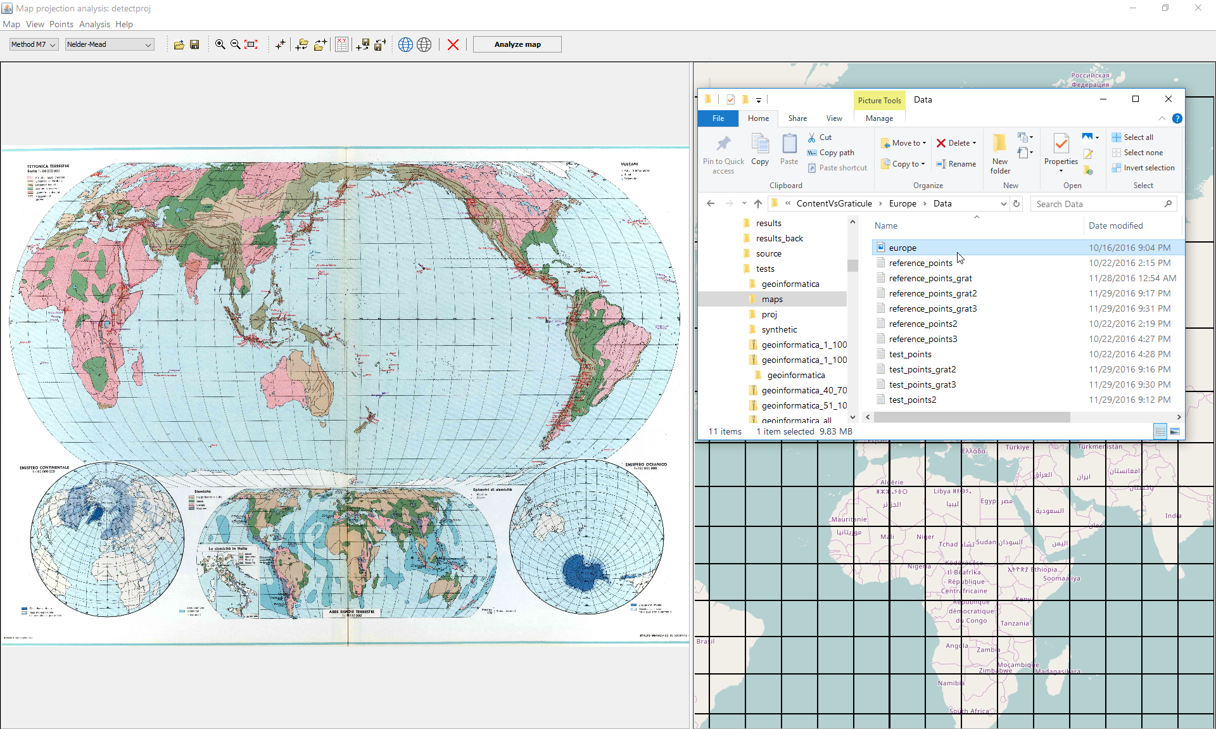
2. Drag the file and drop it over the analyzed map. During the procedure, the drag indicator *Move* is drawn.  
     
   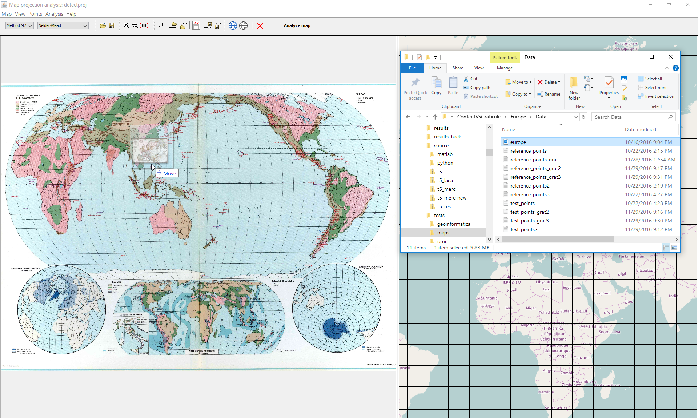
3. Subsequently, the analyzed map is drawn.  
     
   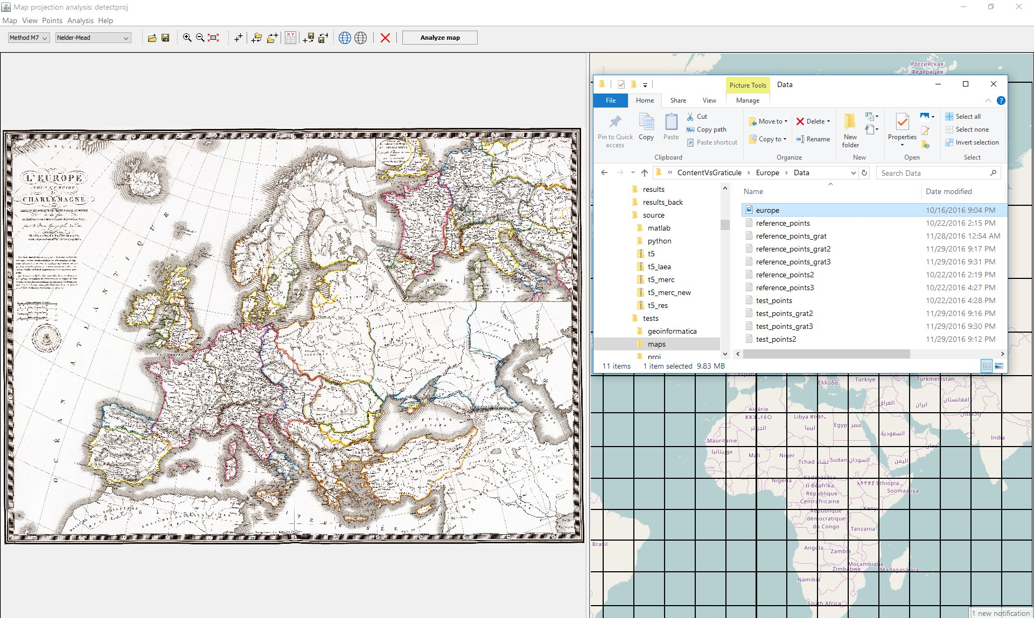

*Created with the Personal Edition of HelpNDoc:* [*Full-featured EPub generator*](http://www.helpndoc.com/create-epub-ebooks)

**Working with control points**

## Working with control points

The analysis is based on the minimization of the squares of residuals between test points and projected reference points.

The control points are collected by the user.

A **pair** of control points contains the control points on the analyzed map and on the reference map.

 Symbol of the test point on the analyzed map

 Symbol of the reference point on Open Street Map

*Created with the Personal Edition of HelpNDoc:* [*Easily create EPub books*](http://www.helpndoc.com/feature-tour)

**Choose control points**

### How to choose control points

Let us summarize several recommendations how to choose and place the control points:

1. For analysis, at least 5 points are required.
2. Due to the computational complexity, it is not recommended to use more than 20 points.
3. The acceptable inaccuracy in a position of points is about 3 mm on the map
4. The proposed techniques are suitable for sets with approximately the same spatial density of features. The uniform distribution of analyzed collected points on a map (grid, random set) is crucial.
5. On the boundaries of the analyzed region, in particular, it is necessary to place enough points.
6. The analyzed features should be placed “symmetrically”, on both sides of the equator and the central meridian.
7. For the small-scale maps 5 points are sufficient, for the medium-scale maps 10 points are recommended, but for the large-scale maps 15-20 points may be required.

Recommended control point distributions:

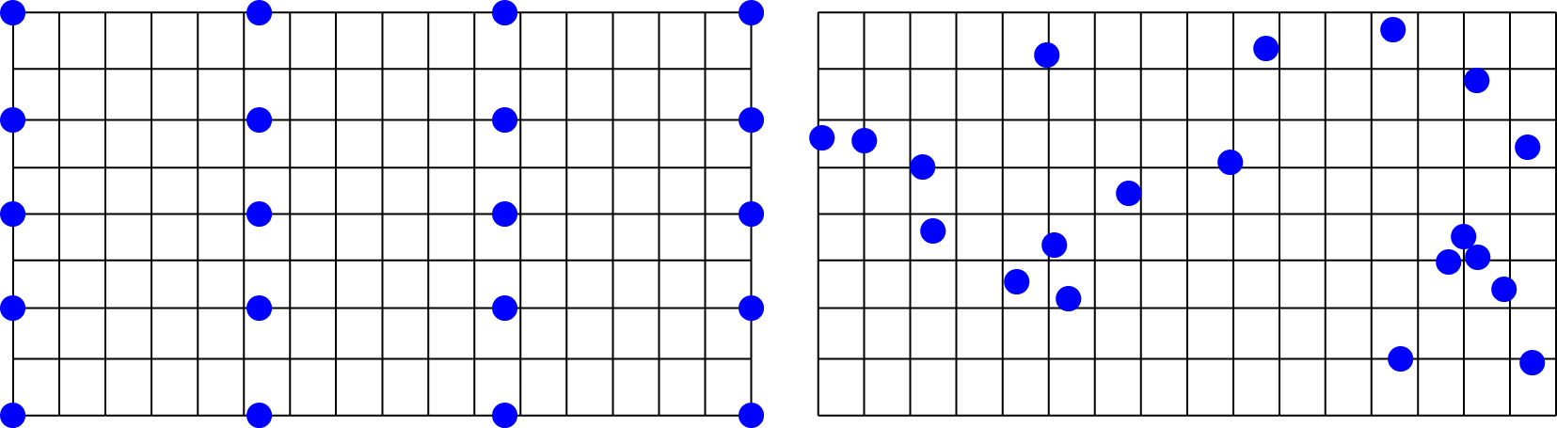

Not recommended control point distributions:

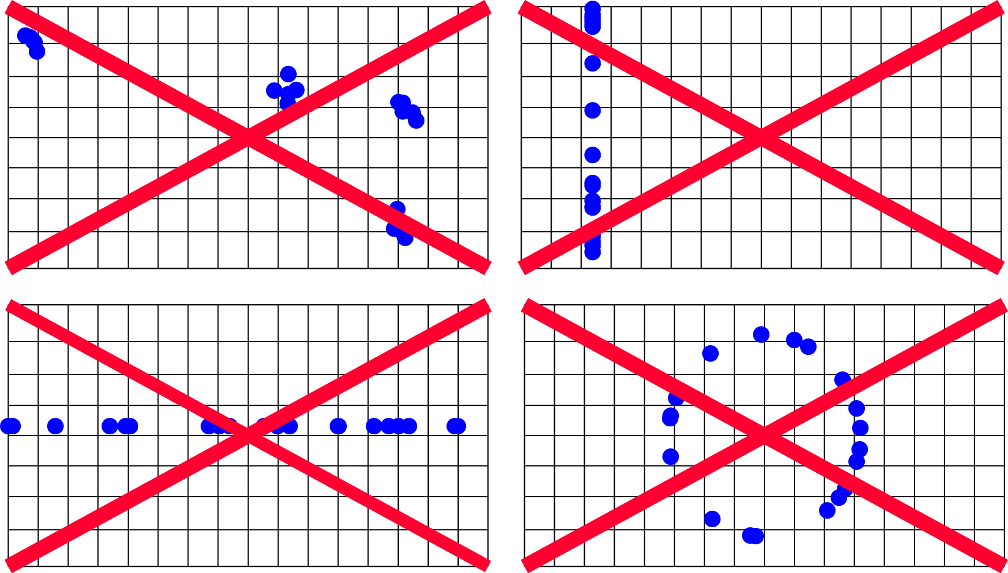

Recommendations for the analyzed territory:

1. The analyzed territory should have similar dimensions in the latitudinal and longitudinal directions.
2. The analyzed territory should be large enough (at least Δ*φ* = Δ*λ* = 3○).
3. It is not recommended to choose the control points near the equator (a similar shape in many projections), near the pole (singular points), or near the central meridian (a similar shape in many projections).

The control point amount, location and distribution significantly affect the results:

1. The estimated parameters fit well inside the convex hull of the analyzed point set; no extrapolation of results outside the analyzed set is supported.
2. For early maps, the graticule is significantly more accurate than the map content. Placing control points in the meridian and parallel intersections brings lower residuals between the original and reconstucted graticule.
3. Omitting some quadrants, when the analyzed features are not placed “symmetrically” on both sides of the equator/central meridian or using only a single quadrant may lead to a detection of the wrong projection,

Control points located on the map items:

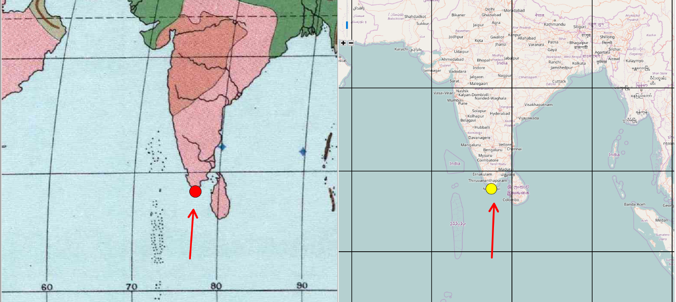

Control points located on the meridian/parallel intersection:

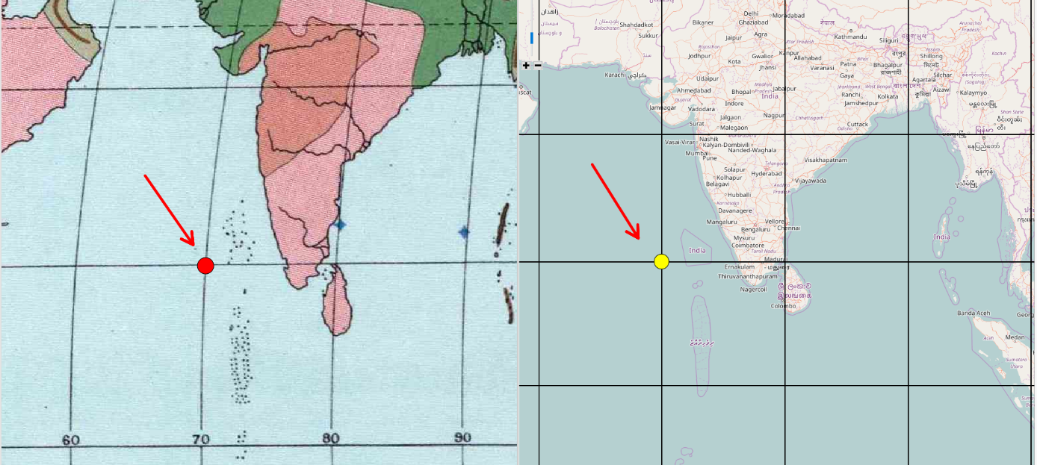

**Case 1: Insufficient amount of control points on parallels**

Result: Bad estimation of the parallel shape lead to the detection of the different type of the projection.

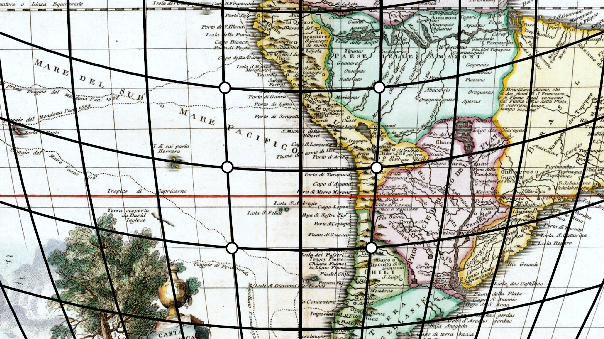

**Case 2: The analyzed features covering a small part of the analyzed territory;**

Result: the estimated graticule fits into the original only inside the convex hull; the wrong projection is detected.

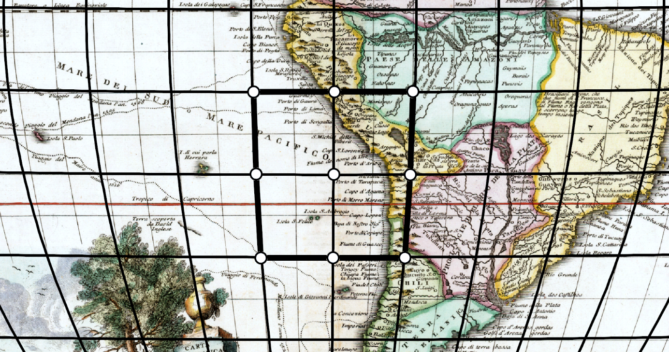

**Case 3: The analyzed features are placed in the single quadrant**

Result: the estimated graticule has a poor fit in different quadrants, the wrong projection is detected

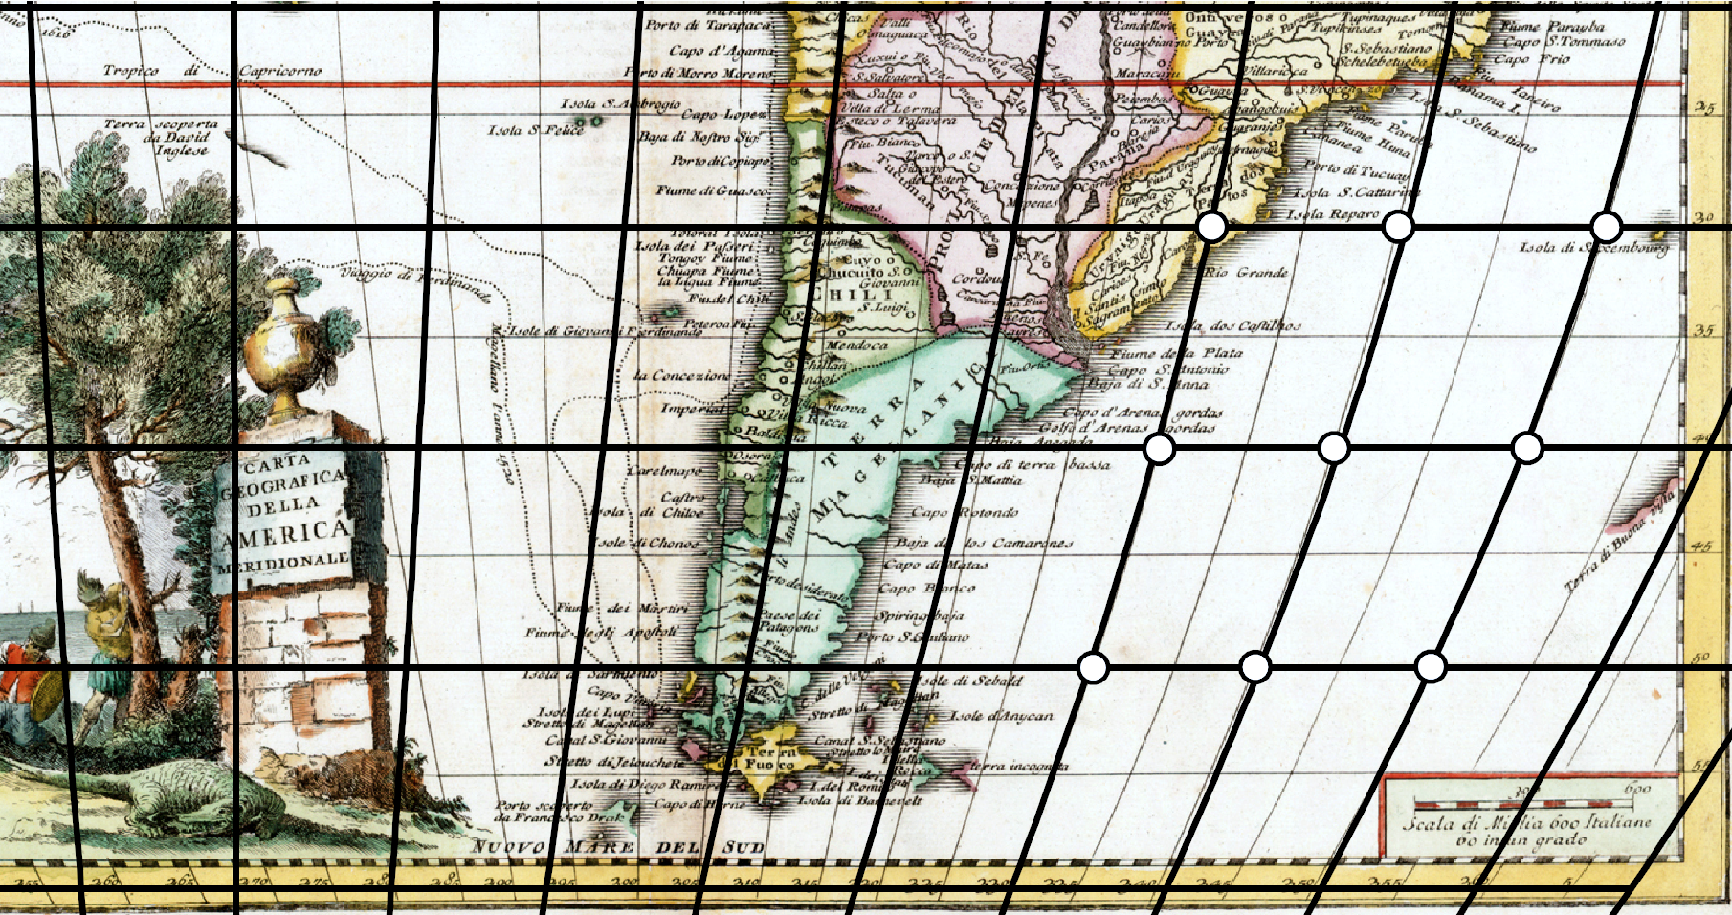

*Created with the Personal Edition of HelpNDoc:* [*Free Web Help generator*](http://www.helpndoc.com)

**Collect control points**

### How to collect control points

For the analysis at least 5 pairs of control points are necessary. To ensure the successful result of analysis, the acceptable inaccuracy in a position of points is about 3 mm on the map.

#### Main controls:

Left mouse click: add control point.

Right mouse click: delete the control point

Mouse wheel: Zoom in/out.

Left mouse drag: move the control point.

Right mouse drag: dynamic shift of the map.

#### Add a pair control points

A pair of control points is represented by the control point on the analyzed map and the control point on the reference map. Regardless the order in which control points are collected (analyzed map first and reference map second or vice versa) a pair will be added to the list.

1. Using mouse wheel or **Zoom in** tool  zoom the map and find a feature on the map suitable for the analysis. Check its depiction on the reference map.
2. In the toolbar, left-click on the **Add control points** tool  .
3. Move the cursor above the desired control point and press the left mouse button. Above the early map, the red control point mark. Analogously, the yellow control point mark appears.

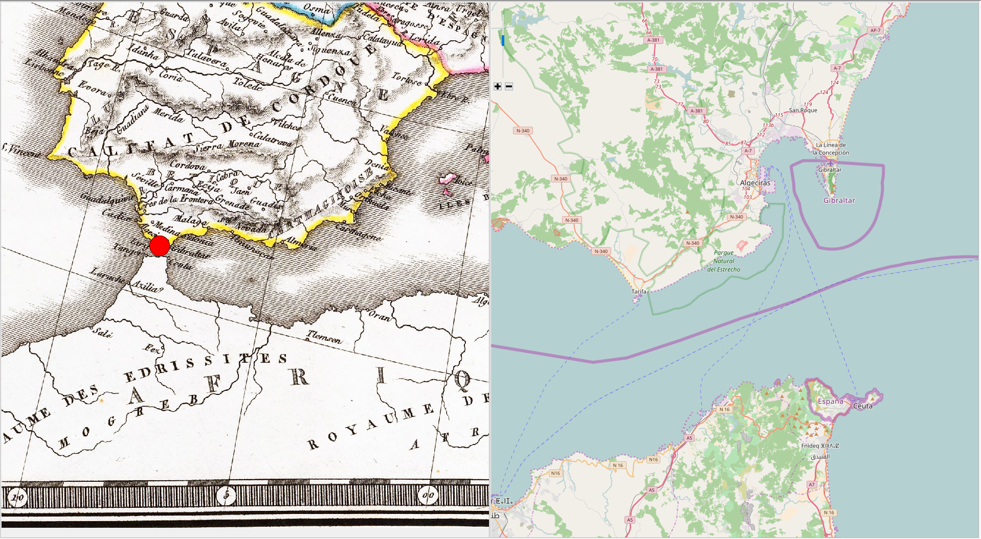

1. Move the cursor above the corresponding point on the second map and press the left mouse button. The control point mark appears.

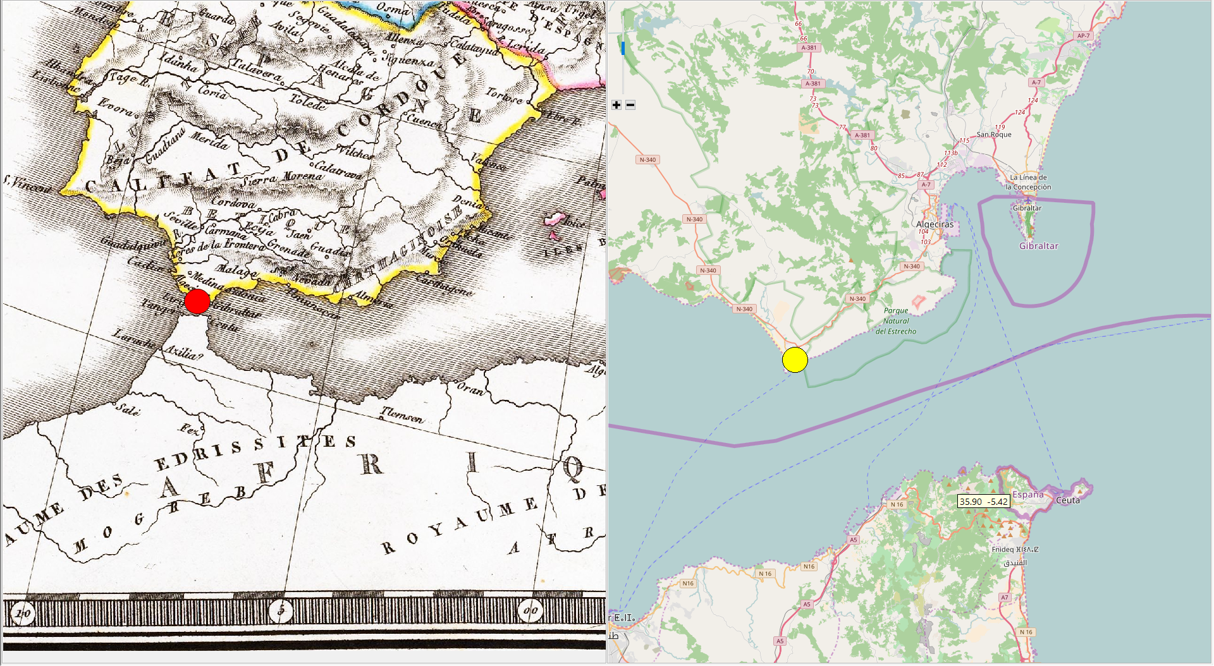

Repeat these steps until all control points are collected.

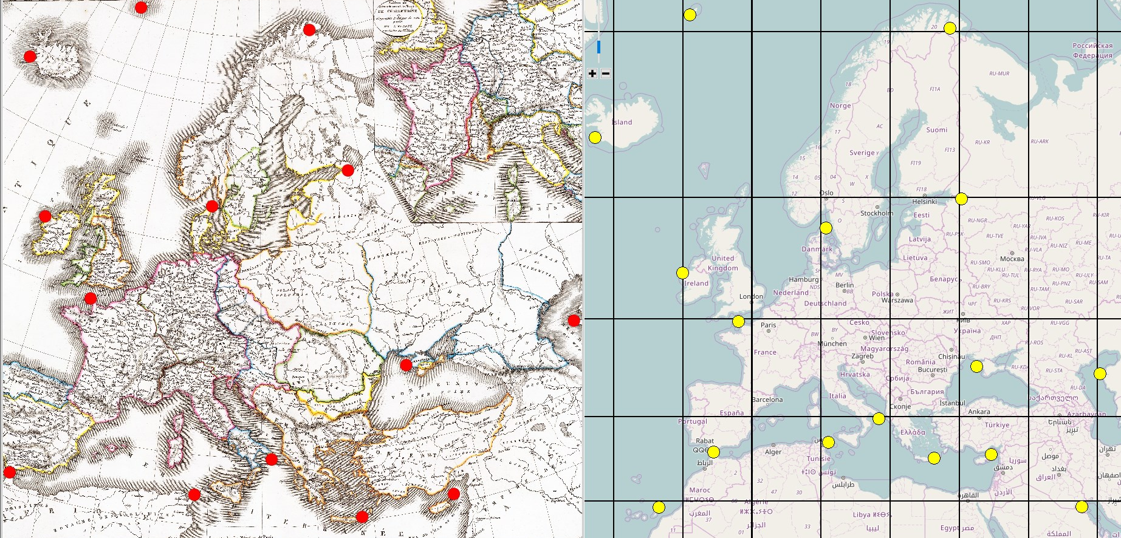

*Created with the Personal Edition of HelpNDoc:* [*Easy EPub and documentation editor*](http://www.helpndoc.com)

**Move control points**

### Move control point

* + - 1. Move the cursor above the desired control point, the pair of control points highlights. On the reference map, its geographic coordinates are displayed.

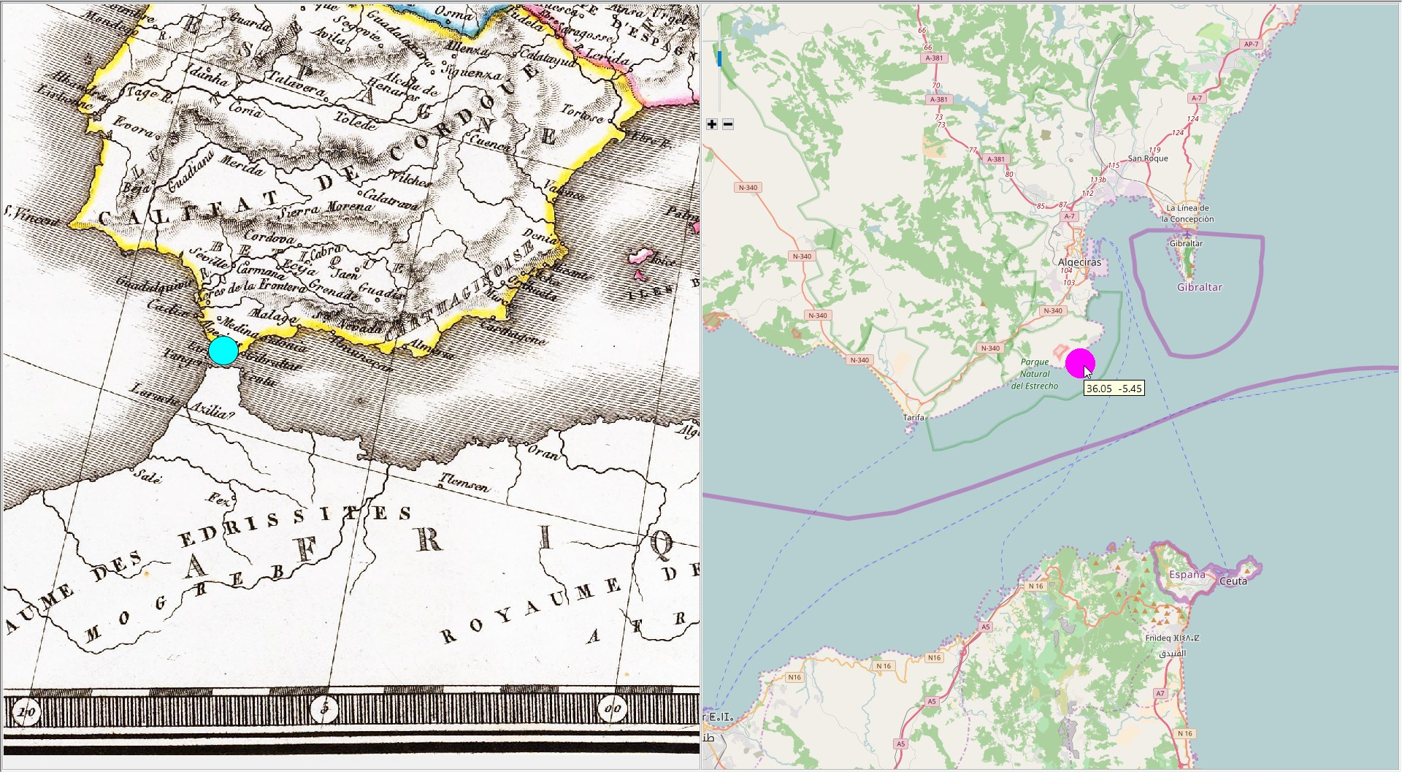

* + - 1. Drag the mouse and move the point to a destination position.

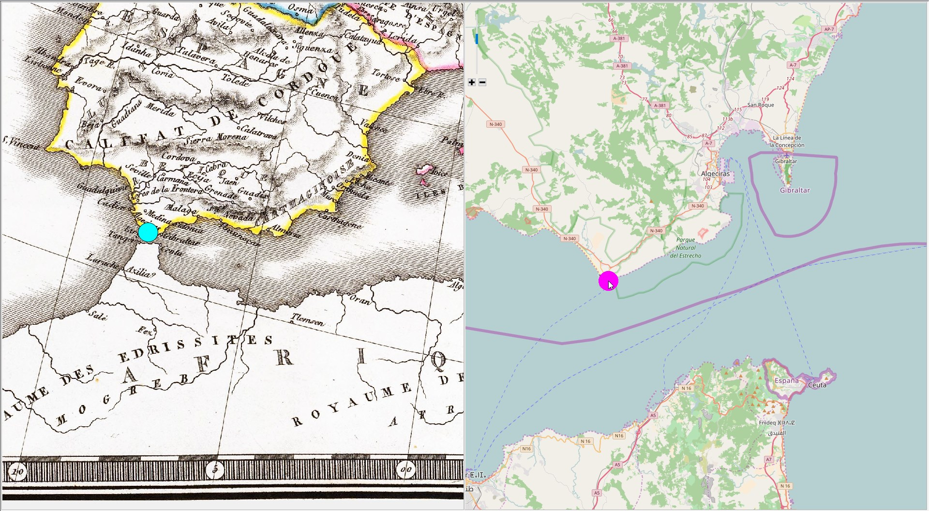

*Created with the Personal Edition of HelpNDoc:* [*Create HTML Help, DOC, PDF and print manuals from 1 single source*](http://www.helpndoc.com/help-authoring-tool)

**Delete control points**

### Delete control points

If a pair of control points is placed both points are deleted. If a single control points is placed, it will be deleted.

This operation can be done on the test/reference maps or from the **List of control points** form.

**Delete a pair of control points:**

* + - * 1. Move the cursor above the desired control point, the pair of control points highlights.  
             
           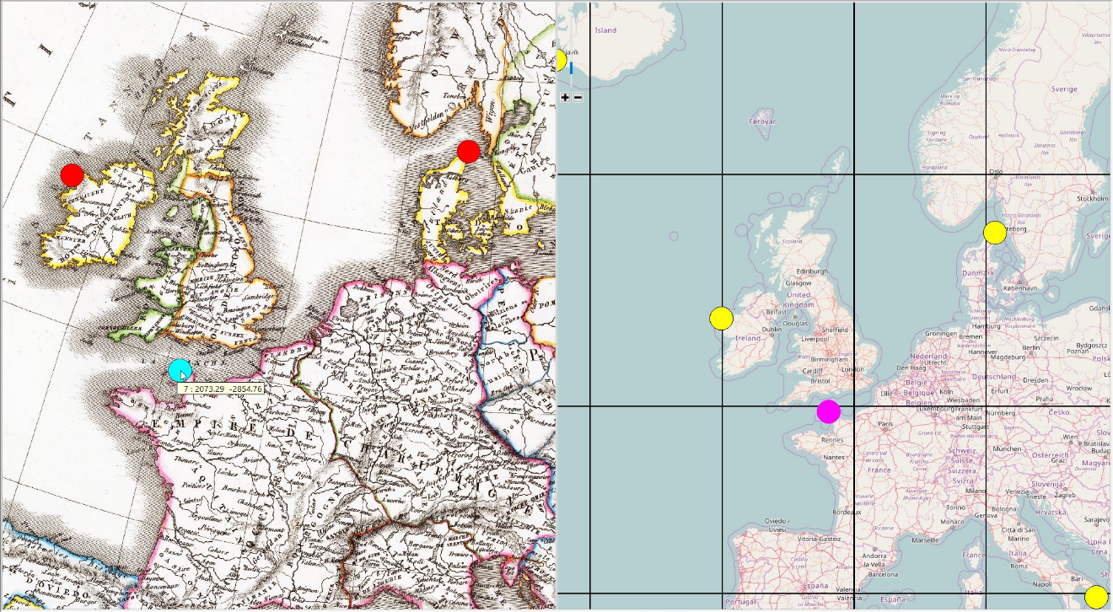
        2. The right button click opens the pop-up menu **Delete control points.**

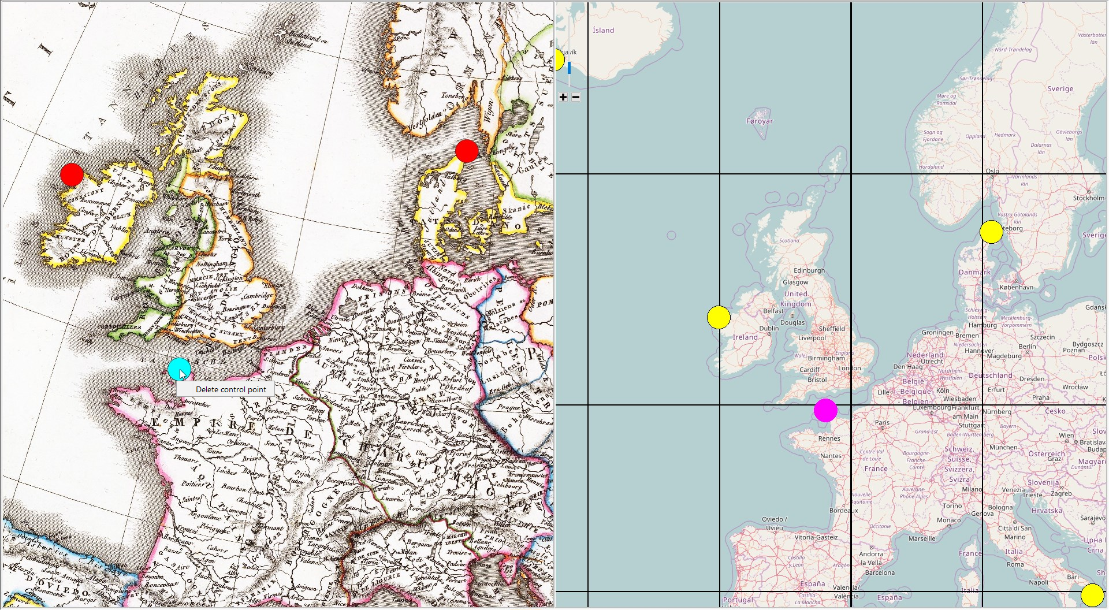

* + - * 1. Click on the **Delete control points** item in the pop-up menu, the control points will be deleted.

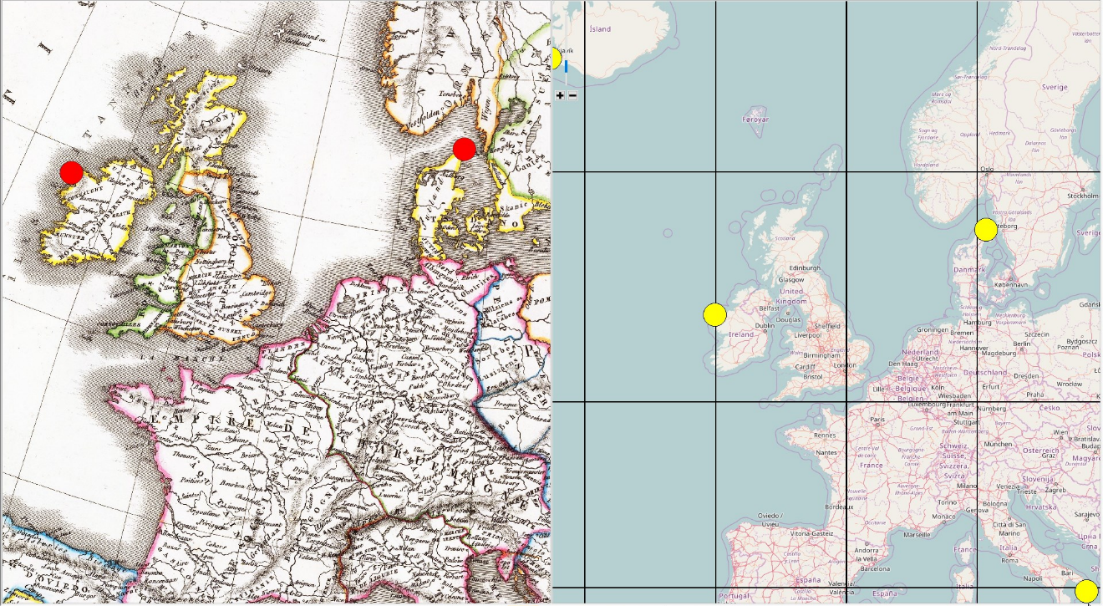

**Delete a control point:**

* + - * 1. Move the cursor above the desired control point, the control point highlights.
        2. The right button click opens the pop-up menu **Delete control points.**.
        3. Click in the menu item, the control point will be deleted.

*Created with the Personal Edition of HelpNDoc:* [*Full-featured Documentation generator*](http://www.helpndoc.com)

**List of control points**

### List of control points

The list of all control points, projected points and residuals can be found in the **List of control points and residuals** form.

It provides a simple management of control points and their properties.

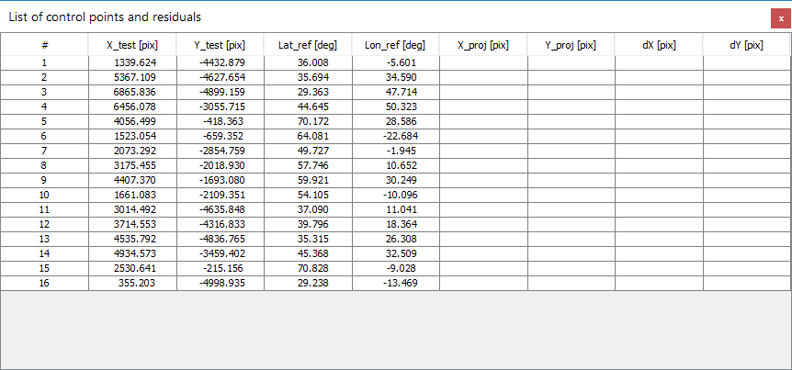

The [x_test, y_test] coordinates refer to the test points, [lat, lon] to the reference points.

If the analysis has been performed, the projected reference point coordinates [X_proj, Y_proj] as well as residuals [dX, dY] between the test and projected reference points are shown.

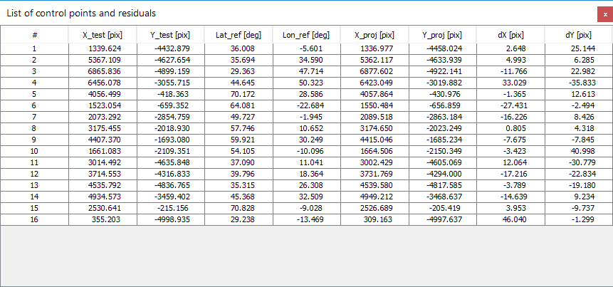

#### Show List of control points

* + - 1. Click in the **Point** menu, and select the **Show control points** item. Alternately, click on the  icon.
      2. Subsequently, the desired form **List of control points and residuals** appears.

#### Identify control point

* + - * 1. Click in the table, a row containing a pair of control points is selected.
        2. Concurrently, the pair of control points on the analyzed and reference map is highlighted.

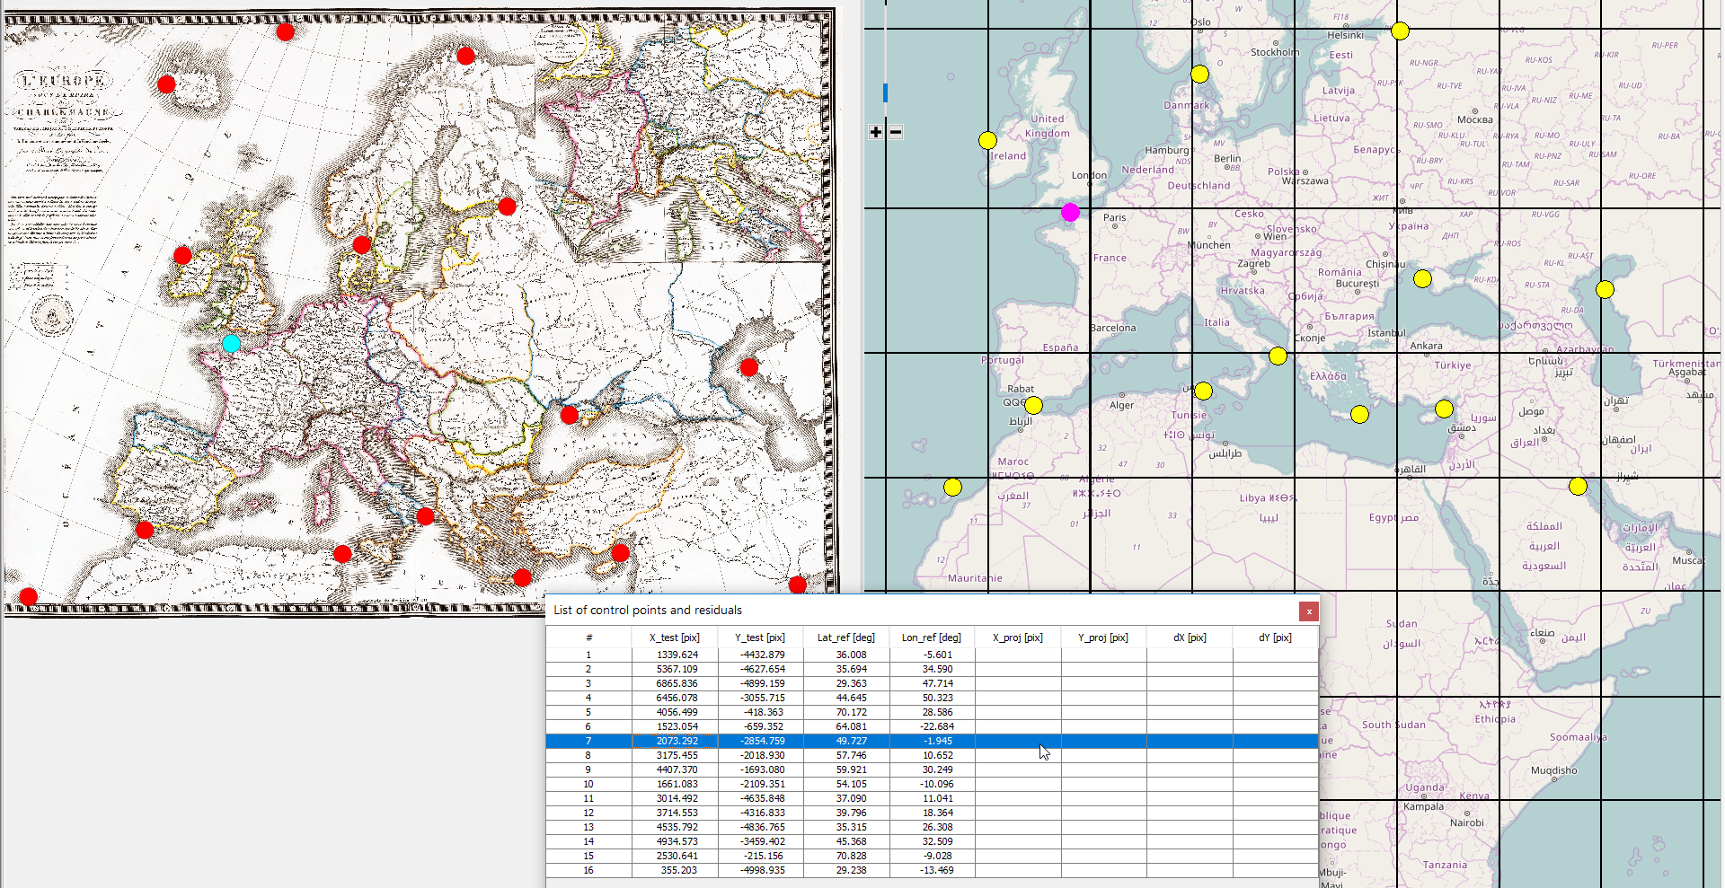

#### Delete control points

* + - * 1. Click in the table, a row containing a pair of control points is selected.
        2. The right button click displays the pop-up menu.  
             
           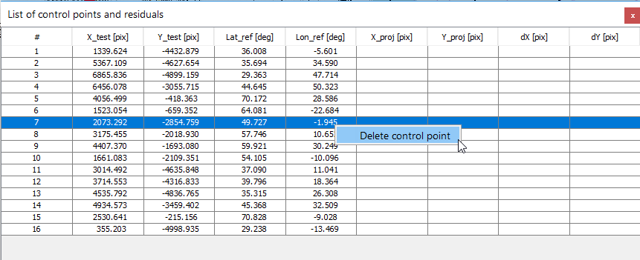
        3. Click on the **Delete control points** item and a pair of control points (or a control point) is removed.   
             
           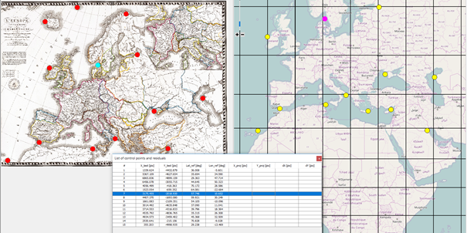

*Created with the Personal Edition of HelpNDoc:* [*Easily create EPub books*](http://www.helpndoc.com/feature-tour)

**Import control points**

## Import control points

The existing control points can be imported from a files.

**NOTE:**

**The import will always clear all control points and results. It is necessary to save the collected control points and exported graticules before importing new control points.**

*Created with the Personal Edition of HelpNDoc:* [*Single source CHM, PDF, DOC and HTML Help creation*](http://www.helpndoc.com/help-authoring-tool)

**Import test points**

### Import test points

For successful import, the control points on the analyzed map should be stored in the text file with the following structure:

X Y

The Cartesian coordinates X, Y are separated with the space or TAB, the decimal separator is “.”

Example of the test file:

1339.6242688888615 -4432.879354333257

5367.109497813664 -4627.653747619174

6865.835845129187 -4899.159199517434

6456.077699356876 -3055.7145981652457

4056.4985269128733 -418.36288676177685

The text file can be imported from the menu or using drag and drop operations.

#### Import test point file

* + - 1. Click in the **Point** menu, and select the **Import test points** item. Alternately, click on the  icon.
      2. In the dialog window **Import test points** select the input TXT file.

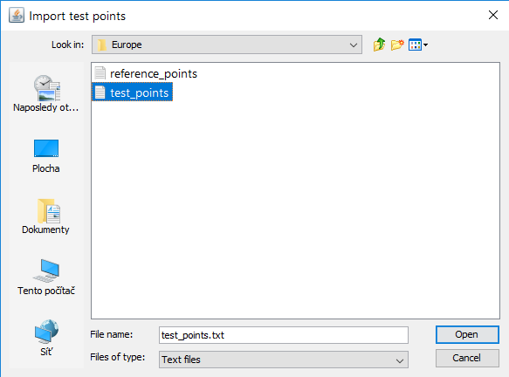

* + - 1. Click on **Open button** to import the early map coordinate file... The imported points are drawn above the analyzed map.

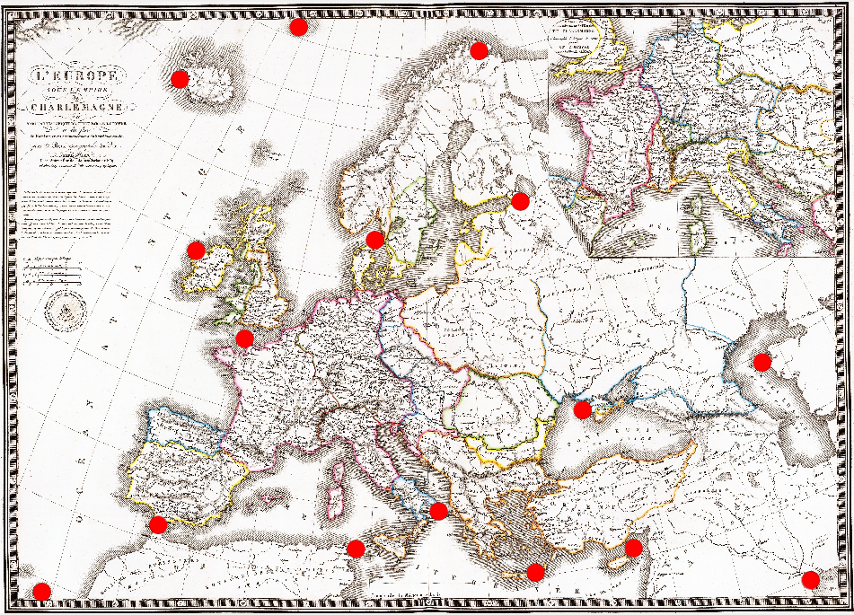

#### Import test point file using drag and drop

1. In the **Windows Explorer** or any two-panel file manager (Total Commander, Free Commander, muCommanser) select the test file (*.TXT file).  
     
   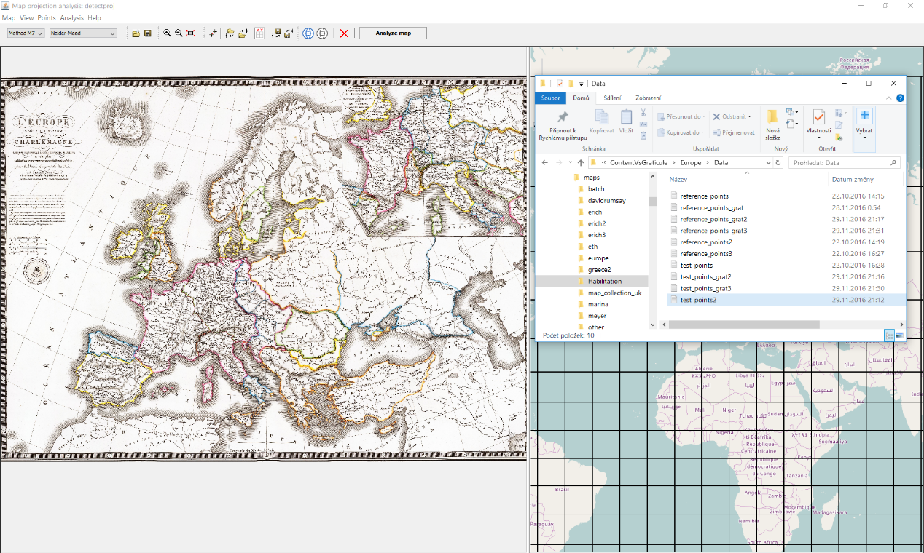
2. Drag the file and drop it over the analyzed map. During the procedure, the drag indicator *Move* is drawn.  
     
   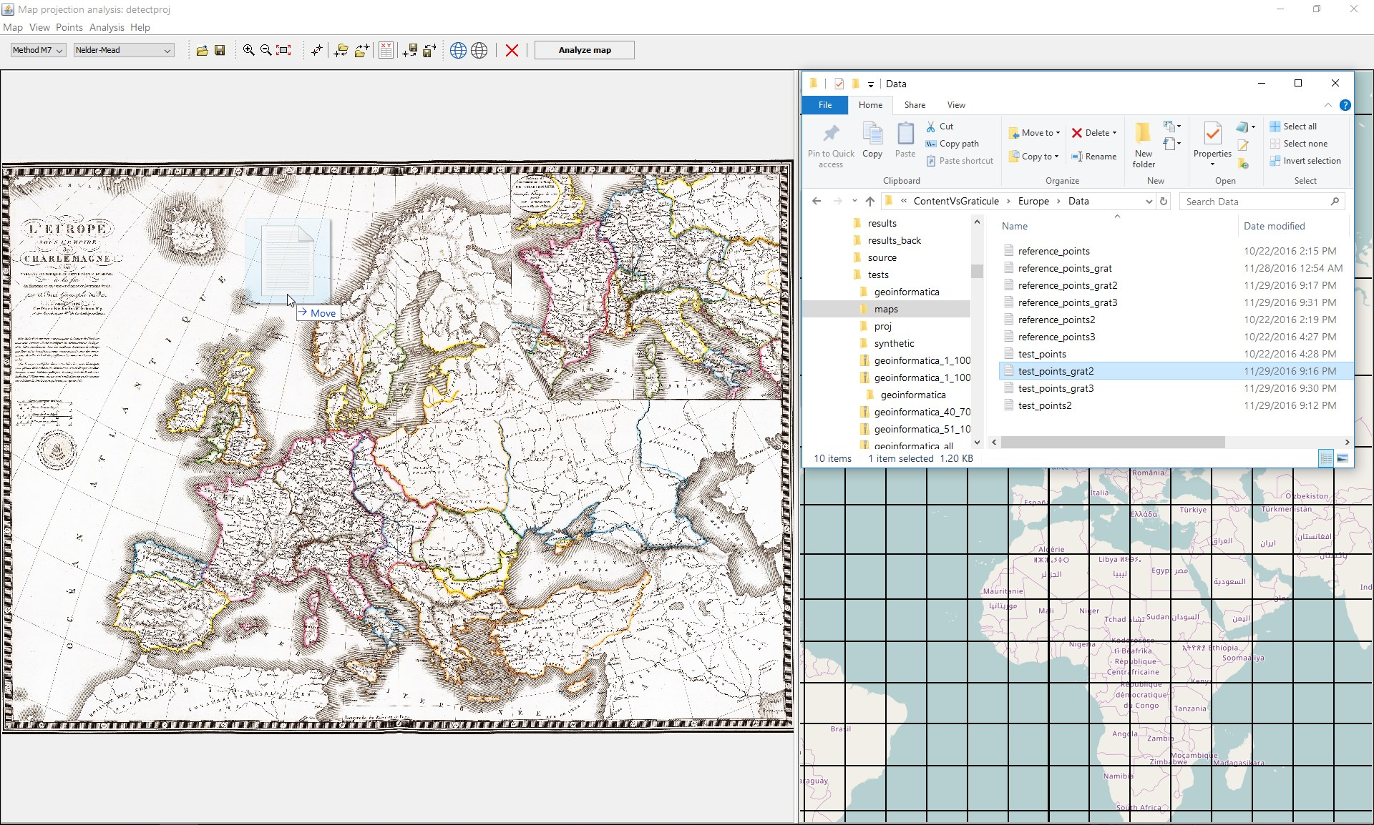
3. Subsequently, the list of test points is drawn.  
     
   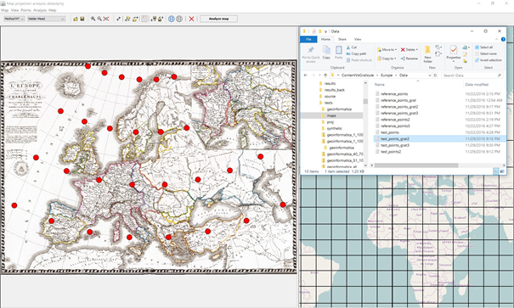

*Created with the Personal Edition of HelpNDoc:* [*What is a Help Authoring tool?*](http://www.helpauthoringsoftware.com)

**Import reference points**

### Import reference points

For successful import, the control points on the reference map should be stored in the text file the following structure:

lat lon

The spherical coordinates lat, lon are separated with the space or TAB, the decimal separator is “.”

Example of the reference file:

36.00800626603582 -5.6009674072265625

35.69410994928452 34.5904541015625

29.363027037783755 47.713623046875

44.64520822374404 50.3228759765625

70.1720640322536 28.58642578125

The text file can be imported from the menu or using drag and drop operations.

#### Import reference point file

* + - 1. Click in the **Point** menu, and select the **Import reference points** item. Alternately, click on the  icon.
      2. In the dialog window **Import reference points** select the input TXT file.

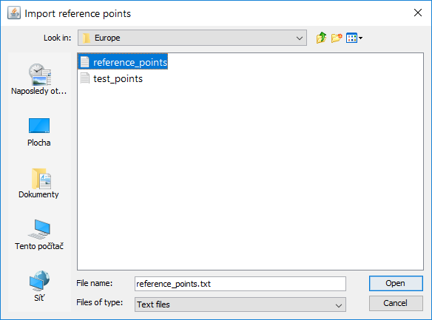

* + - 1. Click on **Open button** to import the early map coordinate file... The imported points are drawn above the reference map.

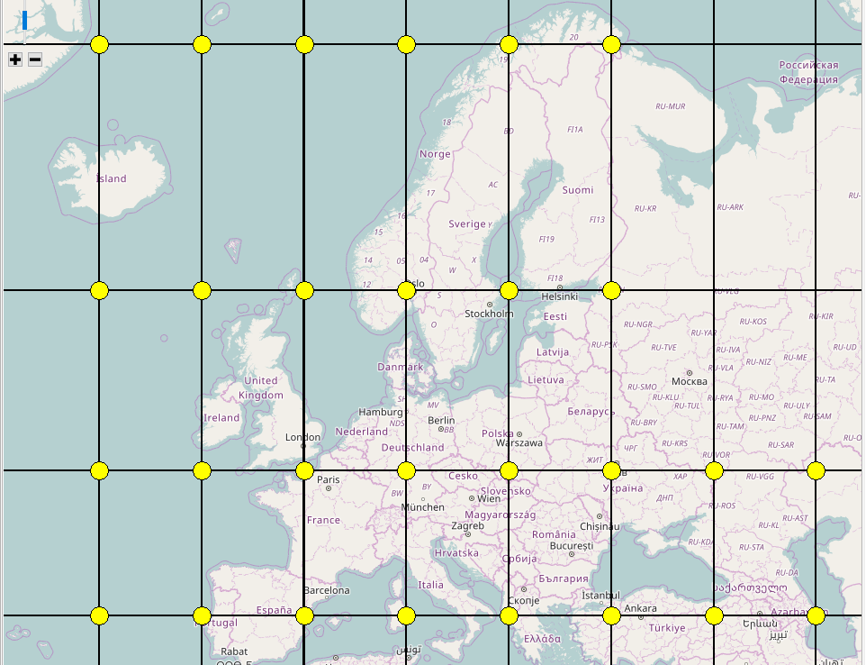

#### Import reference point file using drag and drop

1. In the **Windows Explorer** or any two-panel file manager (Total Commander, Free Commander, muCommanser) select the reference file (*.TXT file).  
     
   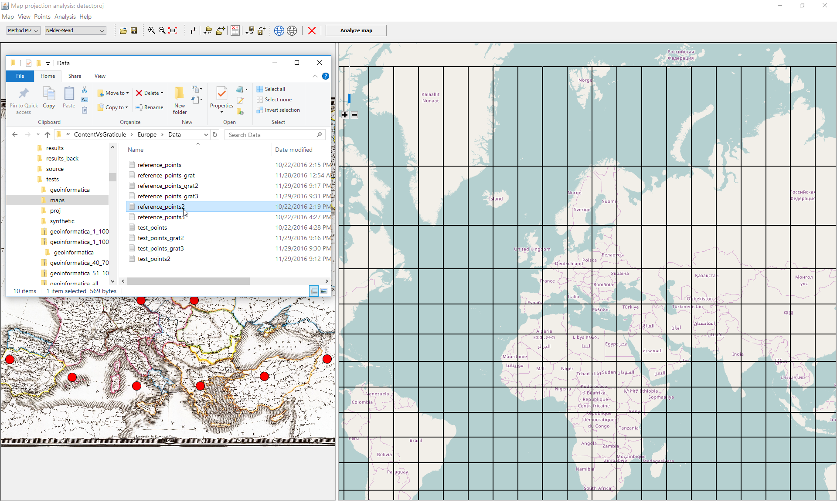
2. Drag the file and drop it over the analyzed map. During the procedure, the drag indicator *Move* is drawn.  
     
   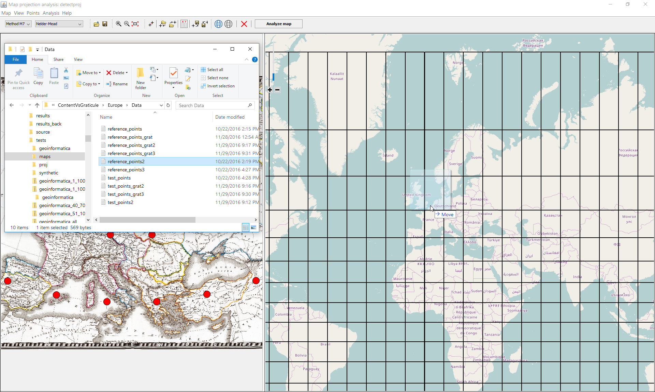
3. Subsequently, the list of reference points is drawn.  
     
   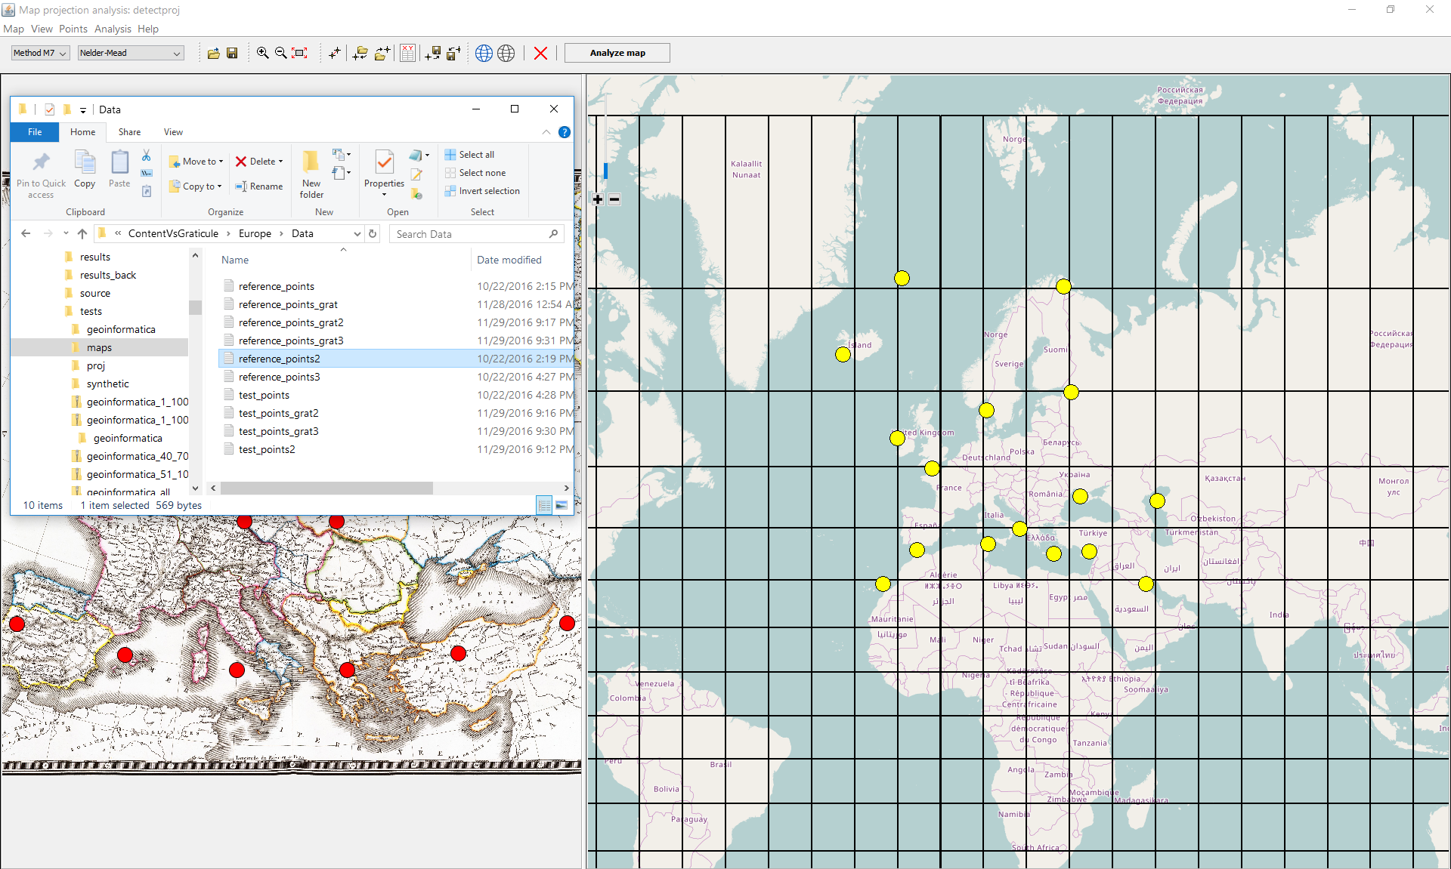

*Created with the Personal Edition of HelpNDoc:* [*Single source CHM, PDF, DOC and HTML Help creation*](http://www.helpndoc.com/help-authoring-tool)

**Export control point**

## Export control points

The test as well as reference points can be saved into separate TXT files.

*Created with the Personal Edition of HelpNDoc:* [*Easily create PDF Help documents*](http://www.helpndoc.com/feature-tour)

**Export test points**

### Export test points

* + - 1. Click in the **Point** menu, and select the **Export test points** item. Alternately, click on the  icon.
      2. In the dialog window **Export test points** select the output TXT file.

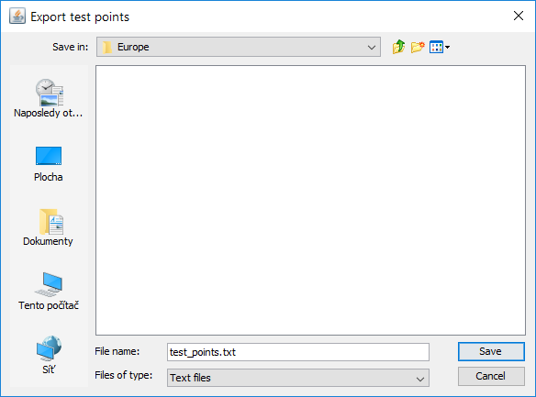

* + - 1. Click on **Save** button to export the test points into the desired TXT file.

*Created with the Personal Edition of HelpNDoc:* [*iPhone web sites made easy*](http://www.helpndoc.com/feature-tour/iphone-website-generation)

**Export reference points**

### Export reference points

* + - 1. Click in the **Point** menu, and select the **Export reference points** item. Alternately, click on the  icon.
      2. In the dialog window **Export reference points** select the output TXT file.   
           
         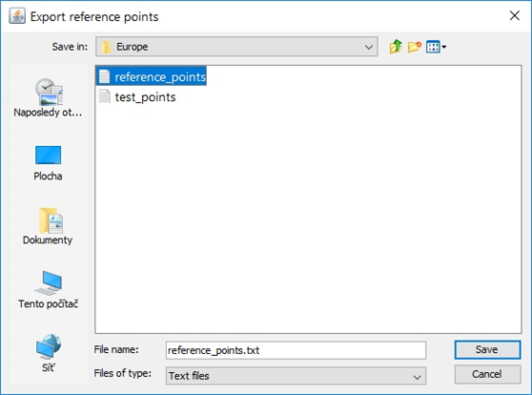

* + - 1. Click on **Save** button to export the reference points into the desired TXT file.

*Created with the Personal Edition of HelpNDoc:* [*Generate EPub eBooks with ease*](http://www.helpndoc.com/create-epub-ebooks)

**Perform analysis**

## Perform analysis

Before analysis, the following sub-steps need to be done:

* selection of the detection method,
* selection of the optimization technique.

At least 5 pairs of control points need to be collected.

*Created with the Personal Edition of HelpNDoc:* [*Easily create HTML Help documents*](http://www.helpndoc.com/feature-tour)

**Select detection method**

### Selection of the detection method

Before analysis it is necessary to select the detection method.

* + - * 1. From the Combo Box select the desired the detection method.   
             
           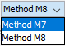  
             
           Alternately, click in the **Analysis** menu, and choose the detection method.

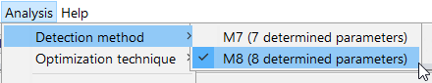

* + - * 1. Click in selected item, the highlighted method is checked and set as active.

Recall that M7 is recommended for the unrotated maps. This option is suitable for most situations.

On the contrary, M8 achieves the best results for the rotated maps (a map rotation *a* is involved). This is typical for situations, when the map is incorrectly placed into the scanner or has a switched orientation on the page.

**NOTE: Although M8 brings lower residuals, some solutions might be artificial and represent only a geometric construct not used by the cartographer.**

*Created with the Personal Edition of HelpNDoc:* [*Produce electronic books easily*](http://www.helpndoc.com/create-epub-ebooks)

**Select optimization technique**

### Selection of the optimization technique

Subsequently, the optimization technique needs to be chosen.

* + - * 1. From the Combo Box select the desired the optimization technique.   
             
           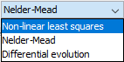  
             
           Alternately, click in the **Analysis** menu, and choose the optimization technique.

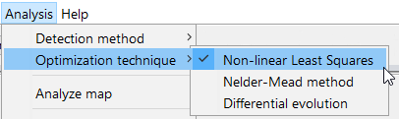

* + - * 1. Click in selected item, the highlighted technique is checked and set as active.

Recall that NLS method represents the convex optimization technique which does not ensure the global minimum; only local minimum is found.

The direct search technique, Nelder-Mead optimization, belongs to the global optimization methods. Due to small population, the global minimum may not be found. However, it is the fastest method. This option is suitable for most situations.

The differential evolution is the most efficient implemented technique performing a deep exploration of the search space. Unfortunately, it is also the slowest technique.

*Created with the Personal Edition of HelpNDoc:* [*Write eBooks for the Kindle*](http://www.helpndoc.com/feature-tour/create-ebooks-for-amazon-kindle)

**Run analysis**

### Run analysis

Recall that at least five pairs of control points need to collected. Due to the time reason, do not use more than 30 control points.

There are also several above mentioned recommendations on the control points that must be respected.

Click on the  button. Alternately, click in the **Analysis** menu, and choose the **Analyze map** item.

Depending on the amount of analyzed points, selected detection method and optimization technique, the results are evaluated within 10 seconds.  
  
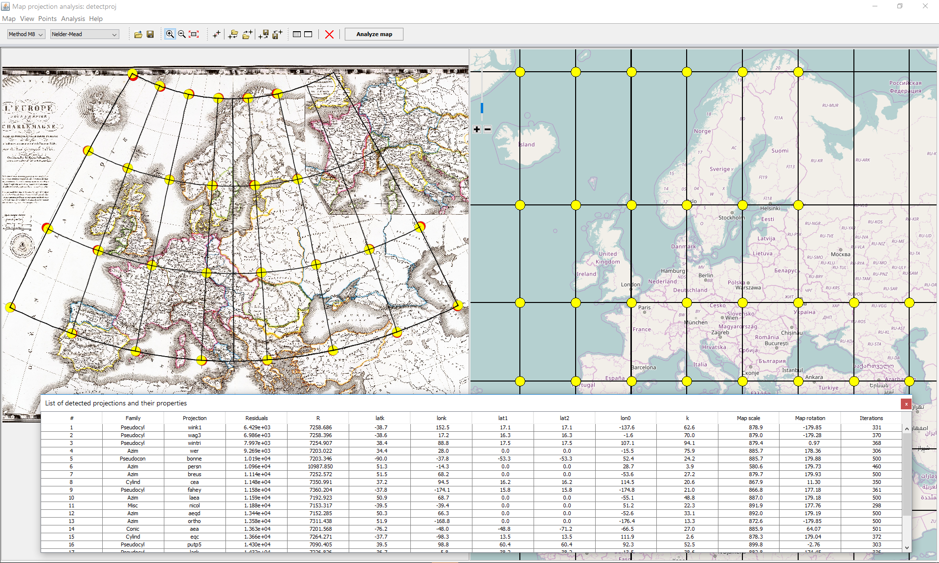  
  
Subsequently, the table **List of detected projections and properties** with the 20 best-fit candidate projections appears.   
  
The reconstructed graticule as well as reconstructed points and the vector of residuals drawn over the analyzed map refer to the best fit projection.

*Created with the Personal Edition of HelpNDoc:* [*Full-featured EPub generator*](http://www.helpndoc.com/create-epub-ebooks)

**Browse results**

### Browse results

Let's look more closely at the results provided by the detectproj software.

**Residuals.** The residuals between the test and projected points can be found in the form **List of control points** form. The possible incorrectly placed control points can be found, moved, or rejected.



**Reconstructed graticule.** The reconstructed graticule is drawn over the analyzed. Depending on the early map, amount of control points, their accuracy, it provides a good fir. Ideally, the positional or shape discrepancies between the early map and reconstructed graticule should be less than the graphical accuracy of the map (0.1 mm) However, there might be some situations, when the results are not great.

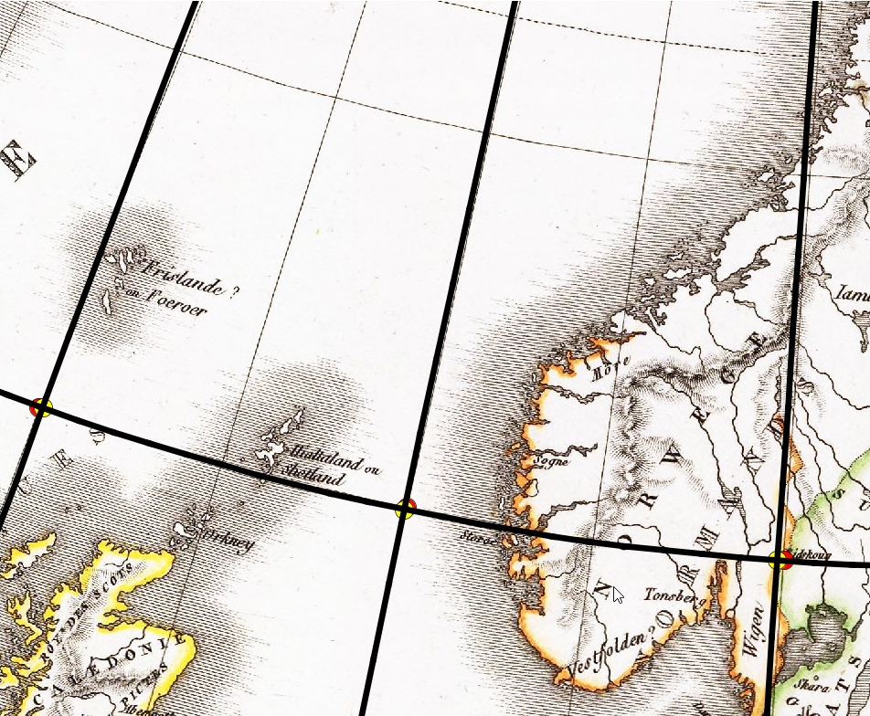

**Projected reference points**. The reference points, drawn with the yellow map markers, projected using the best fit projection, are drawn over the analyzed map. In most situation there is a good fit between the test and projected reference points.

**Vector of residuals.** The vectors of residuals between the test and projected reference points are drawn over the analyzed map. Currently, they are visible only under magnification which indicates a good fit.

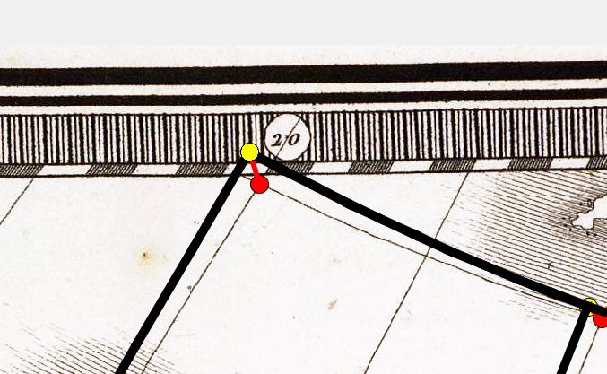

#### Table List of detected projections and properties.

The table summarize results of 20 best-fit projections, their determined parameters as well as the parameters of the analyzed map.



 Position of the projection depending on the objective function value.

 Projection family.

 Projection name.

 Value of the objective function (square of residuals) *f*(x).

 Auxiliary sphere radius *R*′.

 Transformed pole latitude *φk*.

 Transformed pole longitude *λk*.

 Standard parallel of latitude *φ*1.

 Standard parallel of latitude *φ*2.

 Longitude of the central meridian *λ0*.

 Arbitrary constant parameter of the projection *κ*.

 Map scale *S*.

 Map rotation *α*.

 Amount of iterations.

#### Display results of different projections

After completing the analysis 20 candidate projections and their parameters are summarized in the table **List of detected projections and properties**. Currently, the reconstructed graticule, projected points and vector of residuals refer to the best-fit projection. To change the active projection do the following steps

Click on the  button. Alternately, click in the **Analysis** menu, and choose the **Show results** item.  
  
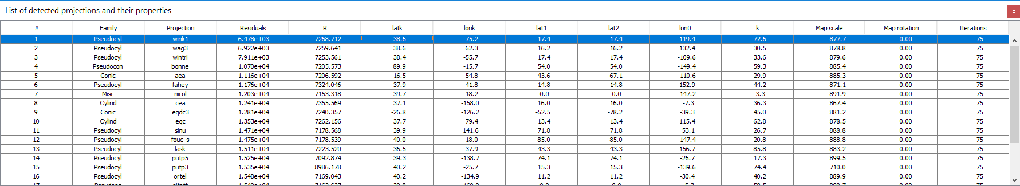

* + - 1. Find the desired projection in the table **List of detected projections and properties**.
      2. In the table, click on the row and make the projection active; the table row which highlights.

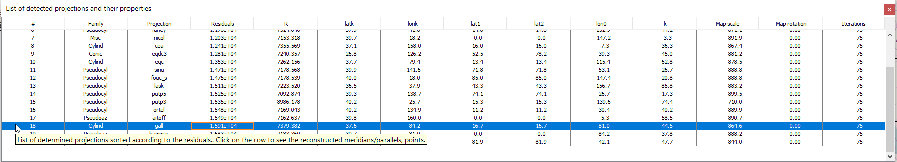  
  
Subsequently, the reconstructed graticule, projected points and residuals refer to the active projection.

The differences between candidate projections are not crucial. Sometimes, the positional differences are less than the graphical accuracy of the map. For example, see the results between the Bonne projection (4th position, normal aspect)

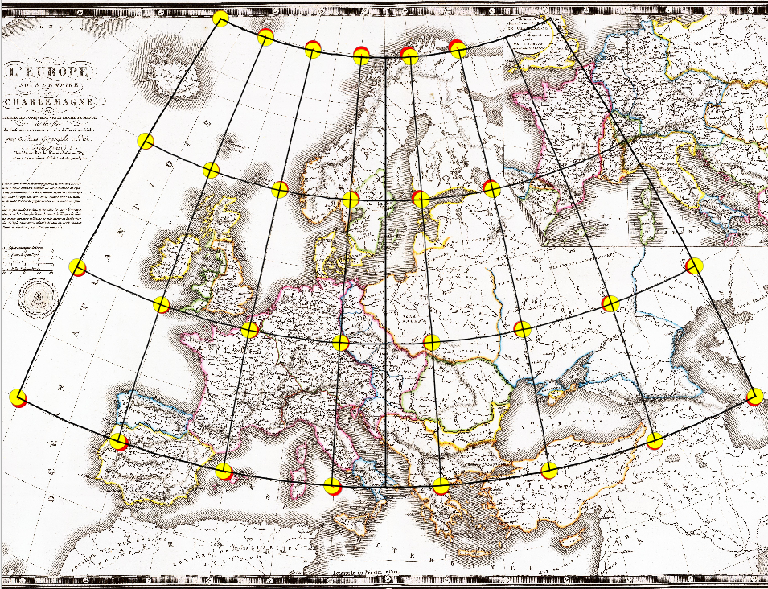

and Gall projection (oblique aspect, 18th position).

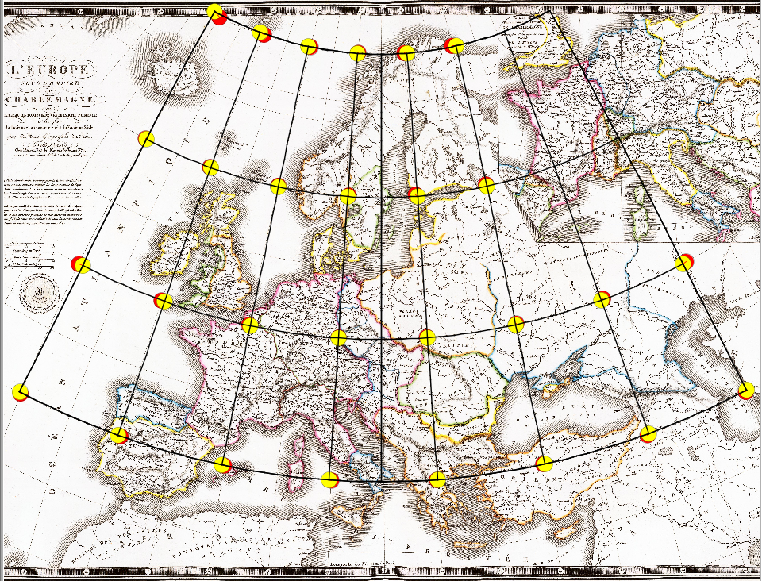  
  
Unlike the Bonne projection with the curved meridians, the Gall projection uses straight parallels.

*Created with the Personal Edition of HelpNDoc:* [*Generate EPub eBooks with ease*](http://www.helpndoc.com/create-epub-ebooks)

**Clear results**

### Clear results

To clear the results represented by the candidate projections, reconstructed graticules and projected reference points, click on the  button. Alternately, click in the **Analysis** menu, and choose the **Clear results** item.  
  
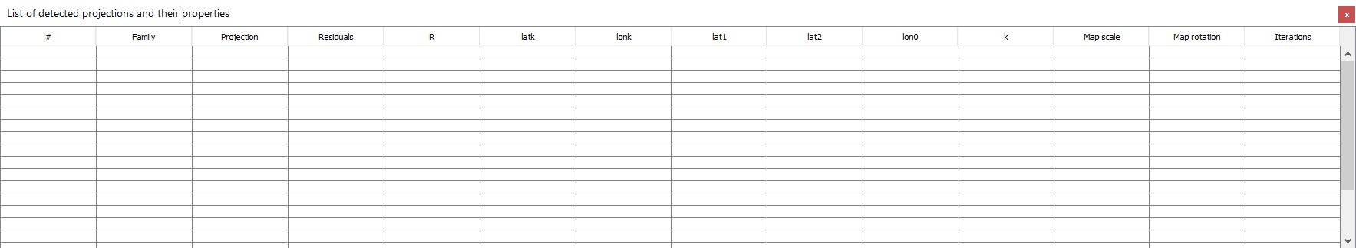

All above mentioned items will be deleted, only the control points remain.

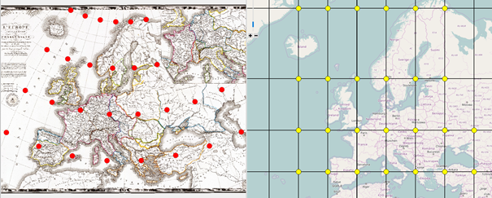

*Created with the Personal Edition of HelpNDoc:* [*Free EBook and documentation generator*](http://www.helpndoc.com)

**Clear all**

### Clear all

All candidate projections, reconstructed graticules, projected reference points, and control points will be deleted.

**NOTE:**

**The deleted data can not be restored! To avoid the data loss use this feature carefully!**

1. Click on the  button. Alternately, click in the **Analysis** menu, and choose the **Clear all** item. The confirmation dialog is shown.

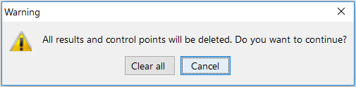

1. Click on the **Clear all** button and all unsaved data will be deleted, only the analyzed map remains.

*Created with the Personal Edition of HelpNDoc:* [*Single source CHM, PDF, DOC and HTML Help creation*](http://www.helpndoc.com/help-authoring-tool)

**Export reconstructed graticule**

## Export reconstructed graticule

The reconstructed graticule, test, and reference projected points can be extracted to the DXF file. It can be processed by CAD or GIS software.

In the DXF file, the following layers are created:

*Meridians Reconstructed meridians*

*Parallels Reconstructed parallels*

*Meridian_labels Labels for meridians represented by longitudes.*

*Parallel_labels Labels for parallels represented by latitudes.*

*Test_points Drawn test points*

*Test_point_labels Labels for test points represented by point numbers*

*Reference_points_proj Projected reference points*

*Reference_points_proj_labels Labels for projected reference points*

### Export to the DXF file

Any candidate projection from the **List of detected projections and properties**  may be used to project the reference points and to create a graticule.

* + - 1. Click on the  button. Alternately, click in the **Analysis** menu, and choose the **Show results** item.
      2. In the table, click on the row and make the projection active; the table row is highlighted.  
           
         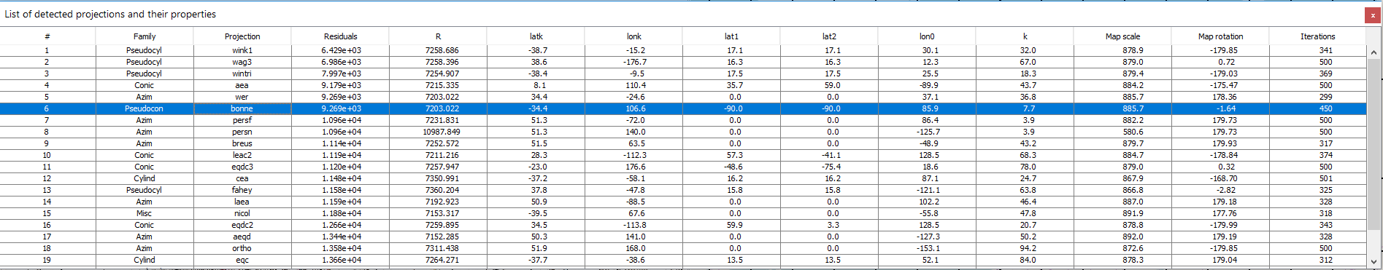
      3. Click in the **Map** menu, and select the **Export graticule** item. Alternately, click on the  icon.
      4. In the dialog window **Export test points** select the output DXF file.   
           
         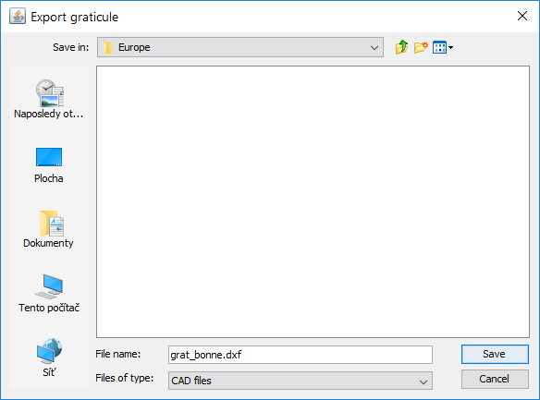
      5. Click on the **Save** button proceeds the export.

### Import DXF file into ArcGIS

To export the created DXF file as well as the analyzed map into ArcGIS, do the folowing steps:

1. Run ArcGISand create an empty project.  
     
   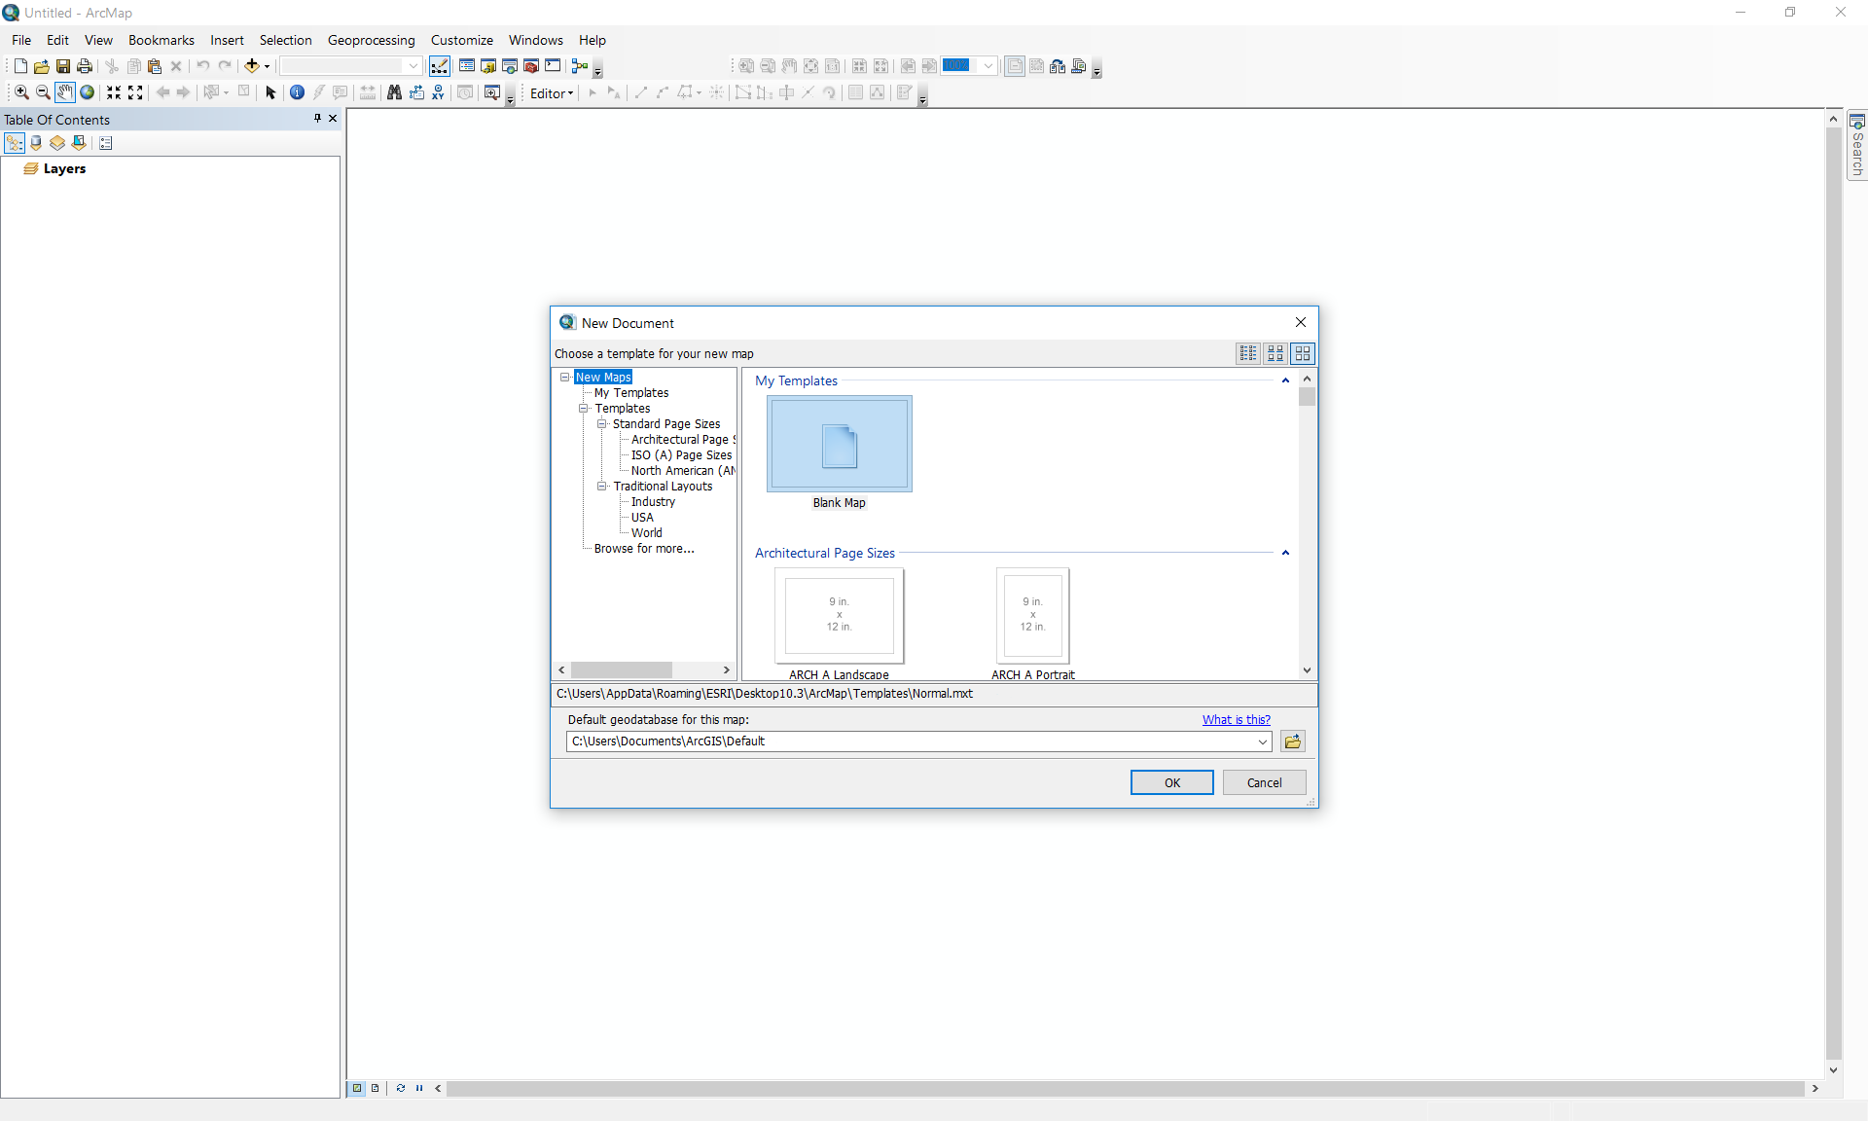
2. In the ArcCatalog select the early map and drag the file into ArcGIS.  
     
    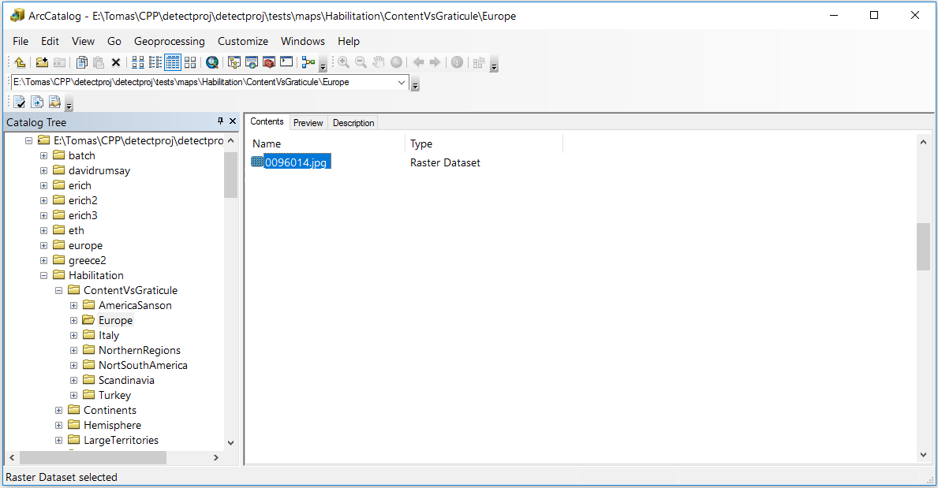   
     
   The raster file is displayed.  
     
   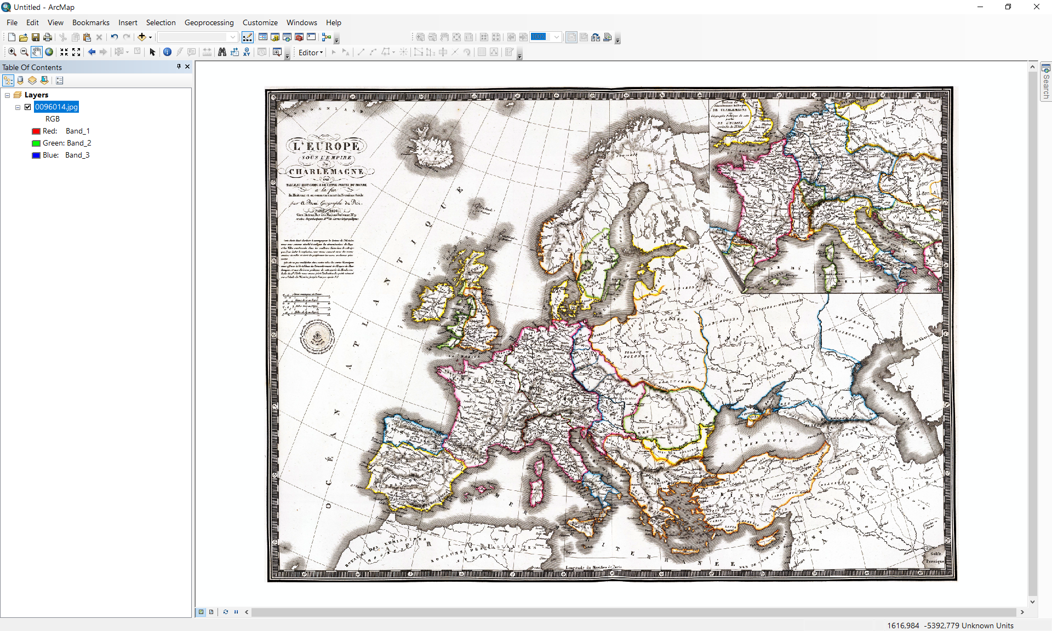
3. In the ArcCatalog select the DXF file and drag it into ARCGIS.   
     
   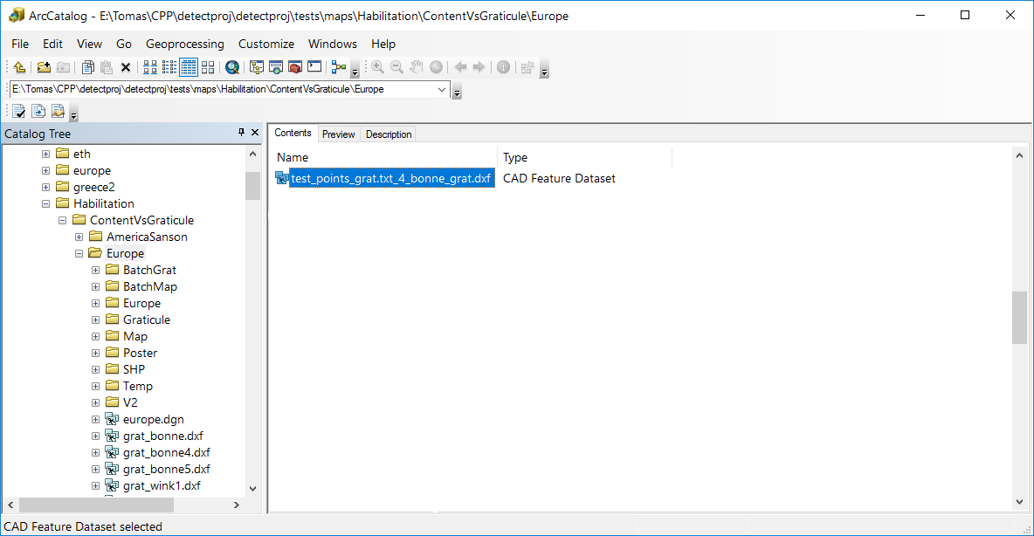
4. The DXF file is displayed above the analyzed map.

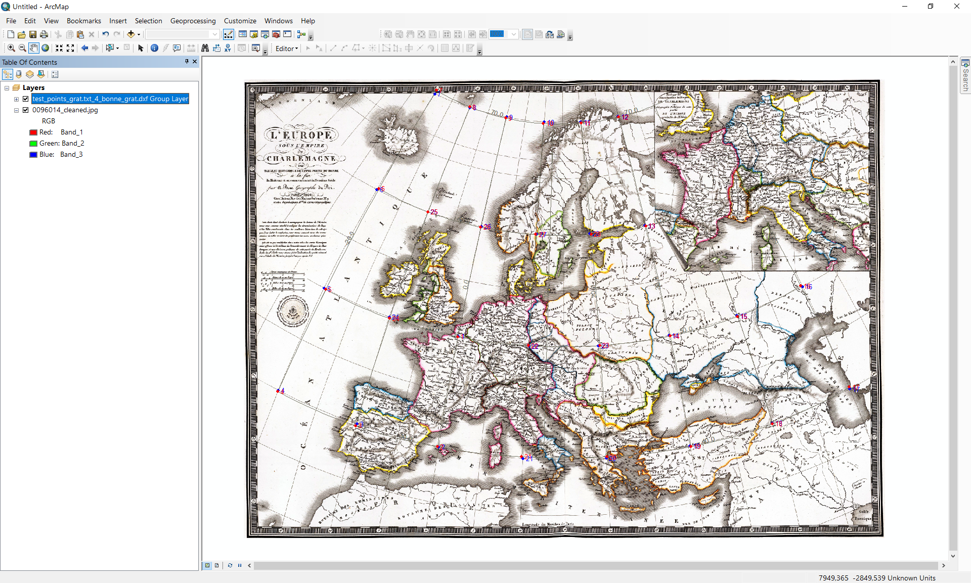

1. To make vector drawing more readable, change the DXF file attributes. Initially, set the size of the point size.   
     
   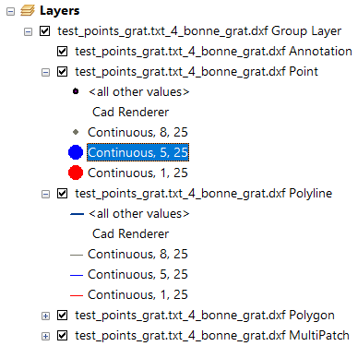  
     
   Subsequently, change the line width.  
     
   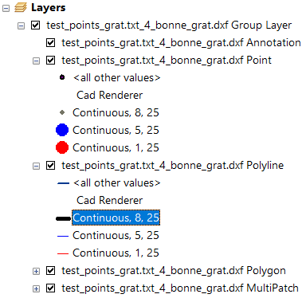

The vector drawing with changed attributes becomes more readable.  
  
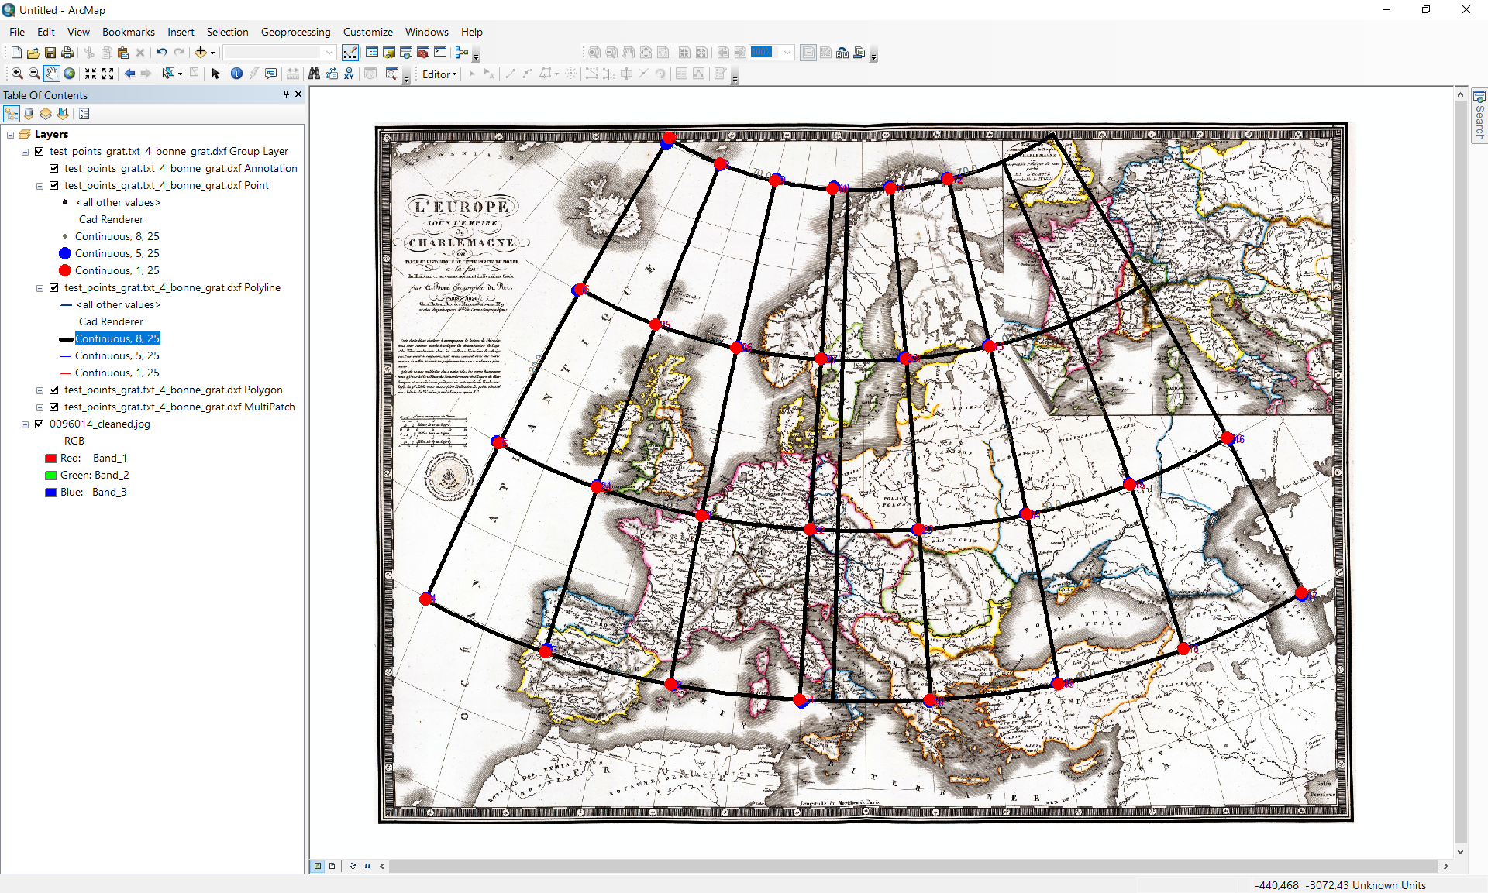

*Created with the Personal Edition of HelpNDoc:* [*Easily create Help documents*](http://www.helpndoc.com/feature-tour)

**Georeferencing analyzed map in ArcGIS**

## Georeference of the analyzed map in ArcGIS

Georeferencing assigns spatial information to each pixel of the map so as it aligns to a known projected coordinate system. In georeferencing small-scale-maps, it is impossible to transform the analyzed map to the reference map coordinate system directly and neglect the influence of the different map projections, unless both projections are the same or very similar. While the linear transformations cannot correct the impact of the distortions, increasing the order of the transformation does not lead to any reasonable result. The higher-order transformation causing the secondary deformation and twist of the map content cannot be used.

Suppose that the analyzed map in Bonne projection needs to be georeferenced (reprojected) to the Mercator projection in ArcGIS software. The determined map projection ℙ parameters are:

*Transformed pole position: φk* = 90.0○, *λk* = 0.0○.

*Standard parallels: φ*1 =53. 5○, *φ*2 =53. 5○.

*Longitude of the central meridian: λ*0 = 14.7○.

*Arbitrary constant parameter: k = 1.0.*

*Auxiliary sphere radius: R*′*= 7202.73m.*

*Map scale:* *S* = 885.8.

*Angle of rotation: α = 0.00.*

The central meridian refers to Paris, so the parallels are shifted by *λ*s = 2.337229167○.

**NOTE:**

**In ArcGIS, only the normal aspect of the projected is supported. Moreover, the map rotation a is not supported. Therefore, only M7 results may be utilized.**

### Reproject the analyzed map into Mercator projection

The following steps need to be performed:

1. Analyze the map projection.
2. Creating graticule above the analyzed territory projection to the fishnet.
3. Densify graticule.
4. Assign spherical coordinates to the graticule.
5. Project graticule to Bonne projection.
6. Georeferencing of the early map.
7. Reprojection from Bonne to World Mercator.

### Analyze map projection

Initially, the projection analysis needs to be run:

1. Upload the raster file representing the analyzed map.
2. Collect control points and run the projection analysis.
3. Store the determined parameters of the projection. Subsequently, they will be used to project the raster.

*Created with the Personal Edition of HelpNDoc:* [*Single source CHM, PDF, DOC and HTML Help creation*](http://www.helpndoc.com/help-authoring-tool)

**Creating graticule above the analyzed territory**

### Creating graticule above the analyzed territory

For the graticule construction in ArcGIS, the create fishnet function will be utilized.

1. Run ArcGIS and create the new empty project.
2. From the **System Toolboxes** **select Data Management Tools/Feature Class** select the **Create Fishnet** item; the dialog window appears.   
     
   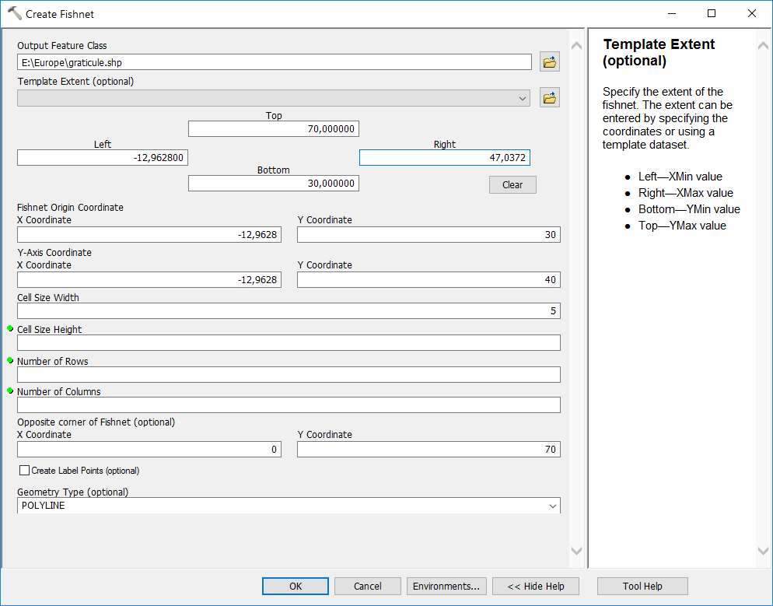
3. In the **Create Fishnet** form, set the graticule properties. Considering the central meridian shift *λ*s = 14.7○, the geographic extent of the graticule is set as:  
     
   *Top*: 70  
   *Left*: -30 +14.7 +2.3372 = -12.9628  
   *Right*: 30+ 14.7 +2.3372 = 47.0372  
   *Bottom*: 30

Set the longitude and latitude directions Dj = Dl = 5○:  
  
 *Cell Size Width*: 5

*Cell Size Height*: 5

1. Click on the OK button, the graticule will be created.  
     
   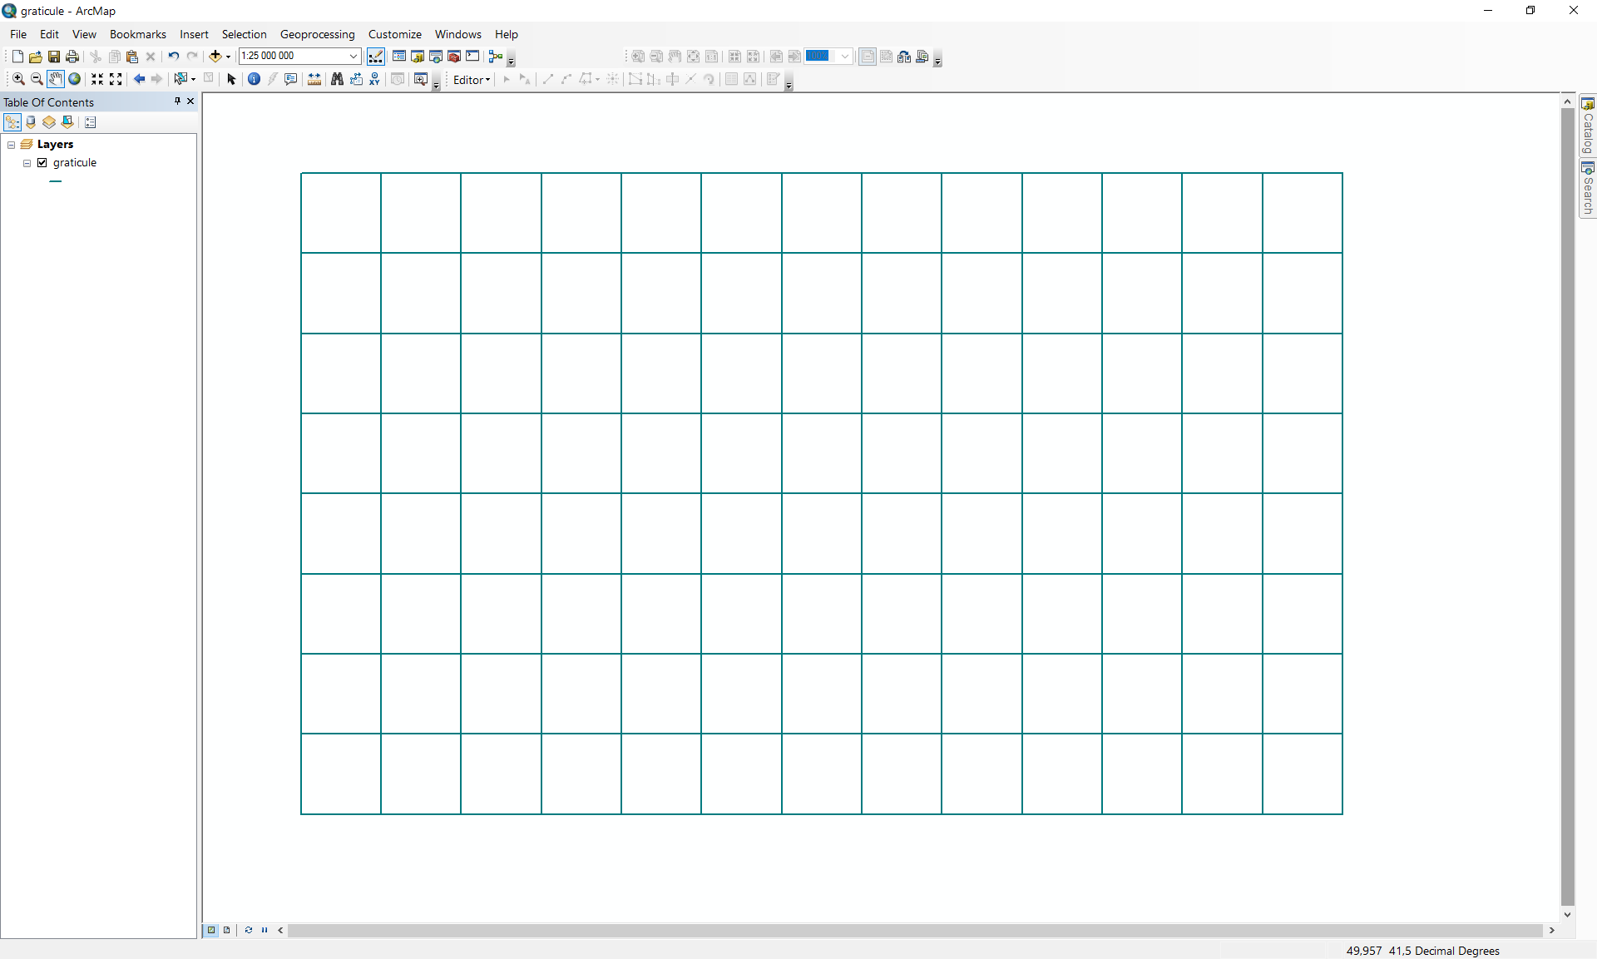

*Created with the Personal Edition of HelpNDoc:* [*Full-featured Documentation generator*](http://www.helpndoc.com)

**Densify graticule**

### Densify graticule

The fishnet function creates a list of polylines with the vertices at intersections of meridians and parallels.

Between these vertices no additional points have been generated. Therefore, the fishnet must be additionaly densified.

1. From the **System Toolboxes** **select Data Management Tools/Editing Tools/Conflation** select the **Densify** item; the dialog window appears.   
     
   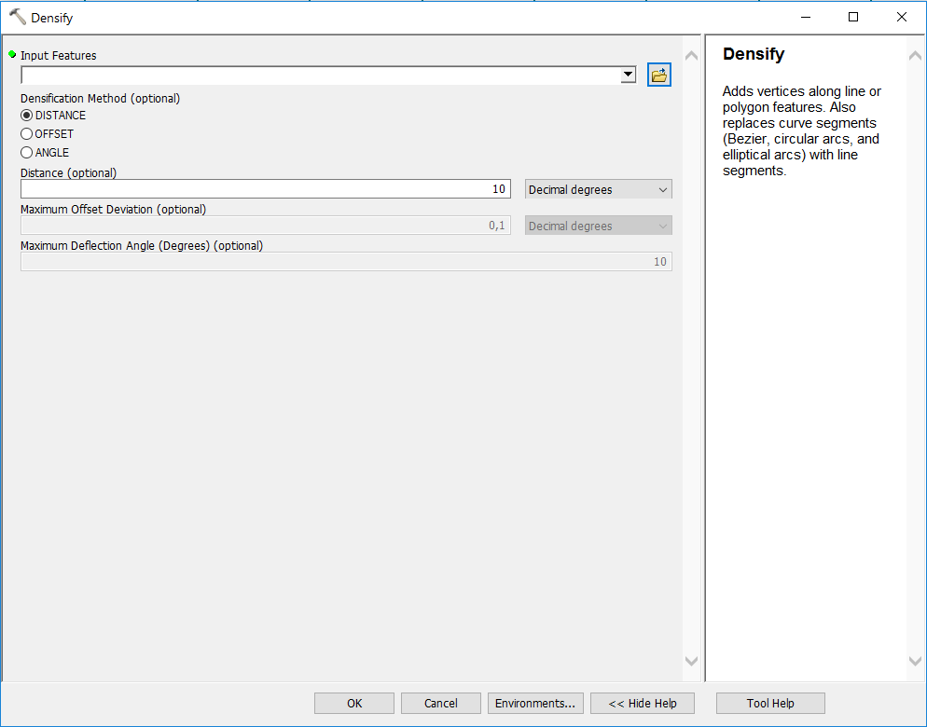
2. In the **Densify window** set the input feature *graticule.shp* and a densification method. For the graticule construction choose point sufficiently close to get a smooth approximation of meridians/parallels.  
     
   *Densification method*: DISTANCE  
   *Distance*: 1 Decimal degrees  
     
   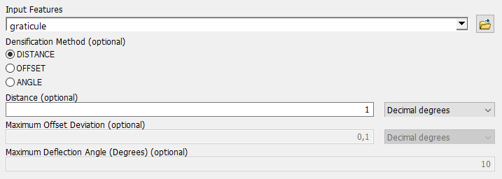  
     
   Click **OK** to start the densification.

*Created with the Personal Edition of HelpNDoc:* [*Easy to use tool to create HTML Help files and Help web sites*](http://www.helpndoc.com/help-authoring-tool)

**Assign spherical coordinates to the graticule**

### Assign spherical coordinates to the graticule

The created graticule points lack the spatial reference. It refers to the spherical coordinates *j*, *l*.

* + - 1. From the **System Toolboxes** **select Data Management Tools/Projections and Transformations/Raster** select the **Define Projection** item; the dialog window appears.   
           
         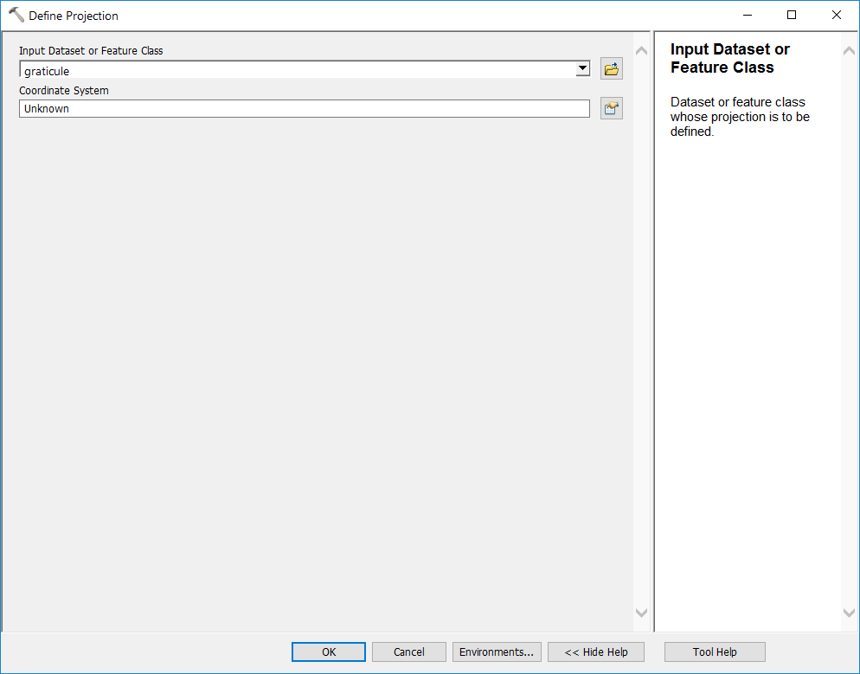
      2. From the drop-down menu setting the **Input Dataset** select *graticule*.
      3. In the **Coordinate System** section click on the icon , the **Spatial Reference Properties** form is displayed.  
           
         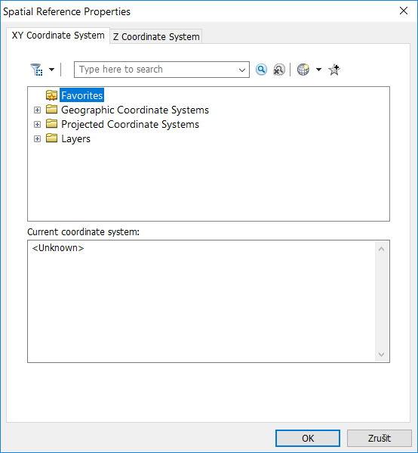
      4. In the **XY Coordinate System** bookmark click on the **Geographic Coordinate Systems** and select **World**, the list of supported system expands. Taking into account the analyzed map projection choose **WGS 1984.**  
           
         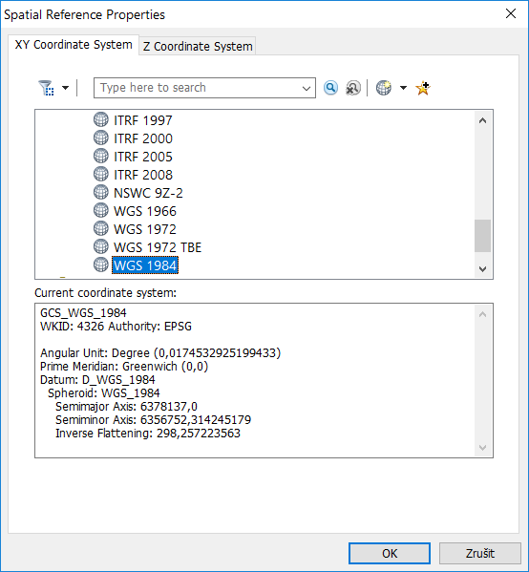
      5. Click on the **OK** button, the selected projection is displayed in edit box. To assign the spherical coordinates to the generated graticule, click on OK button.   
           
         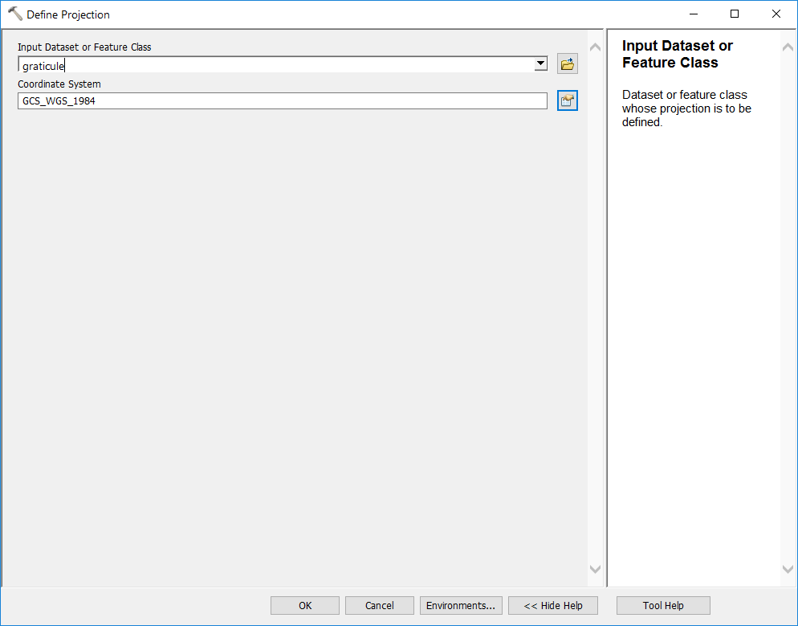
      6. Verify, whether the projection has been assigned correctly. In the list of layers, select the layer **graticule**, the layer gets highlighted. Using the right-mouse click display the context menu and click on the **Properties**.

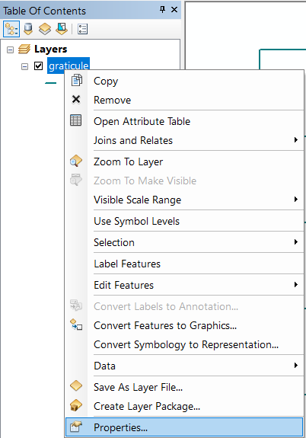  
  
 Subsequently, the **Layer Properties** window appears. Click on the **Source** bookmark and check the projection.  
  
 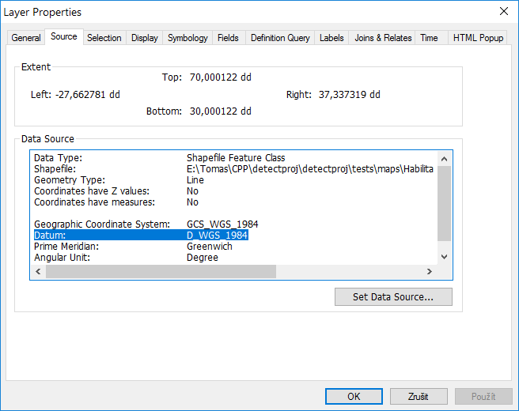

To export the layer into shape file display the context menu, click on the **Properties,** select **Data/Export Data** item.  
  
 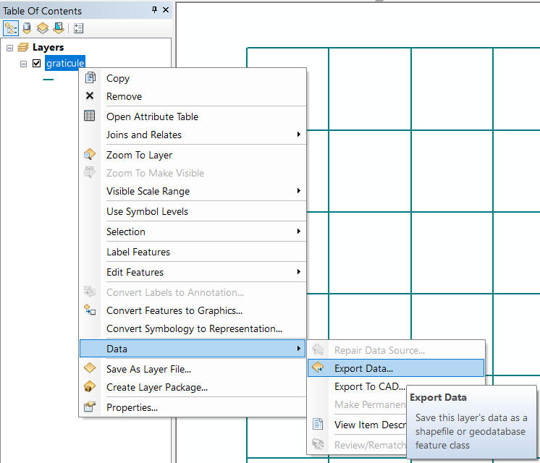

In the **Export Data** form select the path and file name: *graticule.shp* and click on **OK** button. The graticule will be exported to the shape file.

*Created with the Personal Edition of HelpNDoc:* [*Write eBooks for the Kindle*](http://www.helpndoc.com/feature-tour/create-ebooks-for-amazon-kindle)

**Georeferencing of the early map**

### Georeferencing of the early map

For the projection analysis, the test points coordinates *x*, *y* are the pixel coordinates. Dimensions of the raster in the detectproj and ArcGIS may be different. Therefore, the raster must obtain correct dimensions and position.

1. Run ArcGIS and create the new empty project. Click on the  icon int the main toolbar and from the drop-down menu select the item **Add Data**.  
     
   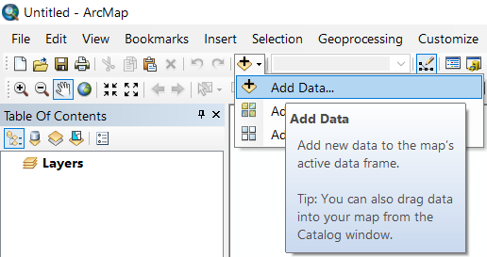  
     
   In the **Add Data** window, find the shapefile *graticule_bonne.shp* and click on the **Add**.  
     
   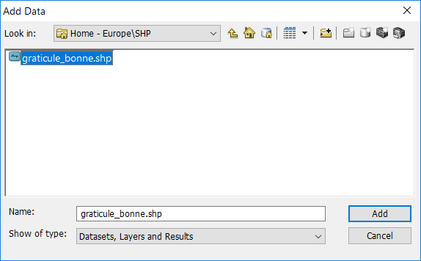  
     
   The projected densified graticule in the Bonne projection appears.  
     
   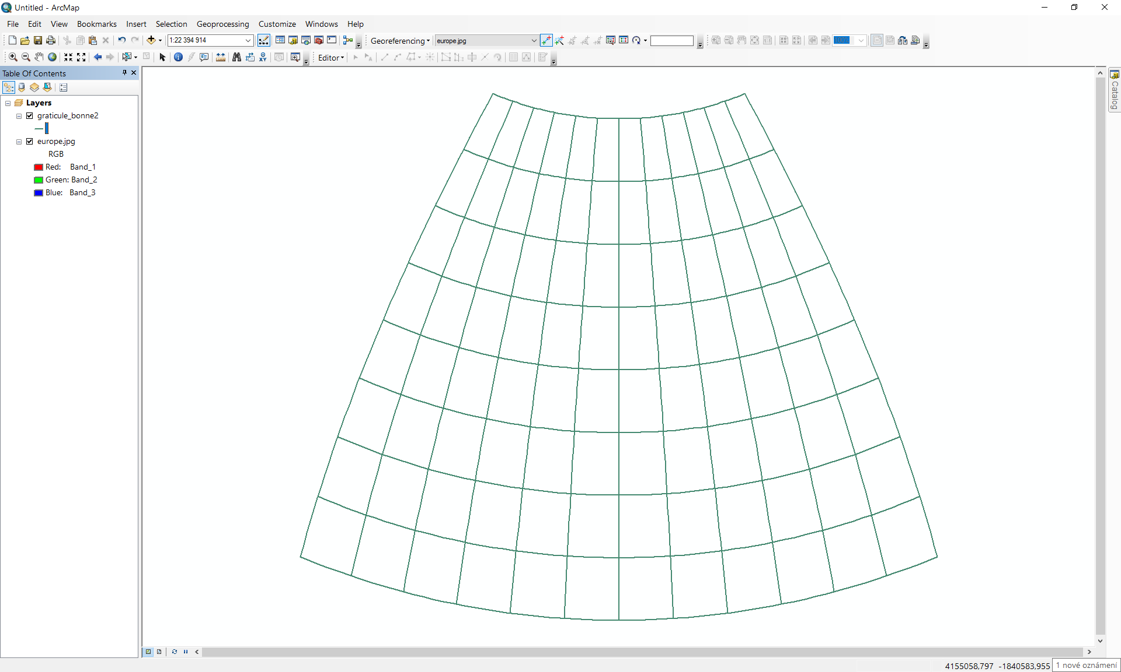
2. Click on the  icon int the main toolbar and from the drop-down menu select the item **Add Data**.   
     
   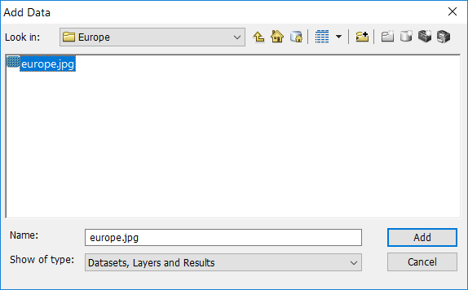  
     
   Select the analyzed early map and click to **Add** button.
3. Unfortunately, the raster has a different scale and it is shifted. Its position and size need to be adjusted. To open the **Georeferencing** toolbox, click in the **Customize/Toolbar** items and select **Georeferencing** item.  
     
   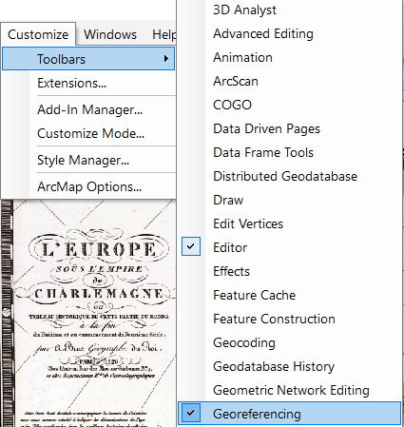  
     
   Subsequently, the Georeferencing toolbox is displayed.   
     
   
4. From the drop-down select the raster that needs to be georefenced: europe.jpg. Zoom to the georeferenced raster file.
5. To add the control points click on the  icon. Select intersection of the central meridian and the southmost parallel as the control point (j=35○) on the analyzed map.  
     
   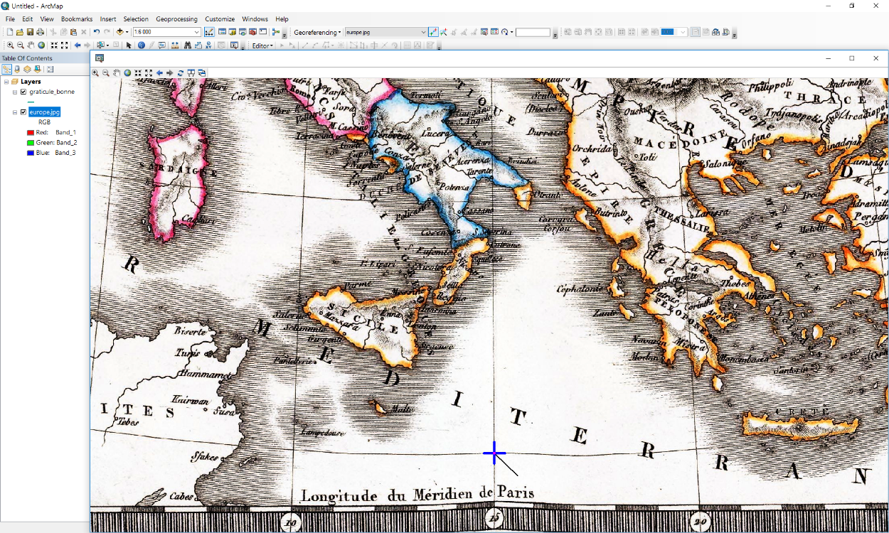  
     
   Zoom to the reconstructed graticule. Find the corresponding point represented by the intersection of the central meridian and the parallel j=35○ on the reconstructed graticule.  
     
   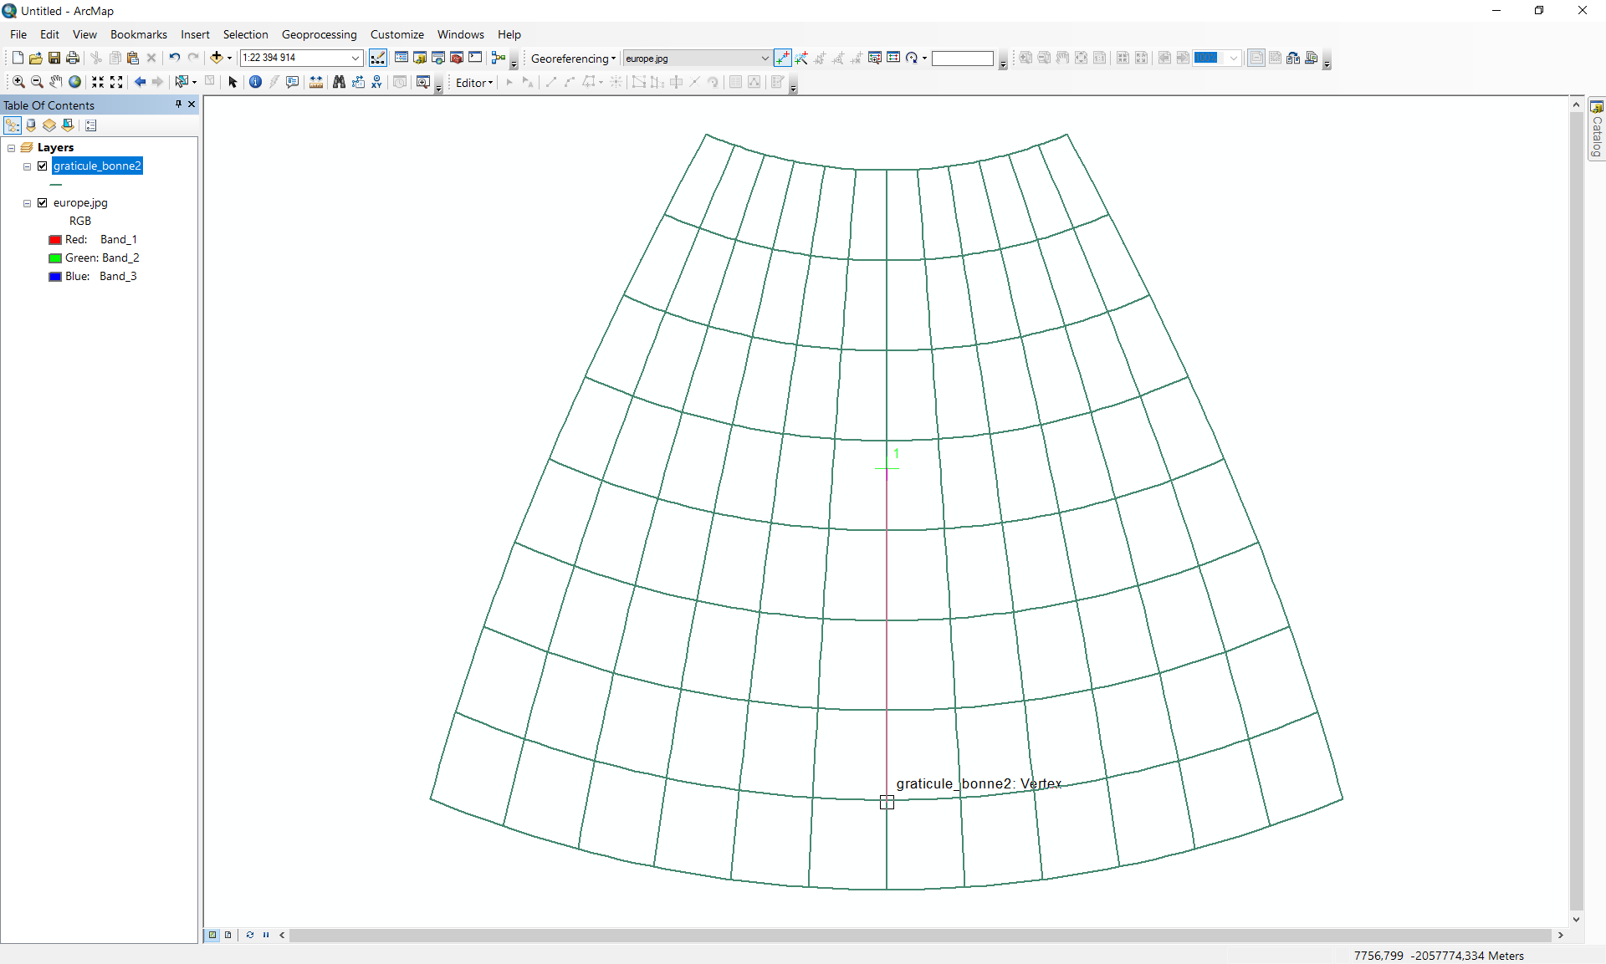
6. Zoom to the georeferenced raster. Find the second control point represented by the intersection of the central meridian and the parallel j=70○ on the analyzed map.  
     
   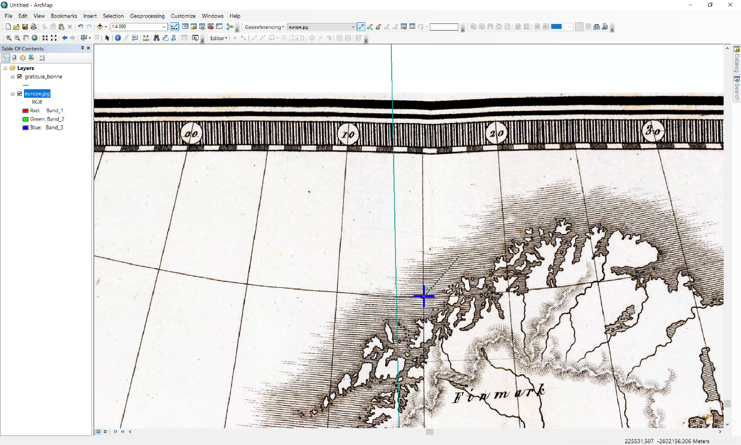  
     
   Zoom to the reconstructed graticule. Find the corresponding point represented by the intersection of the central meridian and the parallel j=70○ on the reconstructed graticule.  
     
   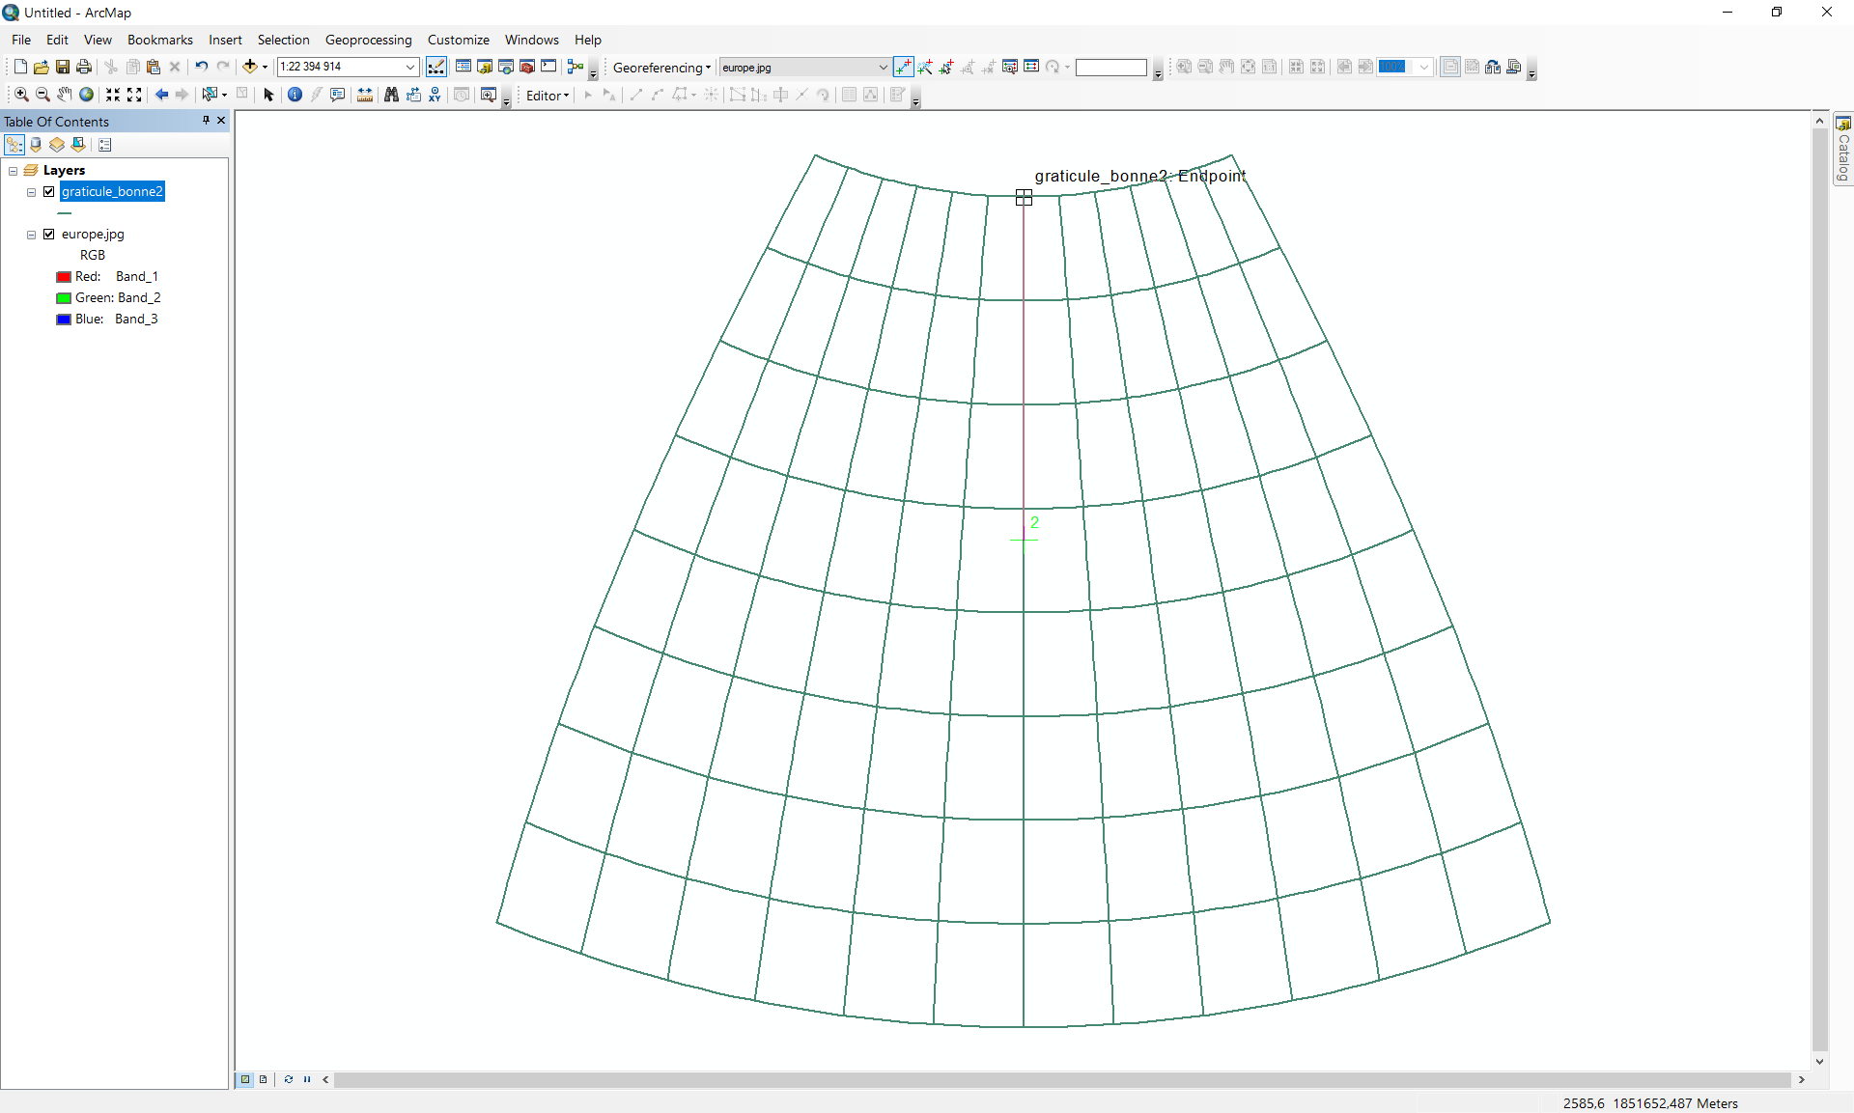  
     
   Subsequently, the georeferenced analyzed map is displayed. The reconstructed meridians and parallels fit well to the original.  
     
   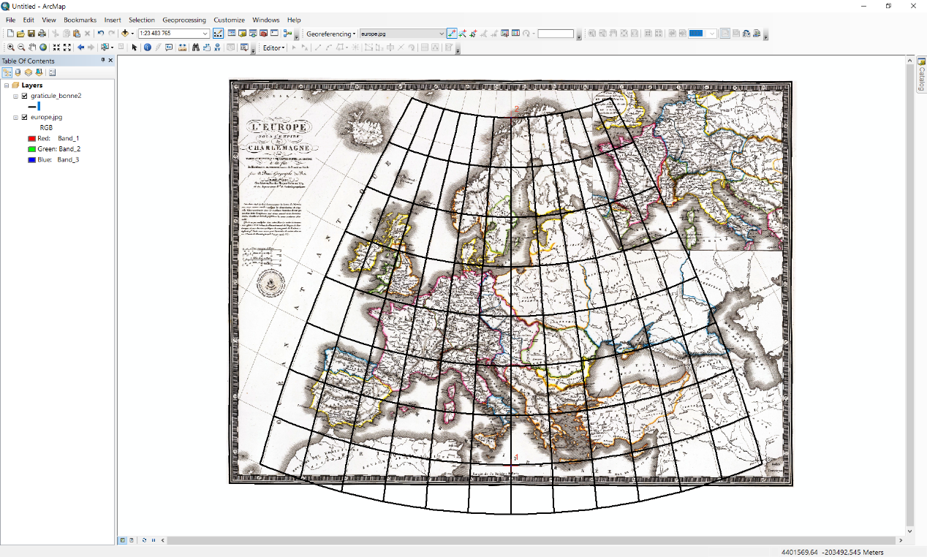
7. Unfortunately, the JPG format does not support storing the georeference directly. Therefore, the raster file needs to be exported to another format keeping the georeference information, the recommended raster format is IMG. To export the raster file display the context menu, click on the **Properties,** select **Data/Export Data** item.  
     
   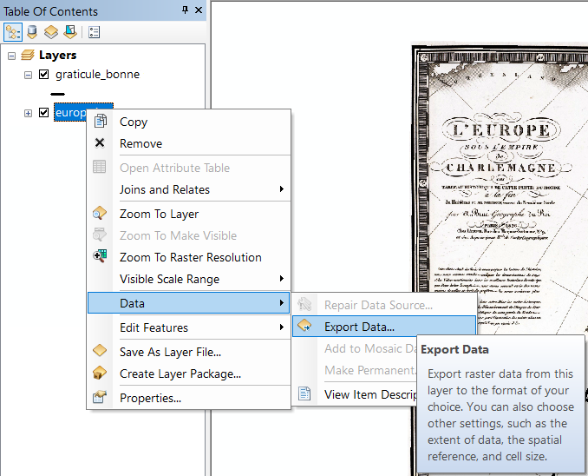
8. In the **Export Data** form select the path, format (IMG), and file name: *graticule_bonne.img* and click on **OK** button. The raster will be exported to the IMG file and added to the map.  
     
   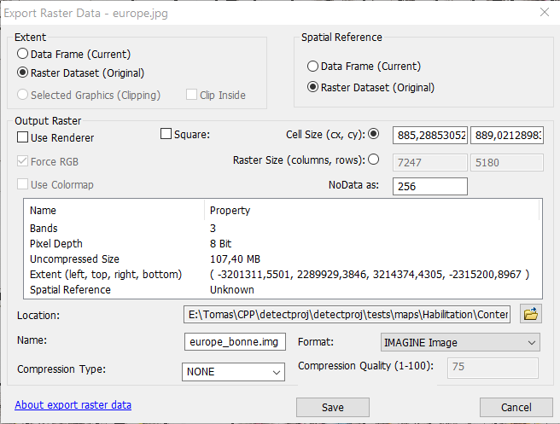
9. Define the projection of the georeferenced raster *europe_bonne.img*. Click on the  to set the destination coordinate system. In the **XY Coordinate System** bookmark click on the **Projected Coordinate Systems** and select **World**, the list of supported system expands, choose **Bonne (World).**   
     
   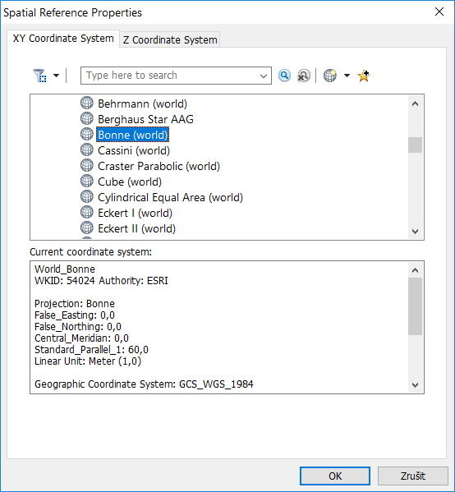
10. To change the Bonne projection properties, double click on the Bonne (world), the **Projected** **Coordinate System Projection Properties** window appears. Set the central meridian longitude *λ*0 = 17.0372○ and the standard parallel latitude *φ*1 =53.5○.  
      
    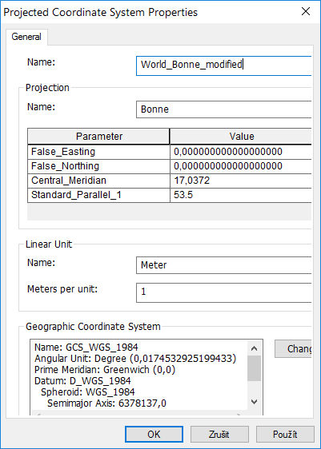  
      
    Change the projection name to *World Bonne Modified*. Click on OK to apply the changes and return to the **Define Projection** window.  
      
    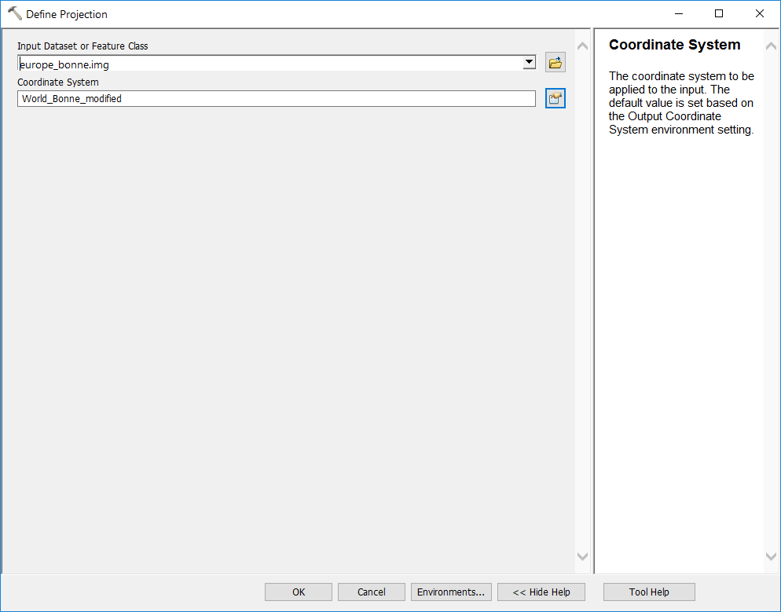  
      
    Click on the **OK** button to assign the Bonne projection to the raster file.

*Created with the Personal Edition of HelpNDoc:* [*Create HTML Help, DOC, PDF and print manuals from 1 single source*](http://www.helpndoc.com/help-authoring-tool)

**Reprojection from Bonne to World Mercator**

### Reprojection from Bonne to World Mercator

The final step of the process represents the reprojection of the analyzed from the Bonne projection to the destination projection represented by the World Mercator.

1. From the **System Toolboxes** select **Data Management Tools/Projections and Transformations/Raster** select the **Project Raster** item; the dialog window appears.   
     
   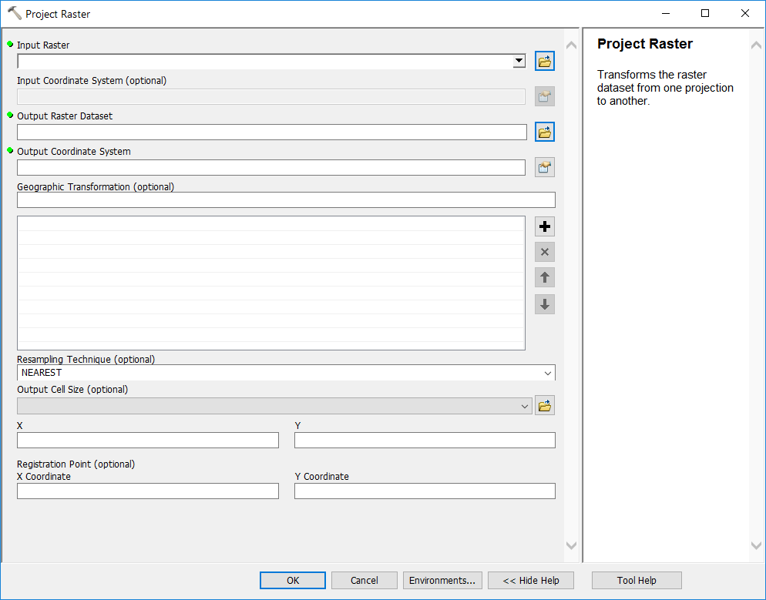  
     
   Select the **Input** and **Output** rasters:  
     
   *Input Dataset*: europe_bonne.img

*Output Dataset*: europe_merc.img

1. Click on the  to set the destination coordinate system. In the **XY Coordinate System** bookmark click on the **Projected Coordinate Systems** and select **World**, the list of supported system expands. Taking into account the analyzed map projection choose **WGS 1984 Web Mercator.**  
     
   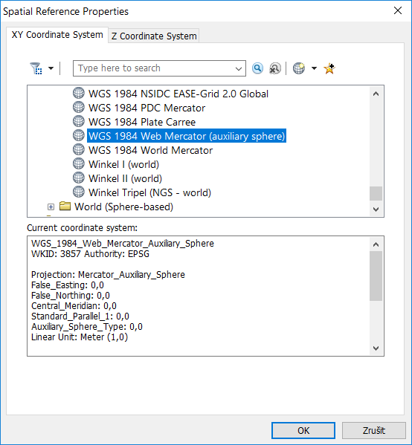  
     
   Click on OK to apply the changes and return to the **Project** window.  
     
   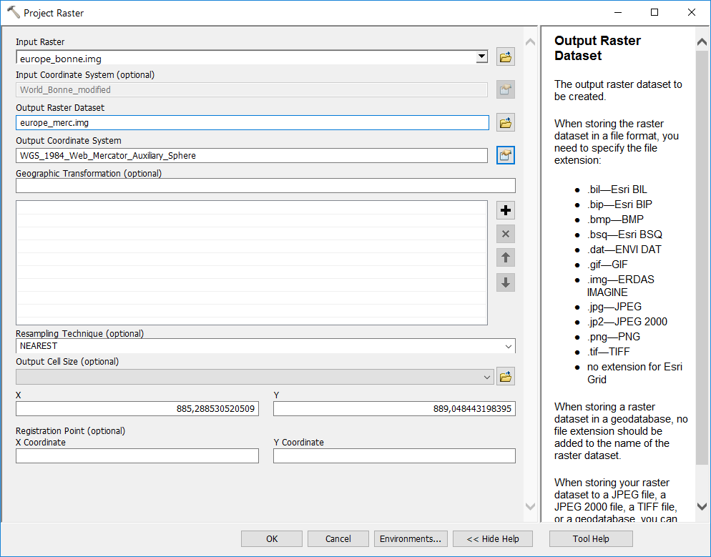
2. In the **Project** window click on OK, the output raster file *europe_merc.img* based on the Web Mercator projection will be created.
3. Subsequently, the reconstructed graticule needs to be reprojected into Web Mercator projection. From the **System Toolboxes** choose **Data Management Tools/Projections and Transformations** andselect the **Project** item; the dialog window appears.  
     
   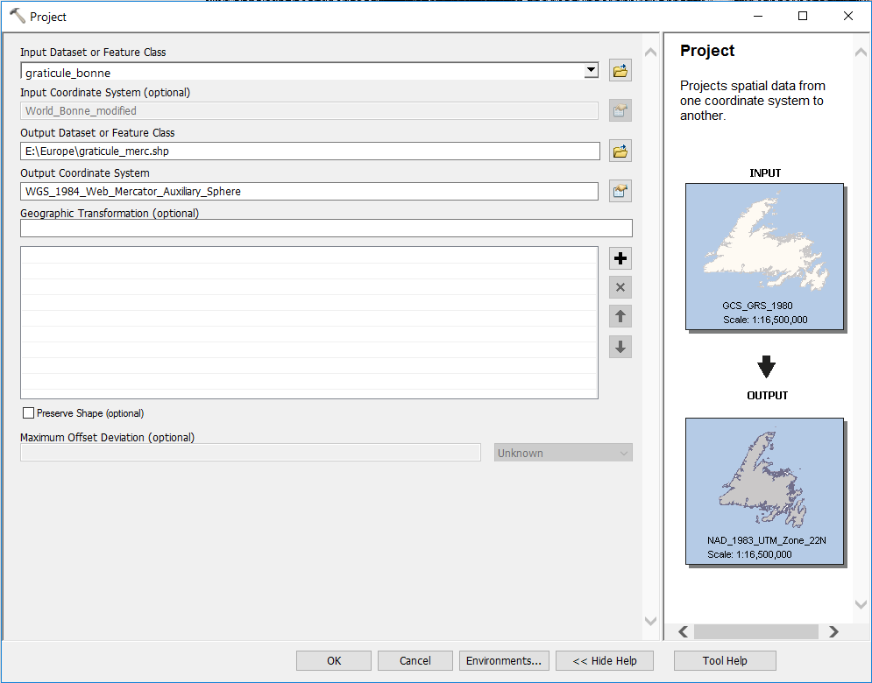  
     
   Select the **Input** and **Output** shape files:  
     
   *Input Dataset*: graticule_bonne.shp  
   *Output Dataset*: graticule_merc.shp  
     
   Set the output coordinate system as *Web Mercator* in the same manner. Click OK button to create the output shape file.
4. Close the current project, create the new empty one. Click on the  icon it the main toolbar and from the drop-down menu select the item **Add Data**. In the **Add Data** window, find the shapefile *europe_merc.img* and click on the **Add**.  
     
   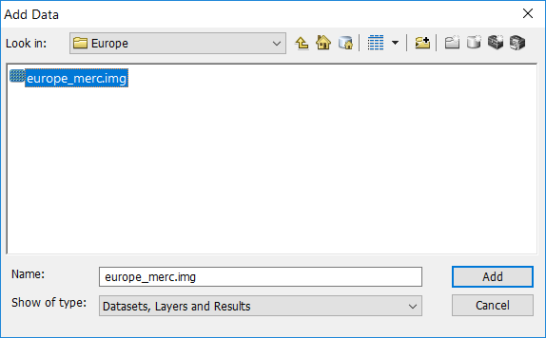  
     
   The analyzed map in the Web Mercator projection appears. Despite irts strange shape, the meridians as well as parallels are represented by the straight lines.  
     
   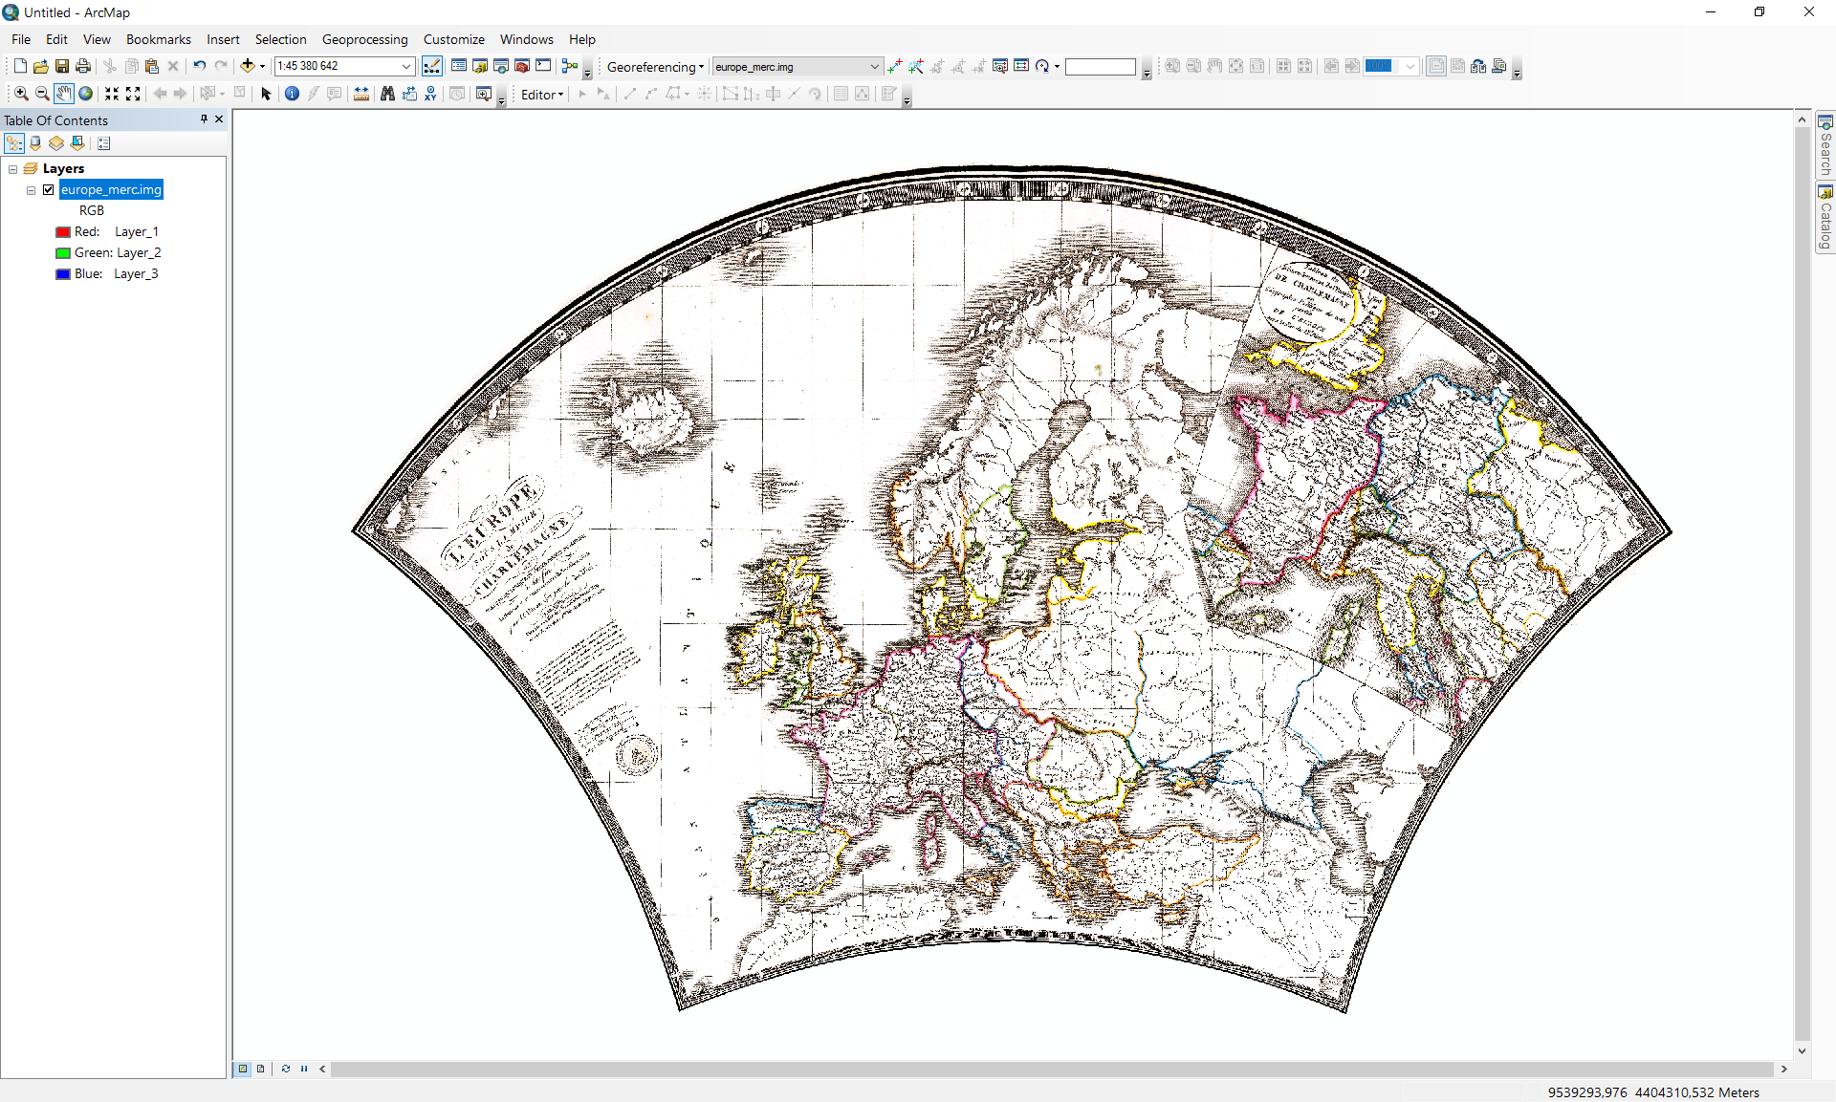
5. Click on the  icon to add the projected graticule *graticule_merc.shp* and click on the **Add**.  
     
   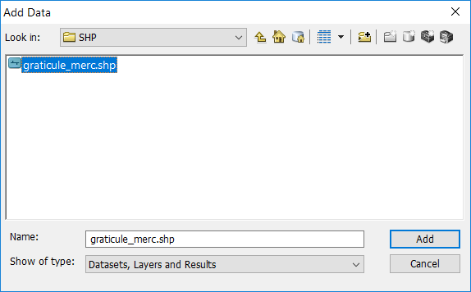  
     
   Select the file *graticule_merc.shp* representing the reprojected graticule. Click on the **Add** button, a superimposition of the imported file and the reprojected early map will be displayed.  
     
   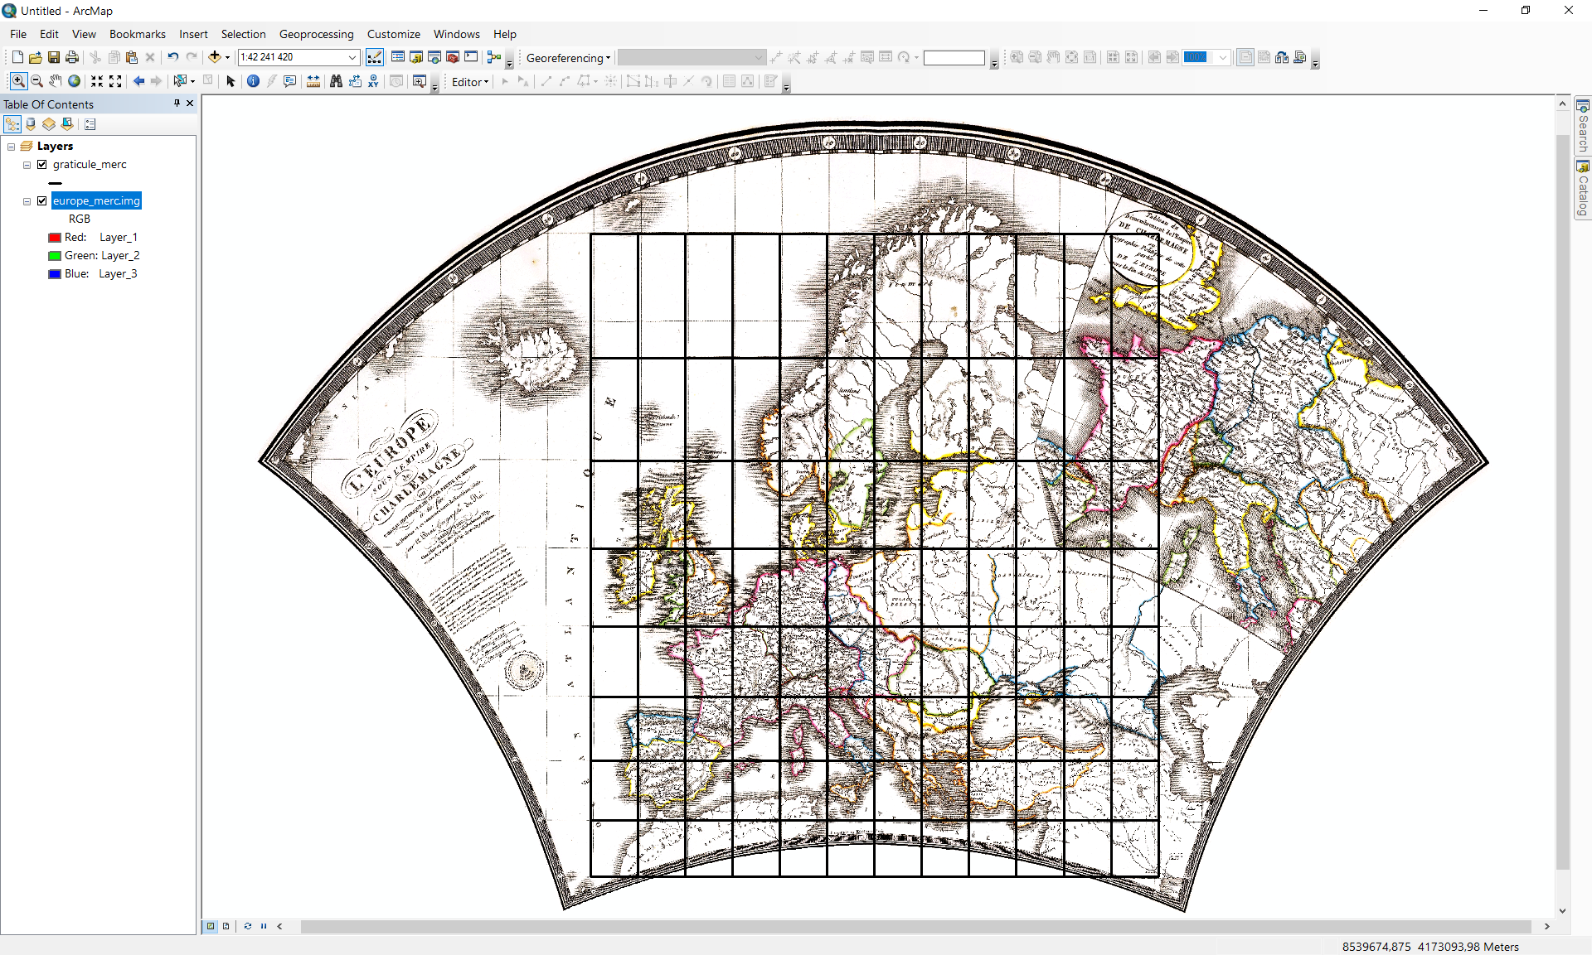
6. To verify the efficiency of the georeferencing, a base map over the analyzed map will be added. Click the **Add Basemap** button, in the **Add Basemap** window select any map, for example *National Geographic* map.  
     
   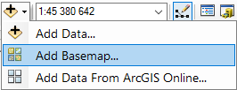  
     
   To proceed the basemap import click on the **Add** button.  
     
   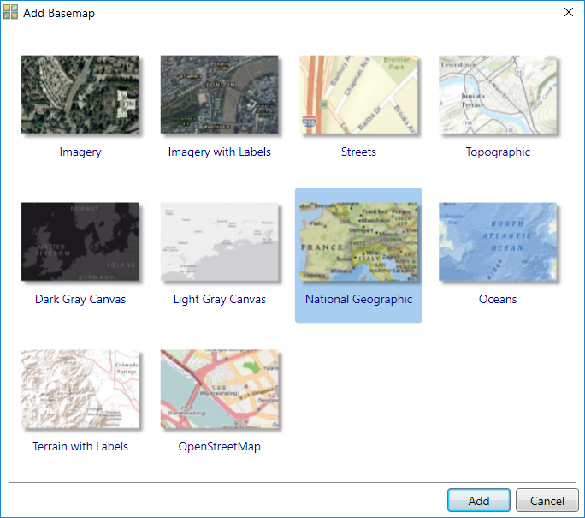  
     
   A superimposition of the basemap, projected early map, and the reconstructed graticule will be shown. The analyzed map content fits well to the digital map.  
     
   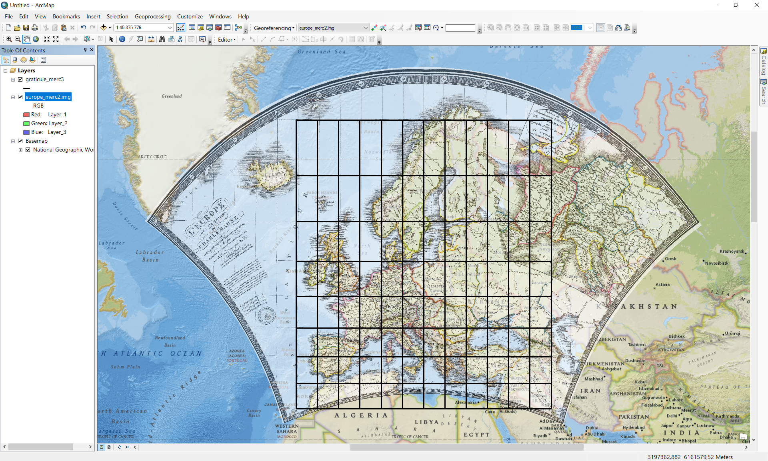

*Created with the Personal Edition of HelpNDoc:* [*Generate EPub eBooks with ease*](http://www.helpndoc.com/create-epub-ebooks)

**Setting parameters**

Several *detectproj* parameters can be set in the form **Settings**. To display the window click in the **Analysis** menu, and select the **Settings** item. Alternately, click on the icon.   
  
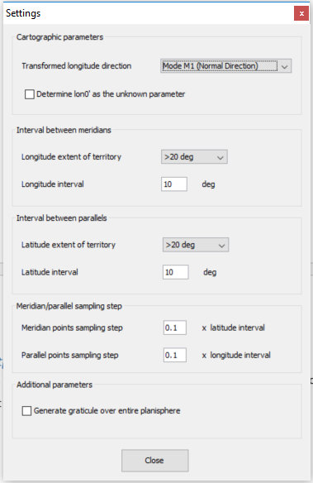

### Setting cartographic parameters.

The following cartographic parameters can be set.

#### Transformed longitude direction.

There is more than one way to measure the transformed longitude *l’.* The appropriate mode M1-M4 may be set from the combo box. In general, it affects the way and direction for measuring the transformed longitude.

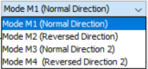

It is not recommended to change this value unless you are an experienced cartograher.

#### Determine l0 as the unknown parameter

To minimize the distortion and provide a true projection of the mapped region, it is neccessarry to set the central meridian longitude l0 . It is frequently chosen in the axis of the symmetry of the mapped region; it passes through the center of the region. This option is important for complicated cases and may significantly improve the results; compare analysis with *l*0 =0

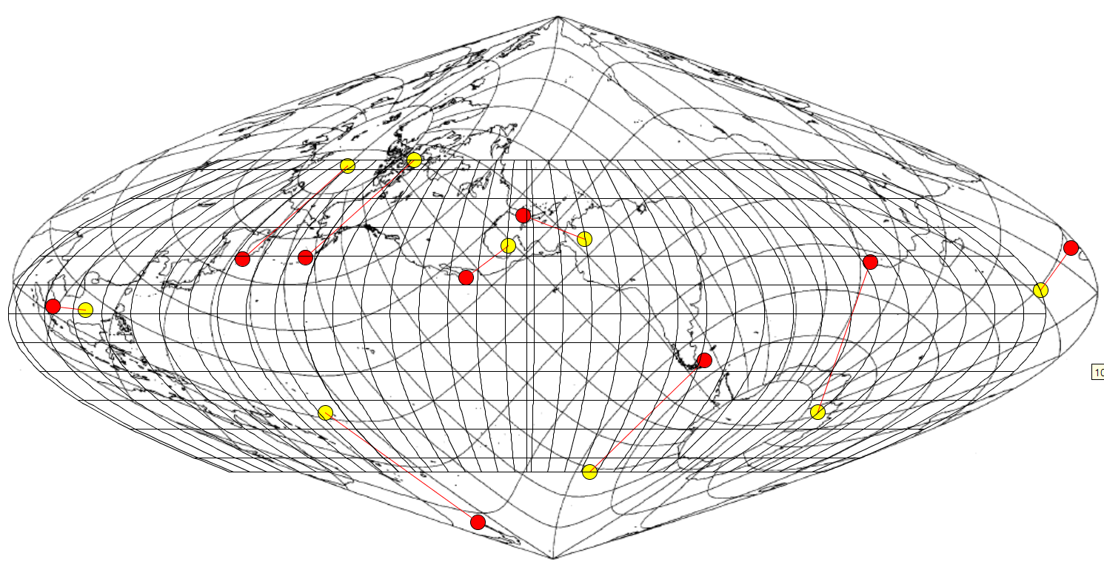

and *l*0  as the determined parameter.

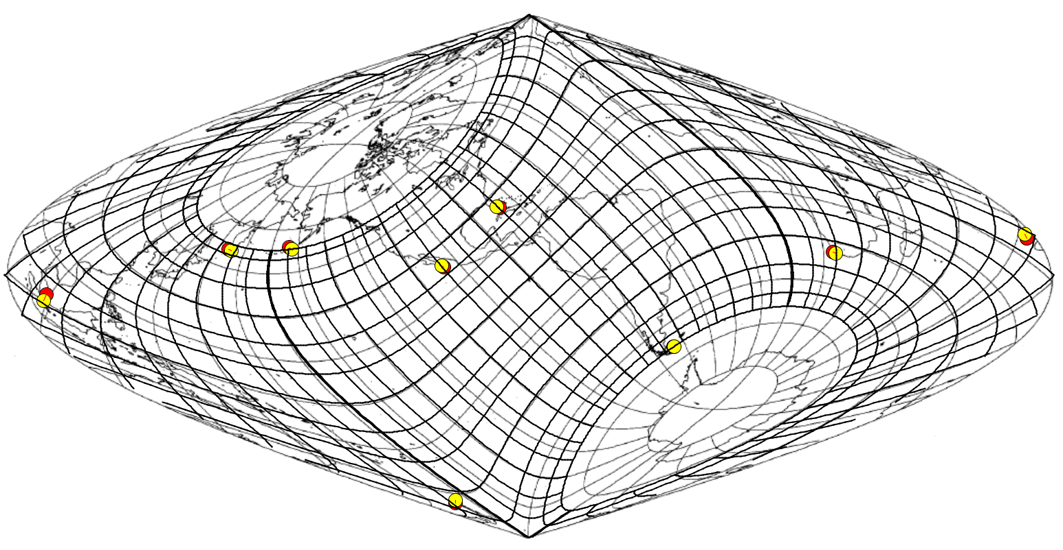

### Setting parameters of the reconstructed graticule.

The following parameters of the reconstructed graticule can be set.

#### Interval between meridians.

Depending on the geographic extent of the analyzed territory in the longitude direction (>20°, >2°, <2°), the intervals between meridians can be set.

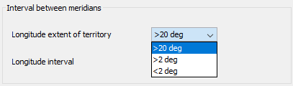

#### Interval between parallels.

Depending on the geographic extent of the analyzed territory in the latitude direction (>20°, >2°, <2°), the intervals between parallels can be set.

#### Meridian sampling step.

A meridian of longitude *l* may be sampled with the step Dj, the default sampling step is set as 0.1 * latitude interval between parallels.

#### Parallel sampling step.

A parallel of latitude *j* may be sampled with the step Dl, the default sampling step is set as 0.1 * longitude interval between meridians.

These options allow to set the graticule parameter so as it fits better with the analyzed early map.

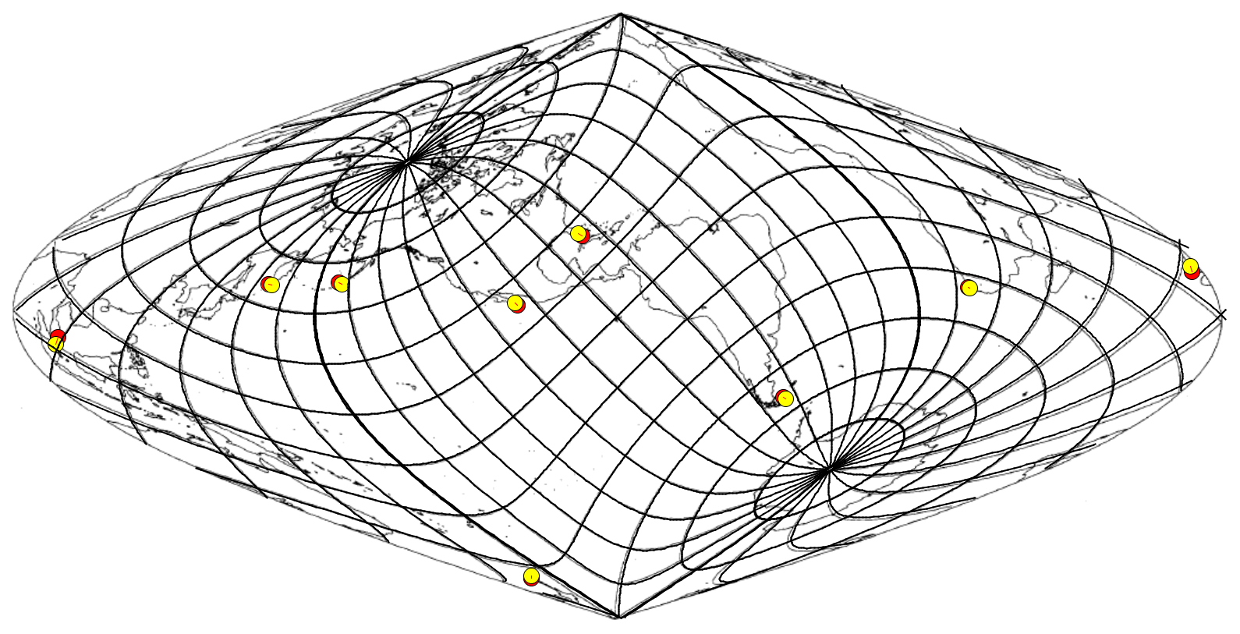

#### Geografic extent of the reconcstructed graticule

The reconstructed graticule is generated over the intervals given by the geographic extent of the reference points, or the entire sphere may be involved. To avoid extrapolation the default value takes into account the geographic extent of the analyzed territory.

*Created with the Personal Edition of HelpNDoc:* [*Benefits of a Help Authoring Tool*](http://www.helpauthoringsoftware.com)